**Dufour 45e Performance (Blanca).**

This document forms the basis of my sail order from Fareast Sails.

**Mainsail measurement data:**

Fractional rig.

I have obtained, from Sparcraft, the rig specification sheet for the **tall three spreader version** of the mast as fitted to this vessel.

Mast profile is the PRE 2014 version of the S830 (Sparcraft changed the specification in 2014).

The diagram below shows the mast slot profile use on Blanca. (**PLEASE note the mast slot changed after 2014**)

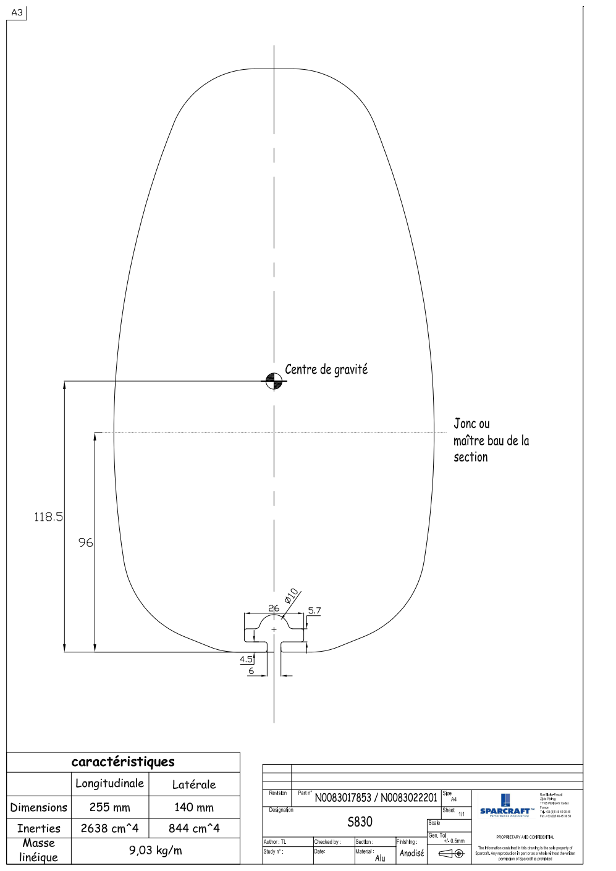

I wish to specify Rutgerson batten fittings. The luff boxes are to be RU-1597 to permit batten tension adjustment and allow the sail to be constructed with a simple batten pocket **closed at the leech** to minimise the potential for fouling the lazy jacks while hoisting, or meeting the backstay.

The batten cars to suit the S830 profile will be RU-1530-11-05 / RU1535-11-05. I will source these myself.

The intermediate luff slides are to be nylon slugs to suit the mast profile shown above. (I will **not** be using Rutgerson intermediate pressure reducing slides.). The sail insertion opening in the mast (Sail gate) has a width of 23mm.

Boom profile is F1700

**Measurements made from the boat.**

“P” = 17200mm from top of the boom to the black line on mast. (The measurement from the top of the boom to the main halyard sheeve is 17350mm to allow for the halyard splice and shackle.).

(The sail design will of course have to allow for the mainsail tack vertical offset (see below) of 44mm PLUS an allowance for mainsail luff stretch. I would anticipate the mainsail luff to be approximately 17050mm but will wait for your design.)

2) “E” = 6050mm measured from the back of the mast to the black band on boom. (The measurement from the back of the mast to the mainsail clew sheave is 6350mm to allow for outhaul splice and shackle.).

The mainsail is loose footed, ie. the foot is slightly convex. The clew is not connected to the boom track, but is held down to the boom with a Velcro strop. A large stainless ring is therefore required at the clew.

3) The distance from the back of mast to the backstay at the level of the top of the boom, with the boom horizontal = 6700mm.

4) For the sail design the **length of the mast crane should be taken as 130mm**.

(The length of mast crane, from back of mast to backstay fixing point, was measured at 145mm BUT the Sparcraft specification sheet gives this dimension as 124mm.).

5) Tack height above boom (measured from top of boom to bearing surface of tack shackle) = 44mm

6) Tack horizontal offset behind mast (measured from back of mast to bearing surface of tack shackle) = 70mm

7) Sail insertion height:

a) Top of boom to bottom of mast gate = 112mm

b) Top of boom to top of mast gate = 193mm

So mast gate has a length of 81mm.

8) I have discussed the expected mast pre-bend with the rig manufacturers. For the sail design the mast pre-bend measured at the midpoint of the mast **should be taken as 100mm**.

9) Position of reefs.

The yacht is fitted with single line reefing for the first and second reefs.

The luff and leech sail reefing points are fitted with Antal ball raced blocks.

The blocks are attached to the sail by webbing loops which pass through stainless steel cringles and are sewn on to reinforcing patches on the opposite side of the sail.

The first reefing block is on the Starboard side of the sail.

The second reefing block is on the Port side of the sail.

I wish to transfer the Antal blocks to the new sail. To enable this I would like the webbing loops (for the attachment of the reefing blocks) to be affixed to the sail as usual (so, to be attached to the opposite side of the sail to the position of the reefing blocks) BUT I would like the webbing loops to be shorter than normal so that they approach BUT DO NOT extend through the stainless steel reefing cringles. I will then use a Dyneema soft shackle to pass through the cringle, to attach the reefing block to the webbing straps. See photographs to illustrate.

**Starting with the LUFF reefing points.**

Since the first and second reefing points on the sail will NOT be attached to the reefing hooks (ram’s horns) at the gooseneck, the vertical and horizontal offsets of these hooks are ONLY important to define the position of the luff cringle for the THIRD reef.

So, for the THIRD reef:

a) Reef hook height above boom = 52mm

b) Reef hook setback (from back of mast) = 88mm.

Since the FIRST and SECOND reefs use reefing blocks attached to the sail as described above, the vertical and horizontal offsets for their reefing cringles must be different from those required by the third reef in order that room is created for the reefing blocks.

So, for the FIRST and SECOND reefs the stainless steel reefing cringles are required to sit, when reefed;

a) Height above the boom = 110mm

b) Horizontal set back = 180mm.

(See photo which I hope helps my explanation.).

**Now the LEECH reefing points.**

The first and second reefing lines pass through the boom, around sheaves in the aft end of the boom and then pass around the leech reefing blocks and are secured to the boom.

The first reefing line is attached to the boom 5410mm from the back of the mast.

The second reefing line is attached to the boom 5100mm from the back of the mast.

**Leech line**

I would line an overhead leech line to be included (as discussed).

**Measurements made from existing sail**

I have also measured the existing mainsail for your information, I am NOT trying duplicate it.

1) Luff of existing sail = 16470 (it was designed to fit a short Tidesmarine luff track which has been removed).

2) Foot of existing sail = 5810mm

3) Battens:

a) First batten length 1225mm

b) Second batten = 2265mm

c) Third batten = 3205mm

d) Fourth batten = 4095mm

e) Fifth batten = 5040mm

As an estimate of the roach in the existing sail (and potential for roach in the new sail) the leech at the level of both the top and first battens clears the backstay by approximately 110mm.

The sail width at ¼ height is 4660mm

Sail width at ½ height is 3375mm

Sail width at ¾ height is 1840mm.

The original sail had two reefs, the first at a height of 2200mm above the tack and the second at a height of 4300mm.

Other:

1. Batten sizes and length to allow me to source locally.
2. Overhead leech line

**Dufour 45e Performance**

**Foresail measurements.**

**Measured:**

1) “I” The yacht cabin / superstructure sits above deck level. It is therefore not possible to measure “I” from max hoist to “Deck level” The distance from “maximum hoist” to the top of the cabin roof immediately in front of the mast as it passes through the deck is 17320mm.

The “I” measurement provided by Sparcraft in their “sailmaker information” is 18400mm. BUT it is taken to an imaginary deck line which is parallel to the water line and is aligned with the rear deck).

2) “A” Maximum luff from headsail swivel to tack is 18030mm. (The existing sail has a luff of 17800mm measured from the tapes at the tack to the tapes at the head). THE NEW FORESAIL MUST BE MADE TO THIS DIMENSION. A longer luff than 17800 may cause the headsail swivel to meet the top luff foil bearing cap and damage it!)

3) “D” Deck shear.

Headsail swivel to front of the fairlead track = 17600

Headsail swivel to the back of its fairlead track cannot be measured because of the position of the standing rigging.

4) Tack to foresail fairlead track (along the deck);

Tack to front of track = 4950mm

Tack to aft end of track = 8200mm.

5) “J” Forestay at deck level to front of mast = 4990

6) “C” Deck to top of tack shackle bearing surface = 170mm

7) “B” Top of tack shackle bearing surface to start of luff track (Luff foil) = 700mm

8) “E” Diameter of the foresail luff tape / rope = 6.5mm.

Slot in luff foil is 2.7mm wide

Internal diameter of the groove in the luff foil = 7.7mm

**Existing sail dimensions: (Measured)**

Luff = 17800mm

Leech = 17060mm

Foot = 5280mm

Luff perpendicular (LP) = 5180mm

**Foresail detail.**

1. UV protection in pale grey Sunbrella on the starboard side of the sail.
2. Head of sail attachment: loops
3. Tack attachment: loops
4. Clew attachment: loops
5. Tri radial with large teardrop reinforcement at the tack, head and clew
6. Leech / foot lines with cleats
7. Telltales and draft stripe

**Foresail detail:**