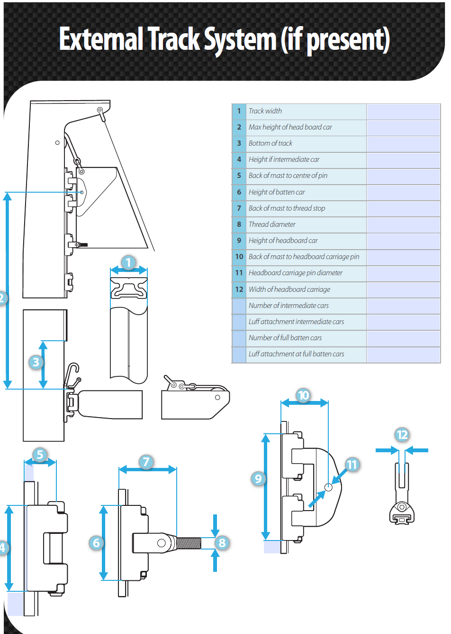
1 = N/A Do not need
2 =
3 =
4 = 85mm
5 =
6 = 85mm
7 =
8 = 10mm
9 =
10 =
11 = 12mm
12 = 14mm

 | - Square Top Mainsail - Lavezzi 40 Catamaran | 6000122 Björn
M0 | Sail Layout | Not Yet Posted
M1 | Tack Cut Back (Aft face of Mast to center of tack Pin - A) | 35mm | HELP
M2 | Tack Cut Up (Top of Boom to Center of tack Pin - B) | 45 mm aft of mast track  Bottom of tack need chafing protection | HELP
M3 | Clew Cut Up (Top of Boom to Center of Tack Pin - X) | Loose Footed | HELP
M4 | Clew type (slug, outhaul car or ring with strap) | Press Ring + Velcro Band | HELP
M5 | Sunbrella clew cover for Furling Mains | na | HELP
M6 | Other Offsets |  | HELP
M7 | Headboard | Maxi Ring with pin 12mm  Fat head about 1,6 meters  max thickness 14mm of headboard | HELP
M8 | Leech Line | Yes with clamcleat
M9 | Foot Line | No
M10 | Tack Ring Type | Press Ring | HELP
M11 | Tack angle | 84 degrees - Leech | HELP
M12 | Jack Line | No | HELP
M13 | Mast Bend (Luff Round) | Mast has a permanent bend of about 60mm (at upper spreader)  Mast is leaning backwards quite a lot. 53 mm per meter at deck level. (More higher up because of permanent mast bend.) | HELP
M14 | Fractional Rig (Yes, No) | No | HELP
M15 | Mast - Keel or Deck Stepped? | N/A
M16 | Number of Reefs | 3 Reefs  Reef 1 front 2150 rear 2120 from sail corner  Reef 2 front 1950 rear 1970 from reef 1  Reef 3 front 1945 rear 1950 from reef 2  Note: Locations for the reefs on the existing sail measured along front- and rear edges of the sail: Measuring point on the reef is inner sida at the bottom of the stainless ring. | HELP
M17 | Intermediate Reefing Diamond Eyes (Yes or No) | Yes 4 only the 1st reef  Extra eyelets locations:  Nr 1: 350 mm from the front edge of the sail 750 mm from the bottom of the sail  Nr 2: 1940 mm from the front edge of the sail 710 mm from the bottom of the sail  Nr 3: 2020 mm from the rear edge of the sail 610 mm from the bottom of the sail  Nr 4: 480 mm from the rear edge of the sail 360 mm from the bottom of the sail | HELP
M18 | Foot Reefing Grommets (next to boom) | N/A | HELP
M19 | Reefing Ring Type | 3 Reefs  Luff and Leech: O ring for blocks: reef 1 and 2 – Starboard  Reef 3: Port Side | HELP
M20 | Luff Length (Max Hoist - P) | 13.940 Max  (13.80m Net Finished size day of Delivery) | HELP
M21 | Foot Length (Max Foot - E) | 5.700m Max  (5.64m Net Finished size day of Delivery) | HELP
M22 | Leech Length (straight line head to clew) | Sailmaker – See tack angle info | HELP
M23 | Bimini to Clear (yes or no) | N/A | HELP
M24 | Foot Round | Sailmaker
M25 | Aspect Ratio | Sailmaker | HELP
M26 | Vessel Backstay Measurement | No Backstay - Catamaran | HELP
M27 | Luff Slides (Part Number) | Car System - Z-spars about 250x150 | HELP
M28 | Foot Slides (Part Number) | Loose Footed | HELP
M29 | Roach Type | See batten Lengths | HELP
M30 | Roach Factor | See batten Lengths | HELP
M31 | MGM | Sailmaker | HELP
M32 | MGU | Sailmaker | HELP
M33 | Batten Type (Partial or Full) | Note: Measured from end to end of the battens  Bottom to top  1: 4995mm  2: 4385 mm  3: 3650mm  4: 2842mm  5: 2078mm  6: 1918mm  7: Fat head batten: 1772 mm | HELP
M34 | Include Battens | N/A
M35 | Install Nylon Batten Holders | Yes  Luff: W1590 - 10mm  Leech: heavy Duty Velcro Pocket | HELP
M36 | Intermediate Sliders | Yes – Webbing  1. Batten car 1  2. Intermediate car with webbing to sail  3. Batten car 2  4. Intermediate car with webbing to sail  5. Batten car 3  6. Intermediate car with webbing to sail  7. Batten car 4  8. Intermediate car with webbing to sail  9. Batten car 5 and fathead batten.  Special bolt M10, existing. – Client will install ???  10. Top traveller. Bolt through head board. | HELP
M37 | Cloth Weight | 9.65 FIBERCON® PRO HYBRID POWERED WITH DYNEEMA - TRI RADIAL
M38 | Cut Type | TRI RADIAL
M39 | Sail Area | Sailmaker
M40 | Cunningham | No | HELP
M41 | Telltails | Yes | HELP
M42 | Triple Stitch | Yes
M43 | Sail Logo and Color(red, blue or black) | No | HELP
M44 | Sail Logo Artwork | N/A
M45 | Sail Numbers and Color | SWE 10978 – (Blue) | HELP
M46 | Draft Stripe and Color(red, blue or black) | Yes (Blue) | HELP
M47 | Overhead Leech Line | Yes
M48 | Specialty Sail | No | HELP
M49 | Boom Cover | No | HELP
M50 | Lazy Bag | No | HELP

 | - Headsail - | 6000122 Björn
H0 | Sail Layout | Not Yet Posted
H1 | Size of Headsail (110, 135, 150 etc.)" | See Luff Leech and Foot | HELP
H2 | Luff Length, Max Hoist, B measurement | 13.060m webbing loop tip to webbing loop tip (Max)  (12.92m Net Finished size day of delivery) | HELP
H3 | Leech Length | 11.615m | HELP
H4 | Foot Length | 5.890m | HELP
H5 | Tack and Head Fittings | Webbing Loops  Tack needs Chafing Protection.  Starts at 220 mm from tack, length 950 mm.
H6 | Clew Type (Press ring or 0-Ring) | Press Ring | HELP
H7 | Leech Line | Yes
H8 | Reefs for Hank on Sail (specify Qty of tiedowns) | No Manual Reefs
H9 | Foot Line | Yes
H10 | Track 1 (Tack to Genoa Track Beginning) | 6.140m | HELP
H11 | Track 2 (Tack to Genoa Track Ending) | 6.590m | HELP
H12 | Vessel "I" Measurement | ??? | HELP
H13 | Vessel "J" Measurement | 3.770m | HELP
H14 | Calculated Forestay Length | Sailamker
H15 | Reef | Compensator (double check)
H16 | LP | Sailmaker | HELP
H17 | Color of Suncover | Ocean Blue - Sunbrella | HELP
H18 | Side of Sail for Suncover (port or Stbd) | Port Side
H19 | Luff Tape Size (such as #6) | 5mm | HELP
H20 | Furler Manufacturer | Profurl C430
H21 | Foam Luff | Yes | HELP
H22 | Cut Type | Tri Radial
H23 | Sail Area | Sailmaker
H24 | Telltails | Yes | HELP
H25 | Anti chafe | Anti chafe for the spreader:  Mid point from clew 3680 mm and 7900mm from top.  Height 500 mm in aft end and 150 mm in front end.  Length 580 mm.
H26 | Triple Stitch | YES
H27 | Logo | No | HELP
H28 | Cloth Weight | 9.65 FIBERCON® PRO HYBRID POWERED WITH DYNEEMA - Tri Radial
H29 | Sail Numbers and Color (red, blue or black) | No | HELP
H30 | Sheeting Stripe (red, blue, black) | No | HELP
H31 | Draft Stripe Color (red, blue or black) | Yes (Blue) | HELP
H32 | Clew Height off Deck | sailmaker | HELP
H33 | Tack Height off Deck | 470mm | HELP
H34 | Luff tape starts 830 mm up from Tack | 830 mm | HELP
H35 | Specialty Sail | No | HELP
 | Customer Note: All details we can check as sailmakers are based on accurate vessel I and J Measurements |  | HELP

