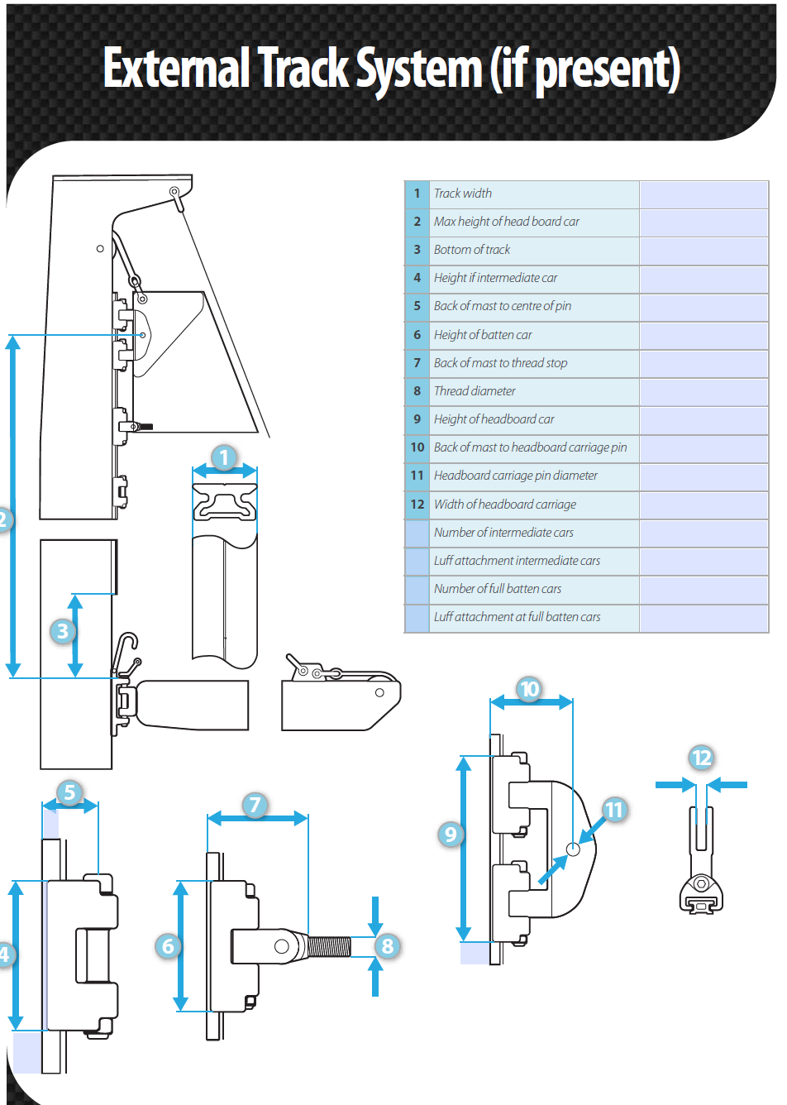
1 = N/A Do not need
2 = Check tomorrow
3 = 40 mm
4 = 85mm
5 = 12 mm from aft side of profile (profile height is 15 mm)
6 = 85mm
7 = 49 mm from aft side of profile (profile height is 15 mm)
8 = 10mm M10
9 = 195 mm
10 = 62 mm from aft side of profile (profile height is 15 mm)
11 = 12 mm
12 = MAX 14mm

 | - Square Top Mainsail - Lavezzi 40 Catamaran | 6000122 Björn
M0 | Sail Layout | Not Yet Posted
M1 | Tack Cut Back (Aft face of Mast to center of tack Pin - A) | 35mm 45mm | HELP
M2 | Tack Cut Up (Top of Boom to Center of tack Pin - B) | 45 mm 35 aft of mast track  Bottom of tack need chafing protection | HELP
M3 | Clew Cut Up (Top of Boom to Center of Tack Pin - X) | Loose Footed | HELP
M4 | Clew type (slug, outhaul car or ring with strap) | Press Ring + Velcro Band MAXI O RING diameter min 50 mm+ Velcro band length 1,8 meter | HELP
M5 | Sunbrella clew cover for Furling Mains | na | HELP
M6 | Other Offsets |  | HELP
M7 | Headboard | Maxi Ring with pin 12mm in headboard car  Fat head about 1,6 meters  max thickness 14mm of headboard | HELP
M8 | Leech Line | Yes with clamcleat
M9 | Foot Line | No
M10 | Tack Ring Type | Press Ring Stainless O-ring | HELP
M11 | Tack angle | 84 degrees – Leech check relative distance from head to clew | HELP
M12 | Jack Line | No | HELP
M13 | Mast Bend (Luff Round) | Mast has a permanent bend of about 60mm (at upper spreader)  Mast is leaning backwards quite a lot. 53 mm per meter at deck level. (More higher up because of permanent mast bend.) | HELP
M14 | Fractional Rig (Yes, No) | No | HELP
M15 | Mast - Keel or Deck Stepped? | N/A
M16 | Number of Reefs | 3 Reefs  Reef 1 front 2150 rear 2120 from sail corner  Reef 2 front 1950 rear 1970 from reef 1  Reef 3 front 1945 rear 1950 from reef 2  Note: Locations for the reefs on the existing sail measured along front- and rear edges of the sail: Measuring point on the reef is inner side at the bottom of the stainless ring. | HELP
M17 | Intermediate Reefing Diamond Eyes (Yes or No) | Yes 4 pcs only the 1st reef  Plus:  4 pcs Extra eyelets locations:  Nr 1: 350 mm from the front edge of the sail 750 mm from the bottom of the sail  Nr 2: 1940 mm from the front edge of the sail 710 mm from the bottom of the sail  Nr 3: 2020 mm from the rear edge of the sail 610 mm from the bottom of the sail  Nr 4: 480 mm from the rear edge of the sail 360 mm from the bottom of the sail | HELP
M18 | Foot Reefing Grommets (next to boom) | N/A | HELP
M19 | Reefing Ring Type | 3 Reefs  Luff and Leech: O ring for blocks: reef 1 and 2 – Starboard  Reef 3: Port Side | HELP
M20 | Luff Length (Max Hoist - P) | 13.940 Max Note: Goose neck 300 mm higher on mast than sail drawing.  (13.80m Net Finished size day of Delivery) | HELP
M21 | Foot Length (Max Foot - E) | 5.700m Max  (5.64m Net Finished size day of Delivery) | HELP
M22 | Leech Length (straight line head to clew) | Sailmaker – See tack angle info  Compare with measurement from top to clew. Difficult to measure angle. | HELP
M23 | Bimini to Clear (yes or no) | N/A End of boom never below XXX mm over deck KOLLA | HELP
M24 | Foot Round | Sailmaker
M25 | Aspect Ratio | Sailmaker Suggestion? | HELP
M26 | Vessel Backstay Measurement | No Backstay - Catamaran | HELP
M27 | Luff Slides (Part Number) | Car System - Z-spars mast about 250x150 | HELP
M28 | Foot Slides (Part Number) | Loose Footed | HELP
M29 | Roach Type | See batten Lengths | HELP
M30 | Roach Factor | See batten Lengths | HELP
M31 | MGM | Sailmaker | HELP
M32 | MGU | Sailmaker | HELP
M33 | Batten Type (Partial or Full) | Note: Measured from end to end of the battens  Bottom to top  1: 4995mm  2: 4385 mm  3: 3650mm  4: 2842mm  5: 2078mm (Front end only in batten pocket not full length, no batten car or holder)  6: 1918mm  7: Fat head batten: 1772 mm front end close to batten nr 6, no separate batten car but batten holder se photo) | HELP
M34 | Include Battens | N/A
M35 | Install Nylon Batten Holders | Yes  Luff: 6 pcs Rutgersson W1590 - 10mm  Leech: heavy Duty Velcro Pocket  Velcro??? Batten installed from front end and adjusted in batten holder (except batten nr 5).  Strong anti chafe material both sides of all batten pockets | HELP
M36 | Intermediate Sliders | Yes – Webbing  1. Batten car 1  2. Intermediate car with webbing to sail  3. Batten car 2  4. Intermediate car with webbing to sail  5. Batten car 3  6. Intermediate car with webbing to sail  7. Batten car 4  8. Intermediate car with webbing to sail  Intermediate cars: Webbing width 25mm. Vertical opening for 12 mm bushing. Pls test all!  9. Batten car 5 and fathead batten.  Special bolt M10, existing. – Client will install ??? Yes, no difference for sailmaker compared to other batten cars M10 inside thread.  10. Top traveller. Bolt through head board. | HELP
M37 | Cloth Weight | 9.65 FIBERCON® PRO HYBRID POWERED WITH DYNEEMA - TRI RADIAL
M38 | Cut Type | TRI RADIAL
M39 | Sail Area | Sailmaker
M40 | Cunningham | No YES in spec! | HELP
M41 | Telltails | Yes | HELP
M42 | Triple Stitch | Yes
M43 | Sail Logo and Color(red, blue or black) | No | HELP
M44 | Sail Logo Artwork | N/A
M45 | Sail Numbers and Color | SWE  10978 – (Blue) 2 lines Stitched to sail. | HELP
M46 | Draft Stripe and Color(red, blue or black) | Yes (Blue) | HELP
M47 | Overhead Leech Line | Yes
M48 | Specialty Sail | No | HELP
M49 | Boom Cover | No | HELP
M50 | Lazy Bag | No | HELP

 | - Headsail - | 6000122 Björn
H0 | Sail Layout | Not Yet Posted
H1 | Size of Headsail (110, 135, 150 etc.)" | See Luff Leech and Foot | HELP
H2 | Luff Length, Max Hoist, B measurement | 13.060m webbing loop tip to webbing loop tip (Max)  (12.92m Net Finished size day of delivery) | HELP
H3 | Leech Length | 11.615m | HELP
H4 | Foot Length | 5.890m | HELP
H5 | Tack and Head Fittings | Webbing Loops  Tack needs Chafing Protection.  Starts at 220 mm from tack, length 950 mm.
H6 | Clew Type (Press ring or 0-Ring) | Press Ring | HELP
H7 | Leech Line | Yes. No lose lines after clam cleat. Must be velcro pocket or similar. Risk of hooking up something on mast othervise.
H8 | Reefs for Hank on Sail (specify Qty of tiedowns) | No Manual Reefs
H9 | Foot Line | Yes
H10 | Track 1 (Tack to Genoa Track Beginning) | 6.140m 1105 from centerline boat | HELP
H11 | Track 2 (Tack to Genoa Track Ending) | 6.590m 1340 from centerline boat | HELP

H12 | Vessel "I" Measurement | Doublecheck tomorrow  See sail drawing  XXX from deck (maststep) to halyard sheave  YYY from deck (maststep) to forstay fitting in mast | HELP
H13 | Vessel "J" Measurement | 3.740mm front side mast to bolt forstay. Deck level is not well defined. Could also be 3770 measured to “deck level” See photo. | HELP
H14 | Calculated Forestay Length | See sail drawing Check tomorrow
H15 | Reef | Compensator (double check) YES
H16 | LP | Sailmaker (Old sail 5310 pls.check) | HELP
H17 | Color of Suncover | Ocean Blue - Sunbrella | HELP
H18 | Side of Sail for Suncover (port or Stbd) | Port Side
H19 | Luff Tape Size (such as #6) | 5mm | HELP
H20 | Furler Manufacturer | Profurl C430
H21 | Foam Luff | Yes Please advise foam or rope. Ropes fixed individually to sail? Bad experience of ropes making a very thick bump! Foam gives wrinkles… | HELP
H22 | Cut Type | Tri Radial
H23 | Sail Area | Sailmaker
H24 | Telltails | Yes, also when reefed | HELP
H25 | Anti chafe | Anti chafe for the spreaders:  Mid point from clew 3680 mm and 7900mm from top.  Height 500 mm in aft end and 150 mm in front end.  Length 580 mm.  AND  XXX for upper spreader. We will check location when it’s less windy. Hopefully tomorrow!  Both sides.
H26 | Triple Stitch | YES
H27 | Logo | No | HELP
H28 | Cloth Weight | 9.65 FIBERCON® PRO HYBRID POWERED WITH DYNEEMA - Tri Radial
H29 | Sail Numbers and Color (red, blue or black) | No | HELP
H30 | Sheeting Stripe (red, blue, black) | No | HELP
H31 | Draft Stripe Color (red, blue or black) | Yes (Blue) | HELP
H32 | Clew Height off Deck | sailmaker | HELP
H33 | Tack Height off Deck | 470mm From center of forstay bolt. 530 from deck. | HELP
H34 | Luff tape starts 830 mm up from Tack | 830 mm XX Double Check tomorrow. | HELP
H35 | Specialty Sail | No | HELP
 | Customer Note: All details we can check as sailmakers are based on accurate vessel I and J Measurements |  | HELP

