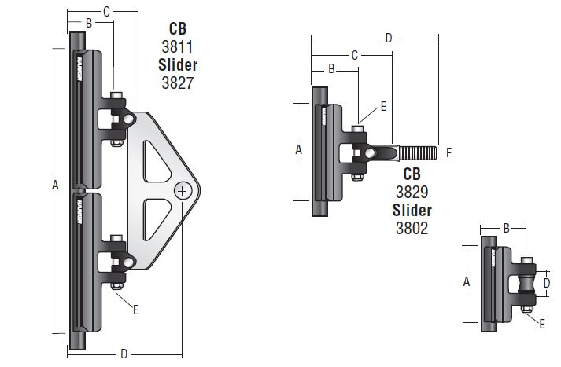

Headboard: A=234mm / B=47mm / C=100mm / D=105mm
Batten Holder car: A=140mm/B=60mm/C=80mm/D=115mm/F=12.0
Intermediate car: A=140mm/B=40mm/D=35mm
-------------------------------------------
Batten Holders: Batten holders insert into the Luff and Leech end of each batten pocket. Each batten box is 150mm long, 60mm wide and 30mm high. Each batten box is secured with 8 screws (4 on each side of the sail). The screws pass through the sail fabric and into the batten box. Batten boxes are made by Incidences sails. Please refer to pictures of batten boxes.
The sail battens are 15mm in diameter and have the following lengths:
Top Batten 235.5cm, top batten pocket: 244cm
2nd Batten 382cm, 2nd batten pocket: 389.5cm
3rd Batten 476.5cm, third batten pocket: 484cm
4th Batten 543cm, fourth batten pocket: 550.5cm
Bottom Batten: 595.5cm, Bottom batten pocket: 603 cm
Car system: ZSPARS batten car system on 32 mm track. Five batten cars and 3 intermediate cars.

-------------------------------------------

 | - Mainsail - | 5000924 Mike
M0 | Sail Layout | Not Yet Posted
M1 | Tack Cut Back (Aft face of Mast to center of tack Pin - A) | 7 cm | HELP
M2 | Tack Cut Up (Top of Boom to Center of tack Pin - B) | 6 cm | HELP
M3 | Clew Cut Up (Top of Boom to Center of Tack Pin - X) | Loose Footed | HELP
M4 | Clew type (slug, outhaul car or ring with strap) | Press Ring | HELP
M5 | Sunbrella clew cover for Furling Mains | na | HELP
M6 | Other Offsets |  | HELP
M7 | Headboard | Yes - Rutgerosn Headboard | HELP
M8 | Leech Line | yes
M9 | Foot Line | No
M10 | Tack Ring Type | Webbed O-Ring | HELP
M11 | Tack angle | 88.5 degrees – boom clears the bimini when horizontal. | HELP
M12 | Jack Line | No | HELP
M13 | Mast Bend (Luff Round) | Std | HELP
M14 | Fractional Rig (Yes, No) | YES | HELP
M15 | Mast - Keel or Deck Stepped? | Deck Stepped
M16 | Number of Reefs | 3 Reefs | HELP
M17 | Intermediate Reefing Diamond Eyes (Yes or No) | Yes | HELP
M18 | Foot Reefing Grommets (next to boom) | N/A | HELP
M19 | Reefing Ring Type | Luff: 12in webbed shackle – See picture.  Leech: Large webbed low friction ring | HELP
M20 | Luff Length (Max Hoist - P) | 17.30 meters Max  (16.90m Net Finished size day of Delivery)  + 217mm Rutgerson Headboard | HELP
M21 | Foot Length (Max Foot - E) | 6.63 Meters Max  (6.56m Net Finished size day of Delivery) | HELP
M22 | Leech Length (straight line head to clew) | Sailmaker | HELP
M23 | Bimini to Clear (yes or no) | No | HELP
M24 | Foot Round | Sailmaker
M25 | Aspect Ratio | Sailmaker | HELP
M26 | Vessel Backstay Measurement | 6.75 Meters from back of mast at boom level. | HELP
M27 | Luff Slides (Part Number) | 5 Batten Holders see pictures | HELP
M28 | Foot Slides (Part Number) | Loose Footed | HELP
M29 | Roach Type | Cruise CAT | HELP
M30 | Roach Factor | 1.35 | HELP
M31 | MGM | Sailmaker | HELP
M32 | MGU | Sailmaker | HELP
M33 | Batten Type (Partial or Full) | 5 full battens, 15mm diameter.  Batten lengths:  Top batten 2.355 meters  2nd batten: 3.82 meters  3rd batten: 4.765 meters  4th batten: 5.43 meters  Bottom batten: 5.955 meters  Batten pockets run from Luff to Leech. The batten pockets lengths are:  Top batten pocket: 2.44 meters  2nd batten pocket: 3.895 meters  3rd batten pocket: 4.84 meters  4th batten pocket: 5.505 meters  bottom batten pocket: 6.03 meters | HELP
M34 | Include Battens | N/A
M35 | Install Nylon Batten Holders | No  Incidence Batten Boxed at Luff and Leech. The batten boxes insert into the luff pockets at the Luff and the Leech. Each batten box is 150mm long, 60mm wide and 30mm high. Four screws pass through each side of the sail fabric to secure the batten boxes in place. Please refer to pictures. | HELP
M36 | Intermediate Sliders | YES – 3 Intermediate | HELP
M37 | Cloth Weight | 9oz Contender Pro Radian + 2 ply on the leech
M38 | Cut Type | Tri Radial
M39 | Sail Area | Sailmaker
M40 | Cunningham | No | HELP
M41 | Telltails | Yes | HELP
M42 | Triple Stitch | Yes
M43 | Sail Logo and Color(red, blue or black) | No | HELP
M44 | Sail Logo Artwork | N/A
M45 | Sail Numbers and Color | No | HELP
M46 | Draft Stripe and Color(red, blue or black) | Yes Black | HELP
M47 | Overhead Leech Line | No
M48 | Specialty Sail | No | HELP
M49 | Boom Cover | No | HELP
M50 | Lazy Bag | No | HELP

 | - Headsail - | 5000924 Mike
H0 | Sail Layout | Not Yet Posted
H1 | Size of Headsail (110, 135, 150 etc.)" | 130 - High clew | HELP
H2 | Luff Length, Max Hoist, B measurement | 17.40m meters  webbing loop tip to webbing loop tip (Max)  (17.22m Net Finished size day of delivery) | HELP
H3 | Leech Length | sailmaker | HELP
H4 | Foot Length | Sailmaker  Note: the foot length of the old sail is 6.63 meters. | HELP
H5 | Tack and Head Fittings | Webbing Loops
H6 | Clew Type (Press ring or 0-Ring) | Press Ring | HELP
H7 | Leech Line | Yes
H8 | Reefs for Hank on Sail (specify Qty of tiedowns) | No Manual Reefs
H9 | Foot Line | Yes
H10 | Track 1 (Tack to Genoa Track Beginning) | Height of track above Deck = 1.25 meters.  T1=6.01 meters | HELP
H11 | Track 2 (Tack to Genoa Track Ending) | T2=7.43 meters | HELP
H12 | Vessel "I" Measurement | 16.84m | HELP
H13 | Vessel "J" Measurement | 4.70m | HELP
H14 | Calculated Forestay Length | Sailmaker
H15 | Reef | N/A
H16 | LP | Sailmaker | HELP
H17 | Color of Suncover | Light Charcoal  CWM334 | HELP
H18 | Side of Sail for Suncover (port or Stbd) | Port
H19 | Luff Tape Size (such as #6) | 5mm finished | HELP
H20 | Furler Manufacturer | Facnor LS290
H21 | Foam Luff | Yes | HELP
H22 | Cut Type | Tri Radial
H23 | Sail Area | Sailmaker
H24 | Telltails | Yes | HELP
H25 | Telltail Window | No
H26 | Triple Stitch | YES
H27 | Logo | No | HELP
H28 | Cloth Weight | 9oz Contender Pro Radian + 2ply on the leech
H29 | Sail Numbers and Color (red, blue or black) | No | HELP
H30 | Sheeting Stripe (red, blue, black) | No | HELP
H31 | Draft Stripe Color (red, blue or black) | Yes - BLACK | HELP
H32 | Clew Height off Deck | Sailmaker  On existing sail the clew height above deck is approximately 1.65 meters | HELP
H33 | Tack Height off Deck | 48 cm | HELP
H34 | Luff tape starts up from Tack | 52 cm | HELP
H35 | Specialty Sail | No | HELP
 | Customer Note: All details we can check as sailmakers are based on accurate vessel I and J Measurements |  | HELP

