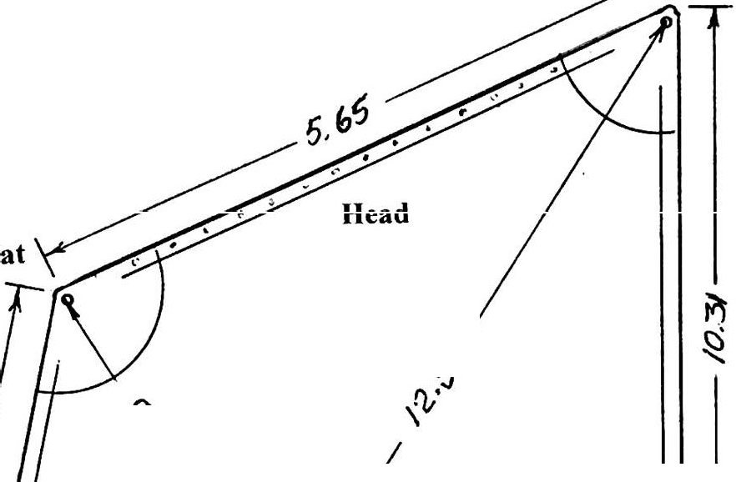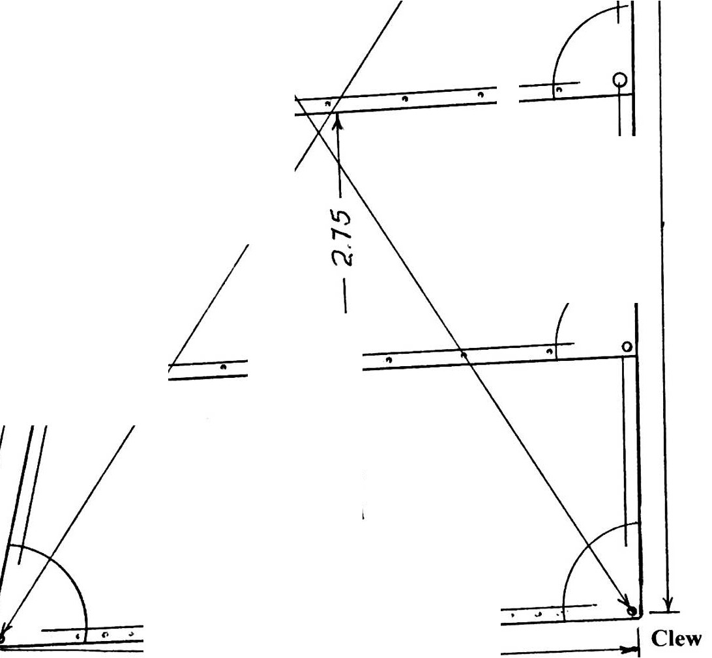Peak

Head

...,.Q
S- .

•
0 • •
I

Luff Leach

0 • • •

Tack
Foot
-> ., ( , , t .

----- 6,90

Main Gaff

All dimensions are in metres
Luff-------------------- 8.31 Leach-----------------I 0.31
Head------------------- 5.65 Foot 6.90
Diagonal, Tack to Peak 12.57
Diagonal, Throat to Clew----------------------------------.9 45

Fsot ot toI st Reef--------2.75 Six reef points, plus luff and leach grommets
nd
I reef to2 reef----- 2.75 Six reef points, pl us luff and leach grommets
Note: both reef lines PARALLEL TO THE FOOT

