 | - Mainsail - Hunter 37 | 8000235 Michael
M0 | Sail Layout | Not Yet Posted
M1 | Tack Cut Back (Aft face of Mast to center of tack Pin - A) | 1.625in | HELP
M2 | Tack Cut Up (Top of Boom to Center of tack Pin - B) | 2.25in | HELP
M3 | Clew Cut Up (Top of Boom to Center of Tack Pin - X) | Loose Footed  2.25in | HELP
M4 | Clew type (slug, outhaul car or ring with strap) | Outhaul Car | HELP
M5 | Sunbrella clew cover for Furling Mains | na | HELP
M6 | Other Offsets |  | HELP
M7 | Headboard | Yes | HELP
M8 | Leech Line | yes
M9 | Foot Line | No
M10 | Tack Ring Type | Press Ring | HELP
M11 | Tack angle | 88.5 | HELP
M12 | Jack Line | No | HELP
M13 | Mast Bend (Luff Round) | Std | HELP
M14 | Fractional Rig (Yes, No) | No | HELP
M15 | Mast - Keel or Deck Stepped? | Keel stepped
M16 | Number of Reefs | 2 Reefs | HELP
M17 | Intermediate Reefing Diamond Eyes (Yes or No) | Yes | HELP
M18 | Foot Reefing Grommets (next to boom) | N/A | HELP
M19 | Reefing Ring Type | Grommet Through sail | HELP
M20 | Luff Length (Max Hoist - P) | 40.50ft Max  (40.095ft Net Finished size day of Delivery) | HELP
M21 | Foot Length (Max Foot - E) | 13.00ft Max  (12.87 feet Net Finished size day of Delivery) | HELP
M22 | Leech Length (straight line head to clew) | Sailmaker | HELP
M23 | Bimini to Clear (yes or no) |  | HELP
M24 | Foot Round | Sailmaker
M25 | Aspect Ratio | Sailmaker | HELP
M26 | Vessel Backstay Measurement | 16’3-1/2” | HELP
M27 | Luff Slides (Part Number) | 7/8 width, 1” height,  1-1/2” length  A009 | HELP
M28 | Foot Slides (Part Number) | Loose Footed | HELP
M29 | Roach Type | Cruise | HELP
M30 | Roach Factor | 1.09 | HELP
M31 | MGM | Sailmaker | HELP
M32 | MGU | Sailmaker | HELP
M33 | Batten Type (Partial or Full) | 2 Full  2 Partial | HELP
M34 | Include Battens | YES
M35 | Install Nylon Batten Holders | YES  W303 | HELP
M36 | Intermediate Sliders | YES  2 | HELP
M37 | Cloth Weight | 8.45oz Challenge Newport All Purpose
M38 | Cut Type | Cross
M39 | Sail Area | Sailmaker
M40 | Cunningham | No | HELP
M41 | Telltails | Yes | HELP
M42 | Triple Stitch | Yes
M43 | Sail Logo and Color(red, blue or black) | No | HELP
M44 | Sail Logo Artwork | N/A
M45 | Sail Numbers and Color | No | HELP
M46 | Draft Stripe and Color(red, blue or black) | Yes (Blue) | HELP
M47 | Overhead Leech Line | No
M48 | Specialty Sail | No | HELP
M49 | Boom Cover | No | HELP
M50 | Lazy Bag | No | HELP

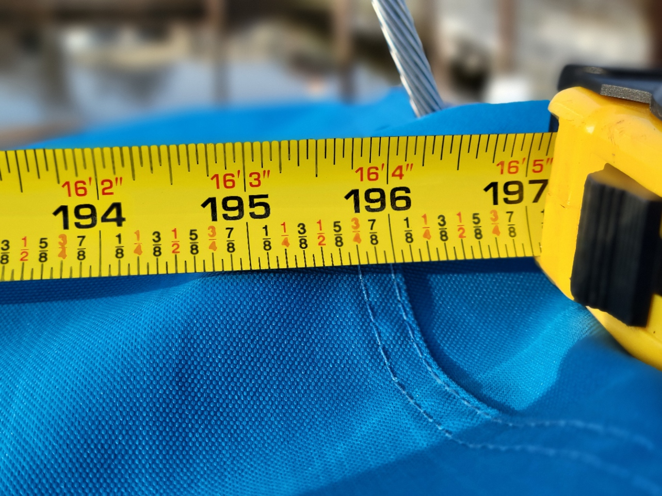

Backstay from face of mast 16’4-1/2”
Luff Slides
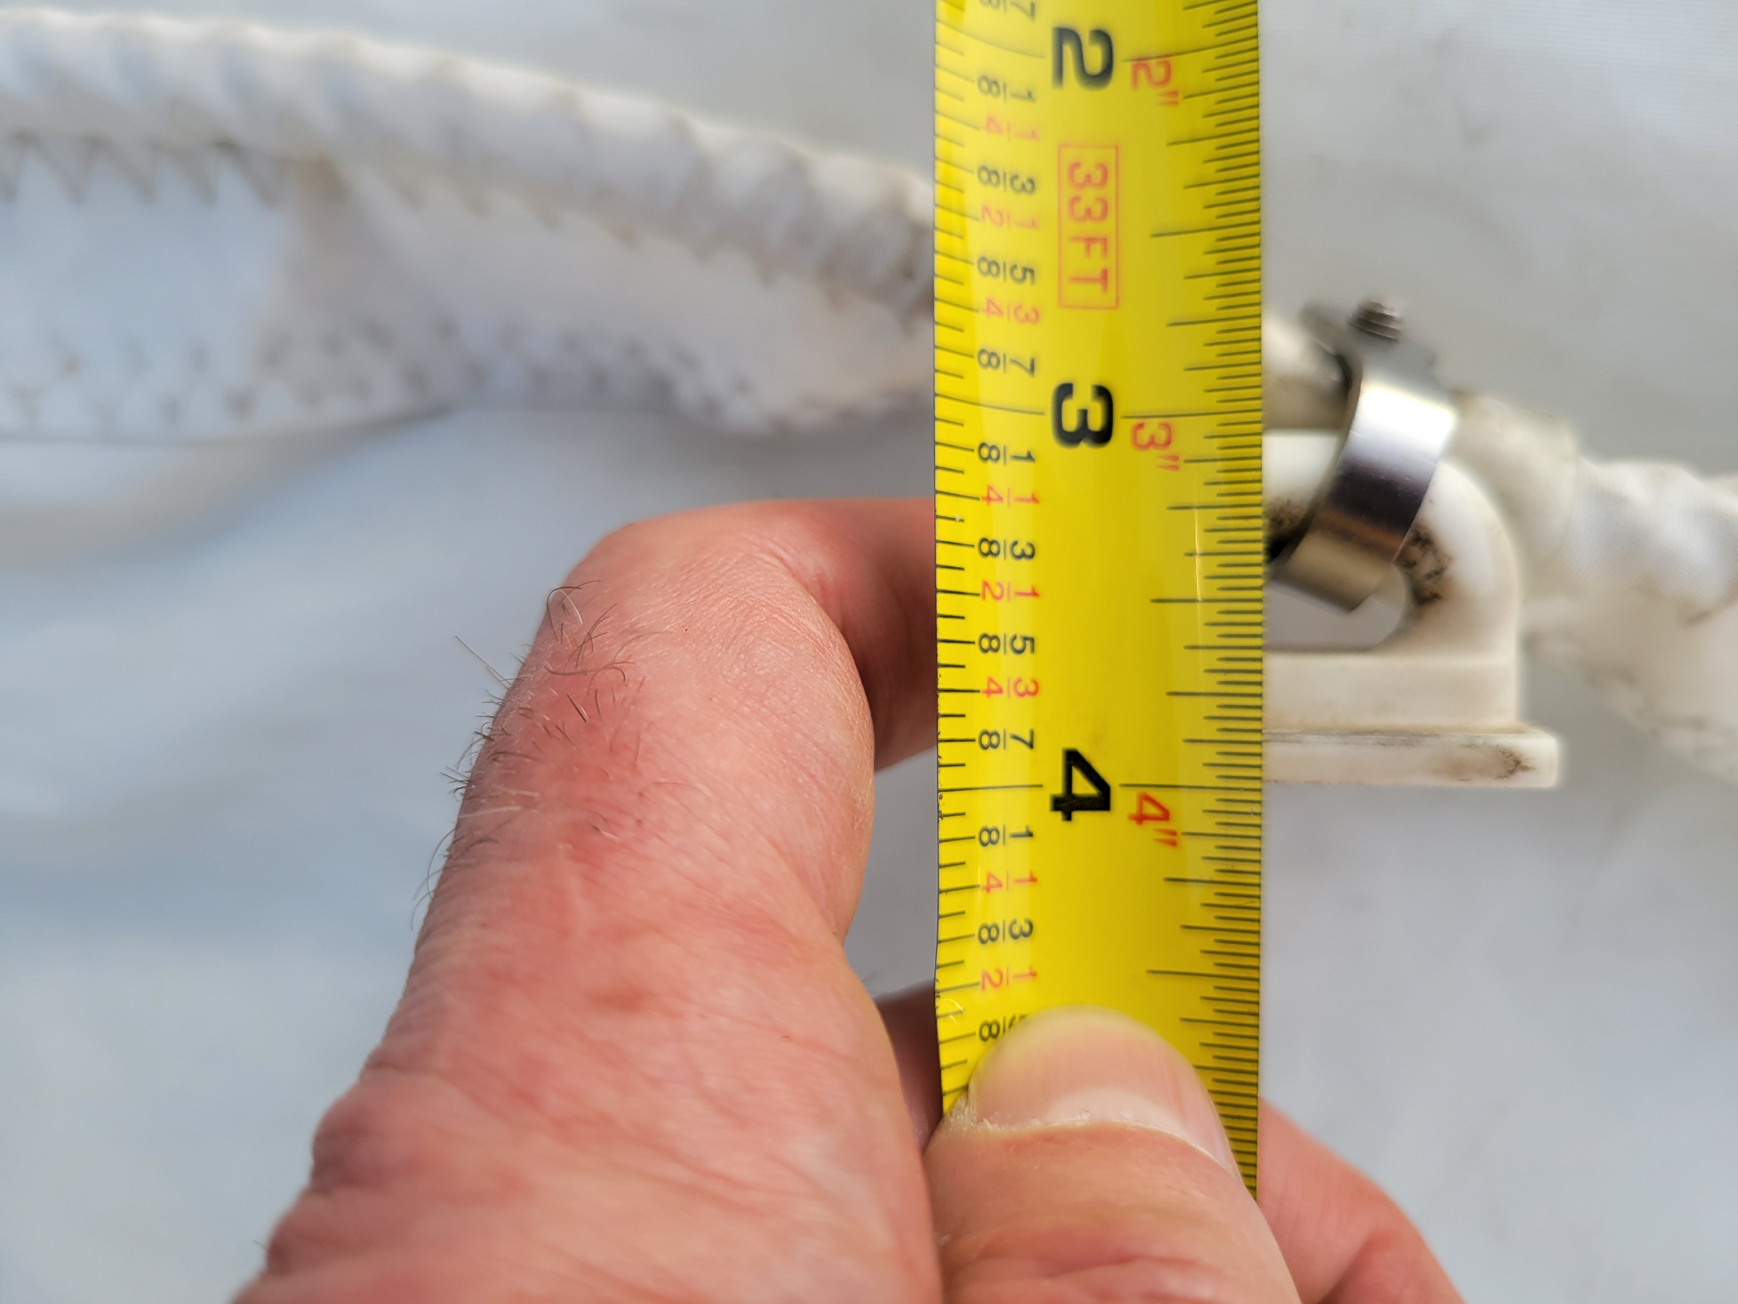
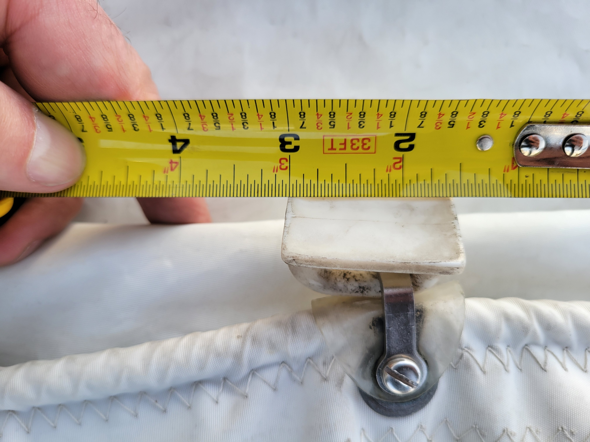

1”Height 1-7/16” length
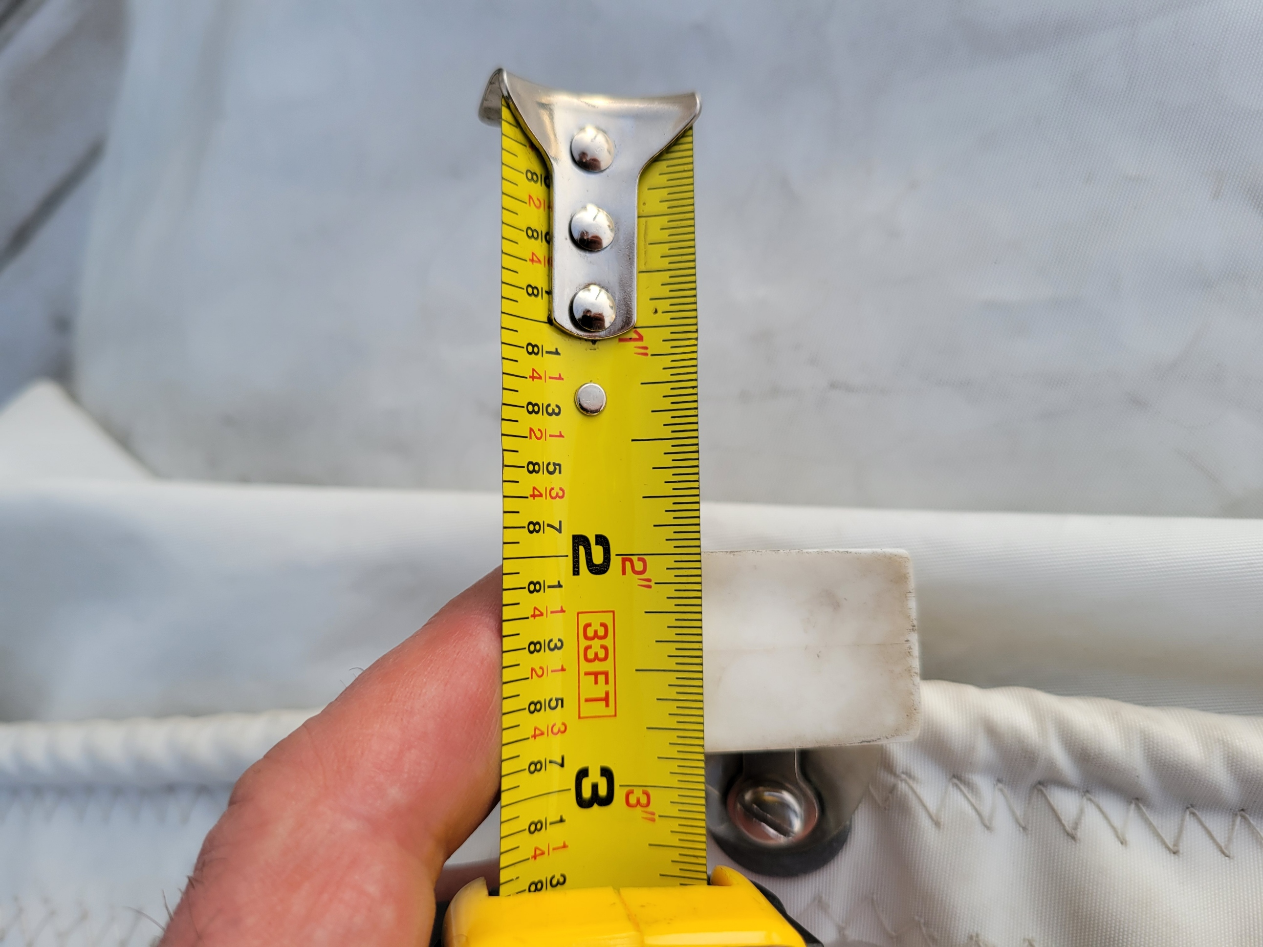

“
7/8” width
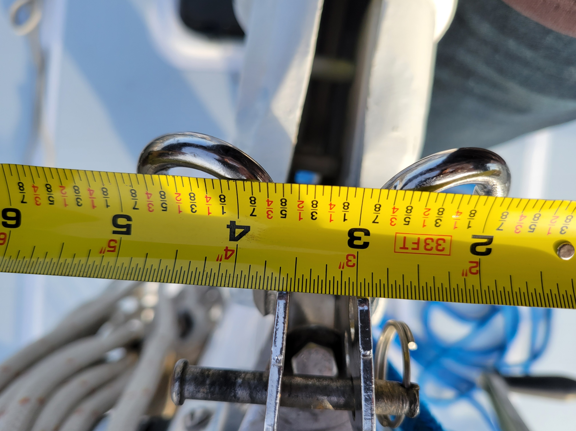

Tack jaw ½” width

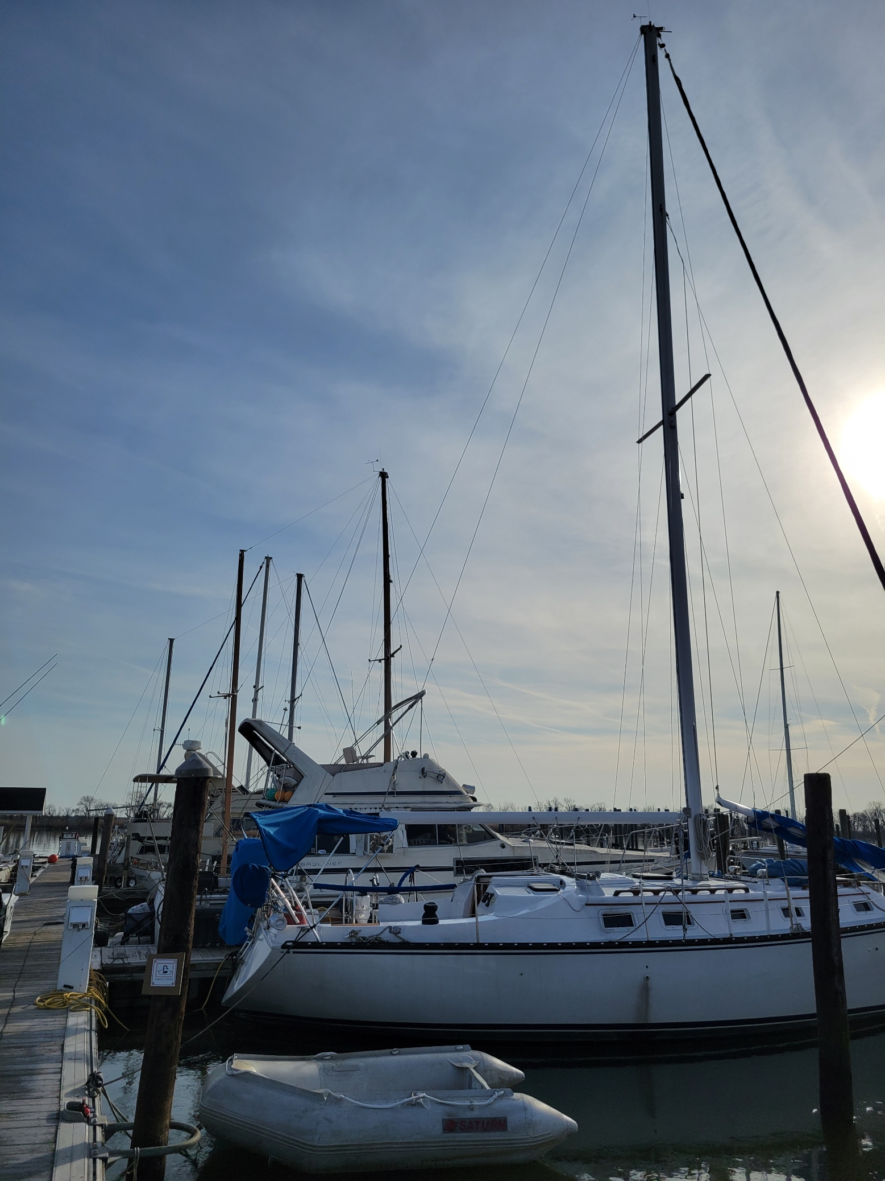
Mast showing backstay
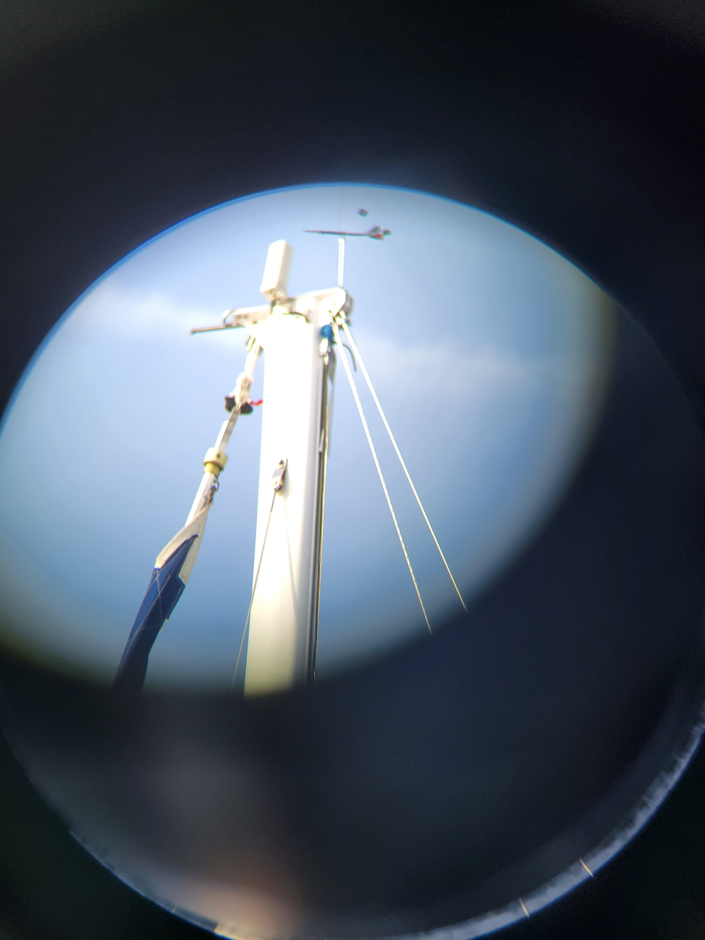
Mast top showing Back stay, topping lift and top sheive of main halyard
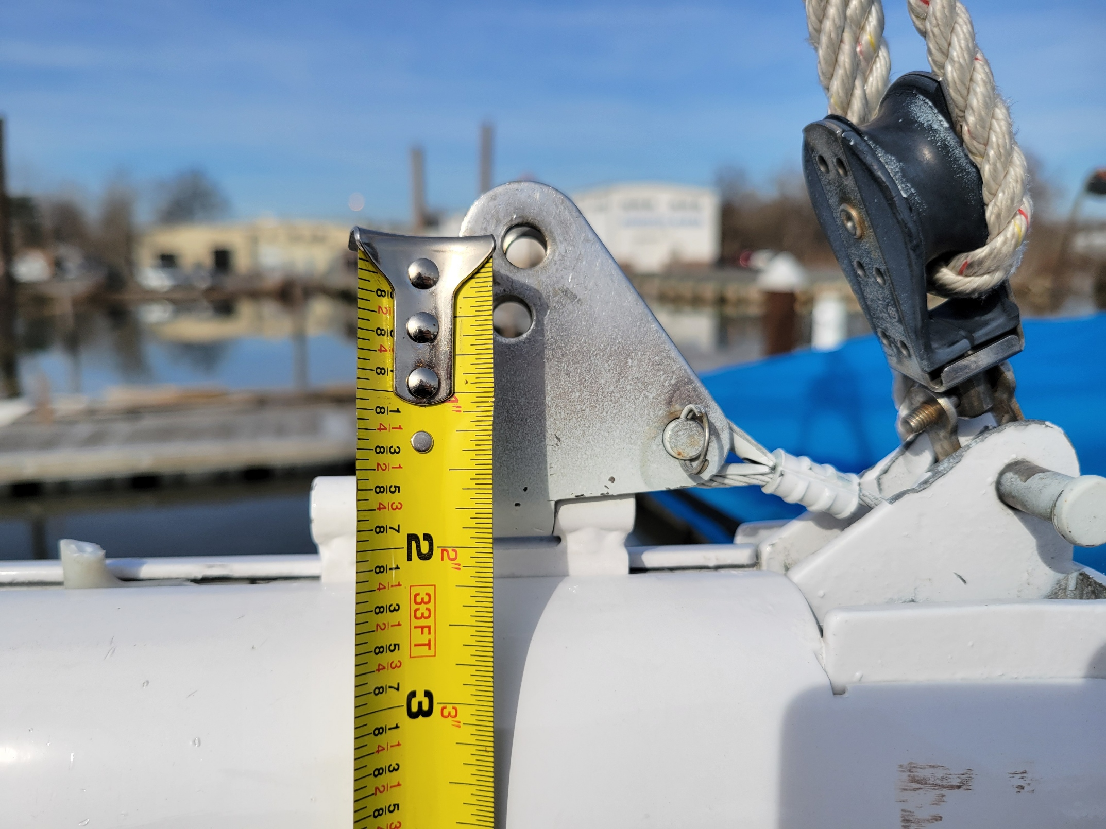

Clew height above boom of 2-1/4 or 1-3/4 depending on pin used
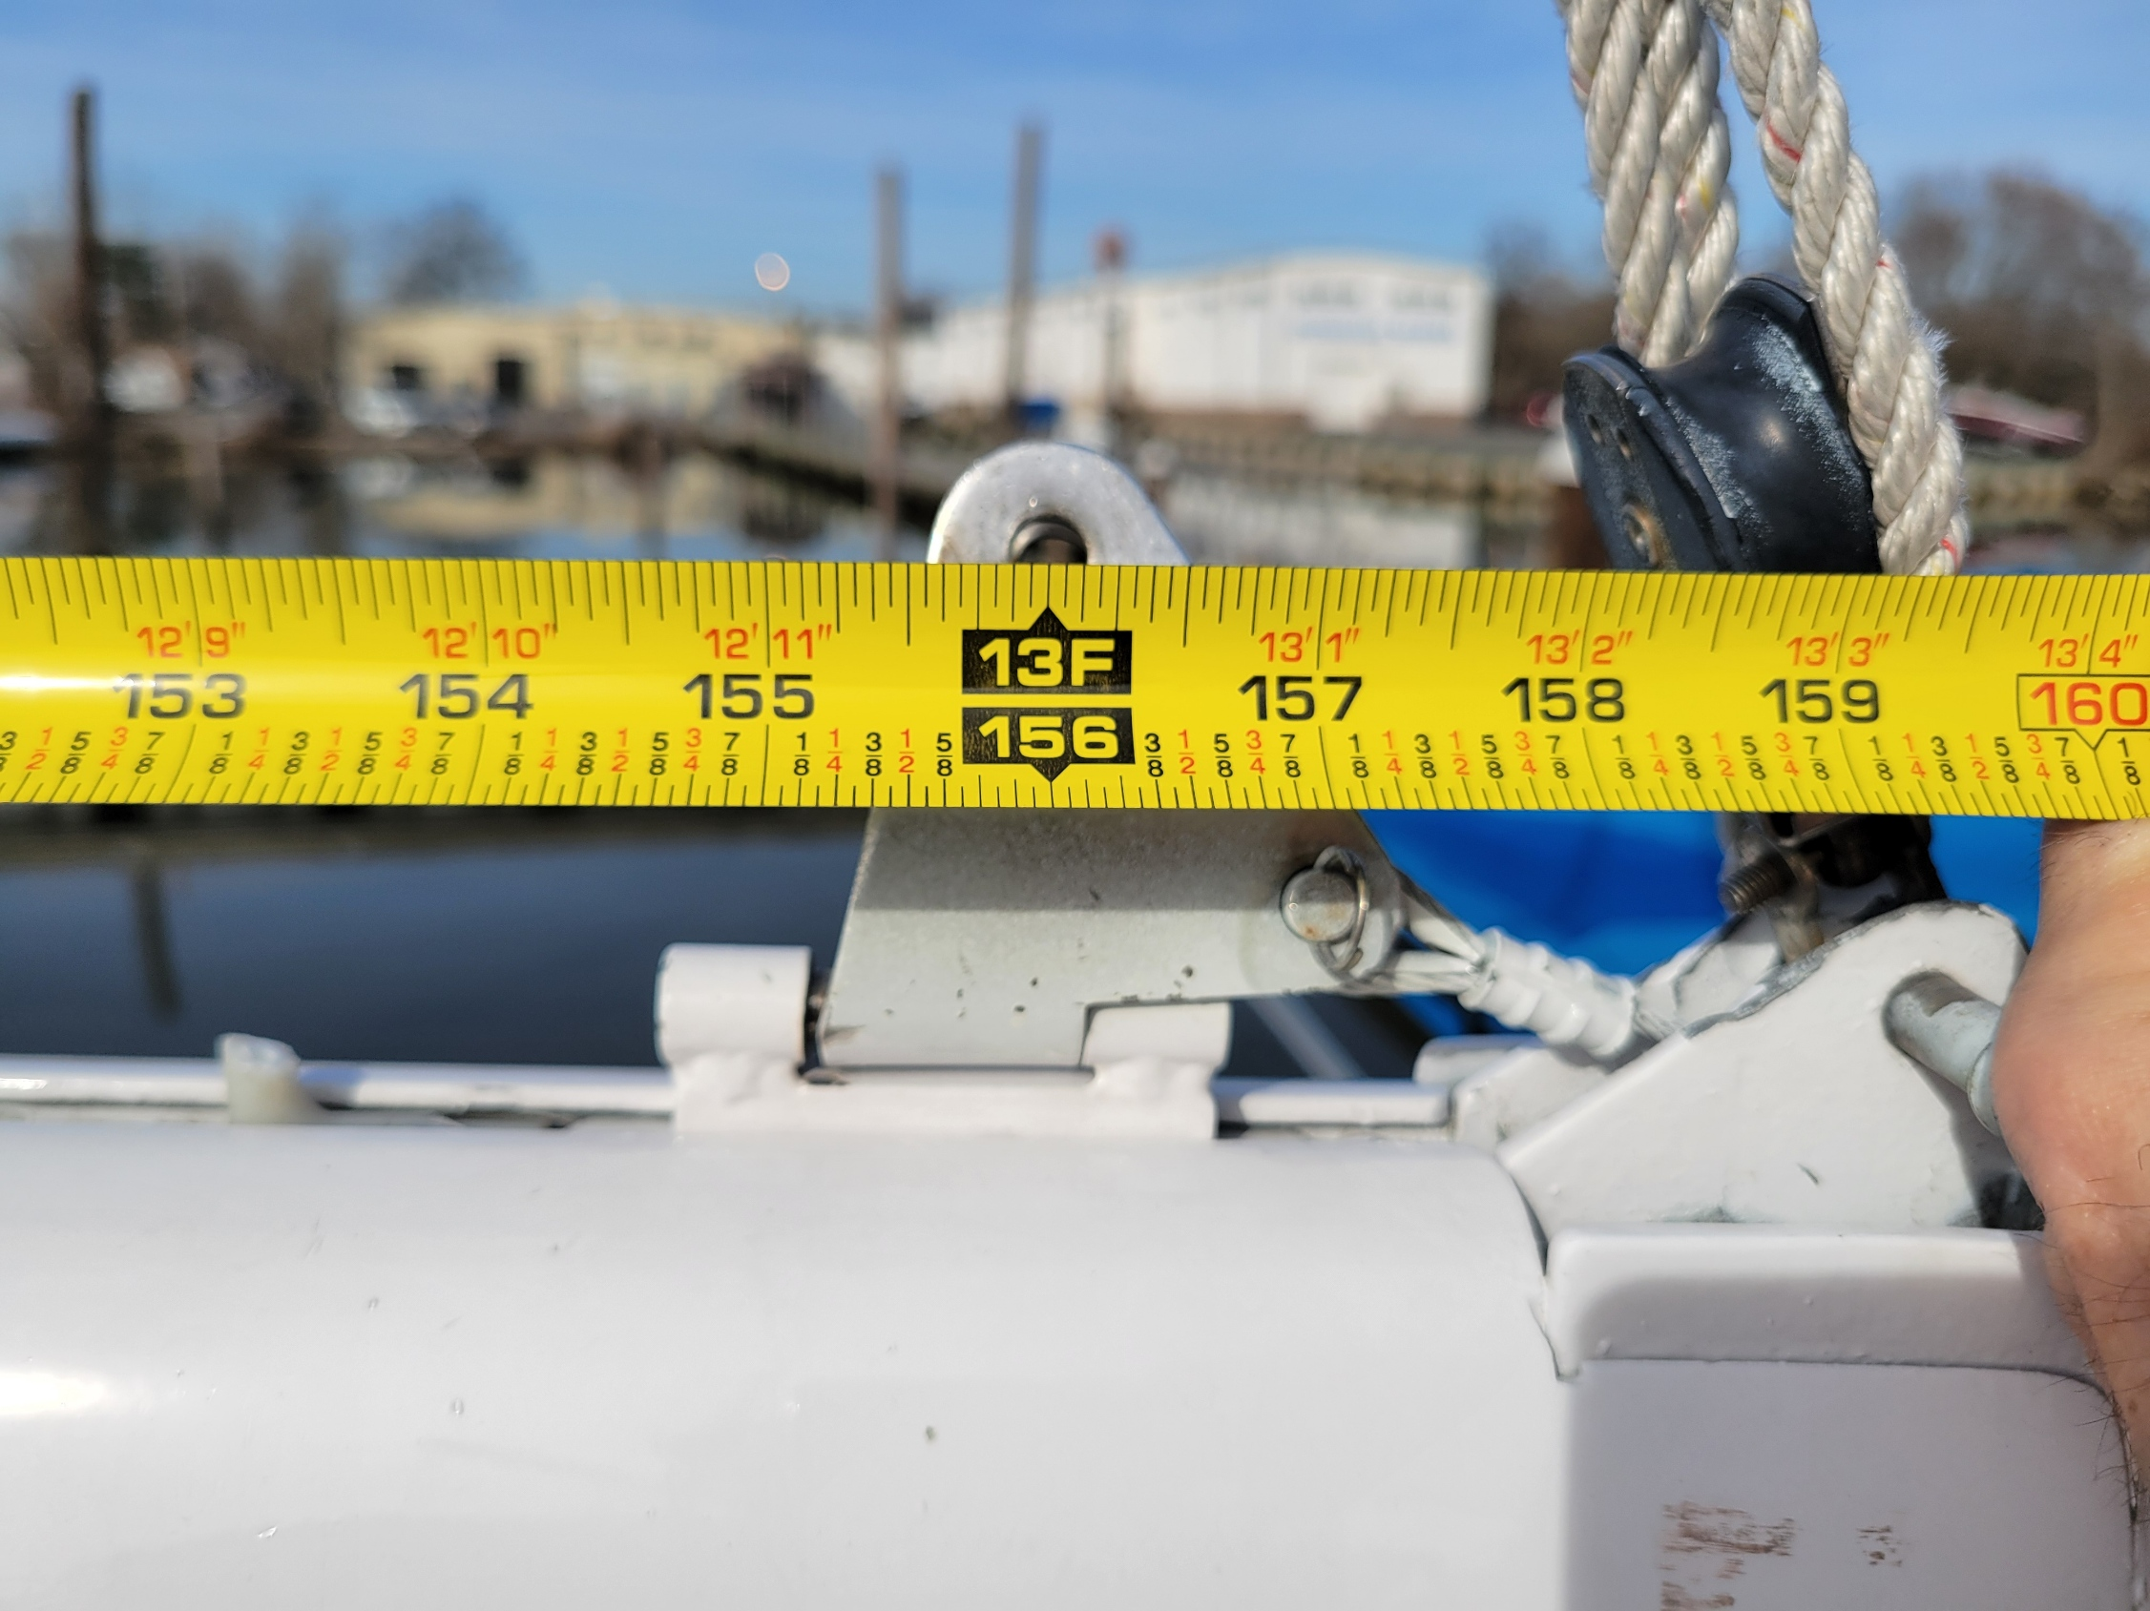

Face of mast to clew and boom car 13’-0”
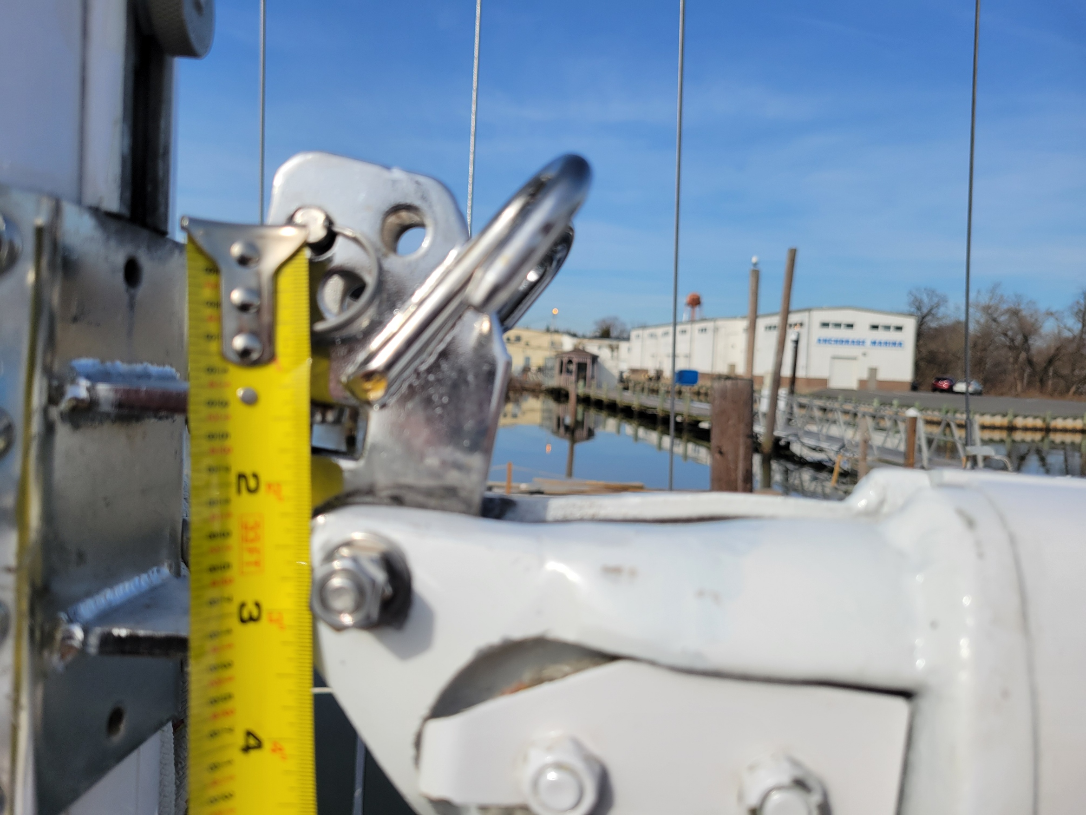
Tack pin height above boom 2-1/4”
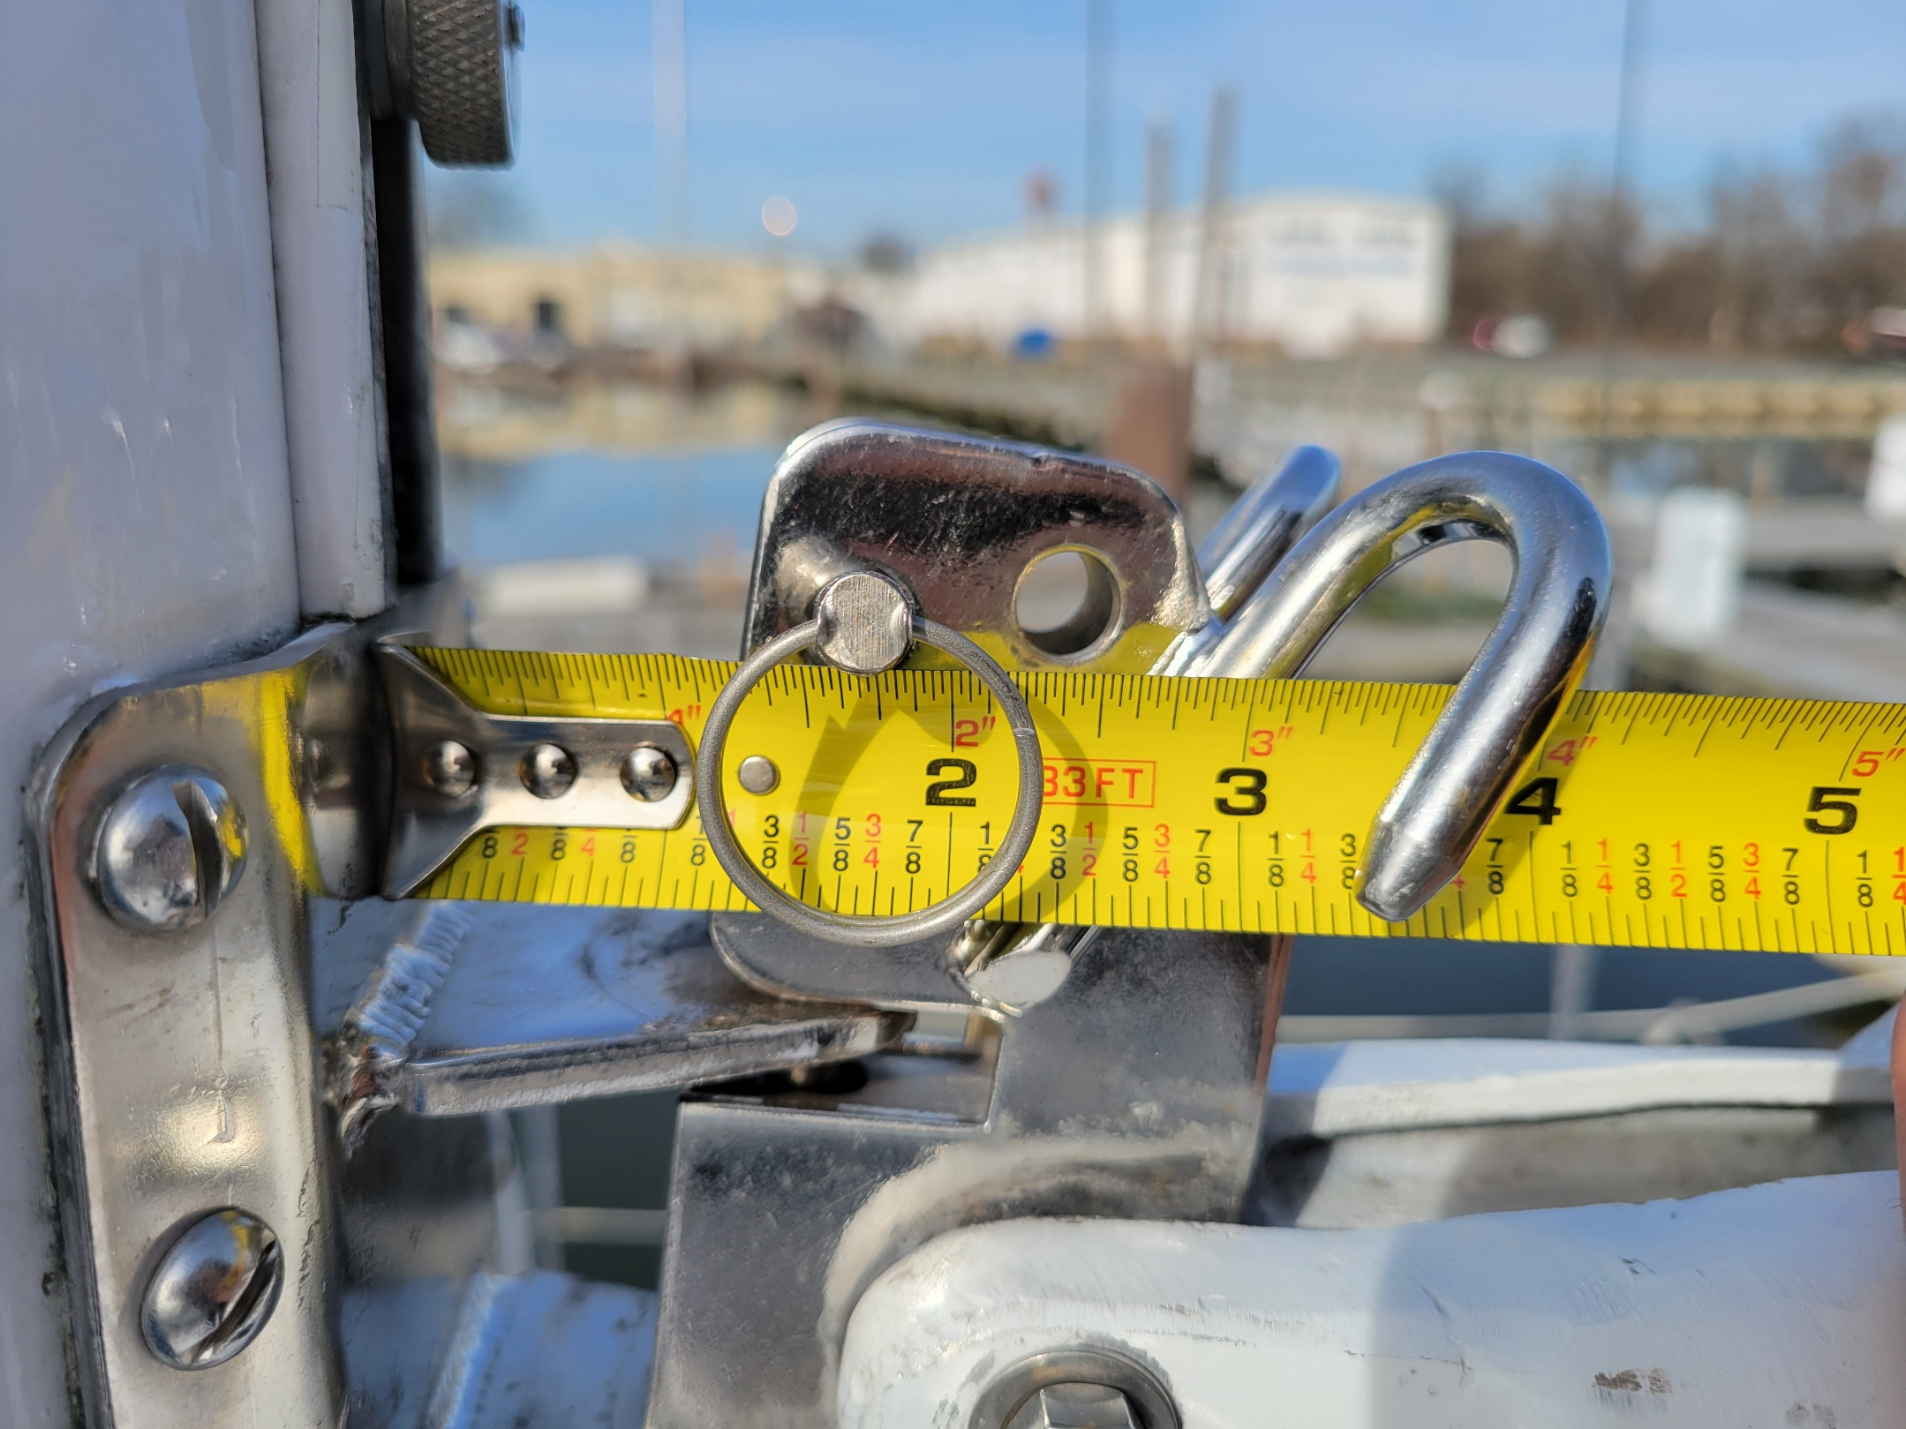
Tack pin from face of mast 1-3/4”.
Reefing hook 3-1/2” from face of mast

Luff Sheive from Tack Pin 40’9” – Note boat specs say luff is 39’6” ?? Measurement was done 3 times. Back stay appears aft of face of mast so head plate would not hit the back stay while tacking.

