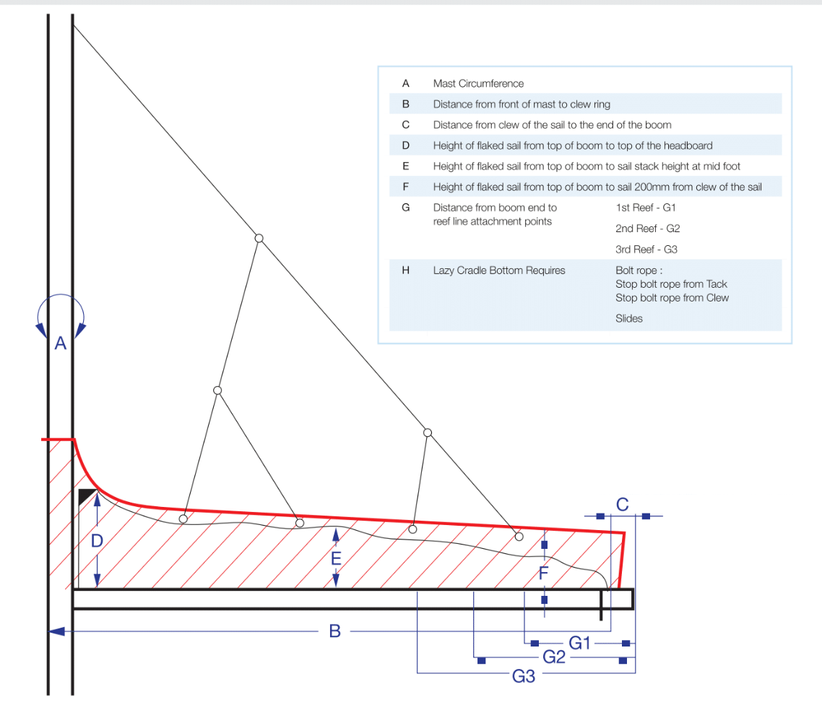

 | - Mainsail - | 7000522 Dan
M0 | Sail Layout | Not Yet Posted
M1 | Tack Cut Back (Aft face of Mast to center of tack Pin - A) | 1.5in | HELP
M2 | Tack Cut Up (Top of Boom to Center of tack Pin - B) | 1in | HELP
M3 | Clew Cut Up (Top of Boom to Center of Tack Pin - X) | Loose Footed | HELP
M4 | Clew type (slug, outhaul car or ring with strap) | O-ring Velcro strap | HELP
M5 | Sunbrella clew cover for Furling Mains | na | HELP
M6 | Other Offsets |  | HELP
M7 | Headboard | Yes | HELP
M8 | Leech Line | yes
M9 | Foot Line | No
M10 | Tack Ring Type | o-ring w/ web | HELP
M11 | Tack angle | 88.5 | HELP
M12 | Jack Line | No | HELP
M13 | Mast Bend (Luff Round) | Std | HELP
M14 | Fractional Rig (Yes, No) | No | HELP
M15 | Mast - Keel or Deck Stepped? | Deck Stepped
M16 | Number of Reefs | 2 Reefs | HELP
M17 | Intermediate Reefing Diamond Eyes (Yes or No) | YES | HELP
M18 | Foot Reefing Grommets (next to boom) | N/A | HELP
M19 | Reefing Ring Type | Yes | HELP
M20 | Luff Length (Max Hoist - P) | 48ft 9in Max  (Net Finished size day of Delivery) | HELP
M21 | Foot Length (Max Foot - E) | 15ft 6in Max  (Net Finished size day of Delivery) | HELP
M22 | Leech Length (straight line head to clew) | Sailmaker | HELP
M23 | Bimini to Clear (yes or no) | N/A | HELP
M24 | Foot Round | Sailmaker
M25 | Aspect Ratio | Sailmaker | HELP
M26 | Vessel Backstay Measurement | 16ft 8in | HELP
M27 | Luff Slides (Part Number) | Tides Strong  Track | HELP
M28 | Foot Slides (Part Number) | Loose Footed | HELP
M29 | Roach Type | 1.1 | HELP
M30 | Roach Factor | Racer | HELP
M31 | MGM | Sailmaker | HELP
M32 | MGU | Sailmaker | HELP
M33 | Batten Type (Partial or Full) | 2 Full  3 Partial | HELP
M34 | Include Battens | YES
M35 | Install Nylon Batten Holders | 1590 Batten Holders | HELP
M36 | Intermediate Sliders | Yes  Webbing Loops | HELP
M37 | Cloth Weight | 4D Carbon/Technoa Membrane w/ Film (black)
M38 | Cut Type | Cross
M39 | Sail Area | Sailmaker
M40 | Cunningham | No | HELP
M41 | Telltails | Yes | HELP
M42 | Triple Stitch | Yes
M43 | Sail Logo and Color(red, blue or black) | No | HELP
M44 | Sail Logo Artwork | N/A
M45 | Sail Numbers and Color | 42082 - Yes | HELP
M46 | Draft Stripe and Color(red, blue or black) | Yes (White) | HELP
M47 | Overhead Leech Line | No
M48 | Specialty Sail | No | HELP
M49 | Boom Cover | No | HELP
M50 | Lazy Bag | No | HELP
A = 23.5 inches
B =16 feet 4 inches
C = 5 inches
D = 38 inches
E = 28 inches
F = 18 inches
G = sail maker
H = Bolt Rope: ½ inch
Stop from Tack: 12 inches
Stop from Clew: 6 inches
 | - - | 7000522 Dan
S0 | Sail Layout | Not Yet Posted
S1 | Size of Headsail (110, 135, 150 etc.)" | Asymmetrical  114.83m2
S2 | Luff Length, Max Hoist, B measurement | Sailmaker | HELP
S3 | Leech Length | sailmaker
S4 | Foot Length | sailmaker
S5 | Tack and Head Fittings | O-Rings
S6 | Vessel "I" Measurement | 48ft | HELP
S7 | Vessel "J" Measurement | 13.5ft | HELP
S8 | Calculated Forestay Length | Sailmaker
S9 | Masthead or Fractional Spinnaker ? | Frac
S10 | Tack up for Code 0's | N/A
S11 | Correct Size for A/Spin or S/Spin | N/A
S12 | LP | N/A | HELP
S13 | Cut Type | Full Radial
S14 | U/V Cover | N/A
S15 | Luff Type | FREE
S16 | Furler Name | None
S17 | Sail Area | 114.83m2
S18 | Cloth Weight | Contender SK60
S19 | Sail Colors | Solid white | HELP
S20 | Sail Numbers and Color (red, blue or black) | 42082 black | HELP
S21 | Sail Logo | No
S22 | Sail Sock (White is std Color) | YES - Black
S23 | Sail Sock Length | Sailmaker
S24 | Wire Size | N/A
S25 | Sail Sock Color |  | HELP
S26 | Specialty Sail |  | HELP
S27 | Score |  | HELP
 | Customer Note: All details we can check as sailmakers are based on accurate vessel I and J Measurements |  | HELP

