==== CUSTOMER SHIPPING INFORMATION ===
First Name : Francois
Last Name : Filion
Address : Place de la Cité,
2590 Boul Laurier, Tour Belle-Cour, suite 1060
City : Quebec
Postal Code : G1V4M6
Country : Canada
Quote Number :31651863.TXT
ID :13225921.TXT
 | - Mainsail - CS 22 | 7000526 Francois
M0 | Sail Layout | Not Yet Posted
M1 | Tack Cut Back (Aft face of Mast to center of tack Pin - A) | 2.125in | HELP
M2 | Tack Cut Up (Top of Boom to Center of tack Pin - B) | 1.5in | HELP
M3 | Clew Cut Up (Top of Boom to Center of Tack Pin - X) | Loose Footed | HELP
M4 | Clew type (slug, outhaul car or ring with strap) | Slug | HELP
M5 | Sunbrella clew cover for Furling Mains | na | HELP
M6 | Other Offsets |  | HELP
M7 | Headboard | Yes | HELP
M8 | Leech Line | yes
M9 | Foot Line | No
M10 | Tack Ring Type | Webbed tack o-ring | HELP
M11 | Tack angle | 88.5 | HELP
M12 | Jack Line | No | HELP
M13 | Mast Bend (Luff Round) | Std | HELP
M14 | Fractional Rig (Yes, No) | No | HELP
M15 | Mast - Keel or Deck Stepped? | Deck stepped
M16 | Number of Reefs | 2 Reefs | HELP
M17 | Intermediate Reefing Diamond Eyes (Yes or No) | yes | HELP
M18 | Foot Reefing Grommets (next to boom) | Sailmaker | HELP
M19 | Reefing Ring Type | Grommet, press ring to all | HELP
M20 | Luff Length (Max Hoist - P) | 7.20m Max  (7.128m Net Finished size day of Delivery) | HELP
M21 | Foot Length (Max Foot - E) | 2.13m Max  (2.108m Net Finished size day of Delivery) | HELP
M22 | Leech Length (straight line head to clew) | Sailmaker | HELP
M23 | Bimini to Clear (yes or no) | no | HELP
M24 | Foot Round | Sailmaker
M25 | Aspect Ratio | Sailmaker | HELP
M26 | Vessel Backstay Measurement | 3,07m | HELP
M27 | Luff Slides (Part Number) | **AO18S, please look at what I have, picture, and let me know if ok | HELP
M28 | Foot Slides (Part Number) | Loose Footed | HELP
M29 | Roach Type | Cruise | HELP
M30 | Roach Factor | 1.07 | 7HELP
M31 | MGM | Sailmaker | HELP
M32 | MGU | Sailmaker | HELP
M33 | Batten Type (Partial or Full) | 1 Full  3 Partial | HELP
M34 | Include Battens | YES
M35 | Install Nylon Batten Holders | YES  A300 | HELP
M36 | Intermediate Sliders | YES  1 | HELP
M37 | Cloth Weight | 6.38 ATL
M38 | Cut Type | Cross
M39 | Sail Area | Sailmaker
M40 | Cunningham | Yes | HELP
M41 | Telltails | Yes | HELP
M42 | Triple Stitch | Yes
M43 | Sail Logo and Color(red, blue or black) | No | HELP
M44 | Sail Logo Artwork | N/A
M45 | Sail Numbers and Color | No | HELP
M46 | Draft Stripe and Color(red, blue or black) | Yes (blue) | HELP
M47 | Overhead Leech Line | No
M48 | Specialty Sail | No | HELP
M49 | Boom Cover | No | HELP
M50 | Lazy Bag | No | HELP

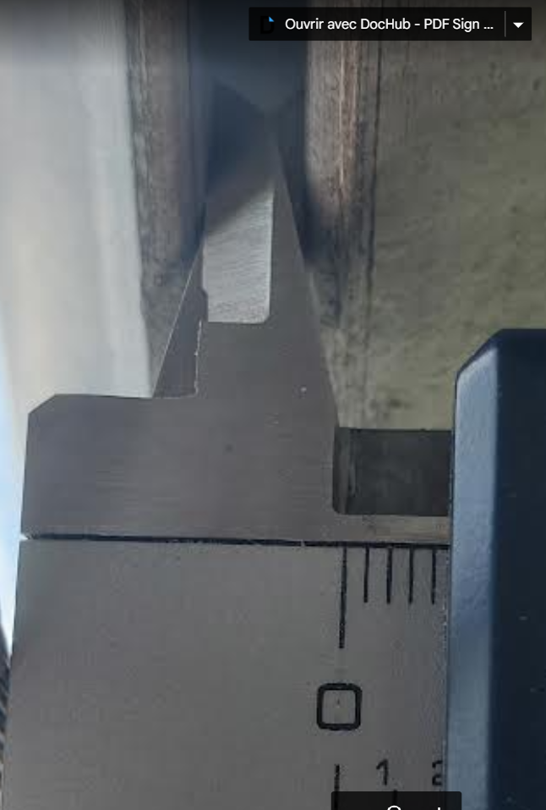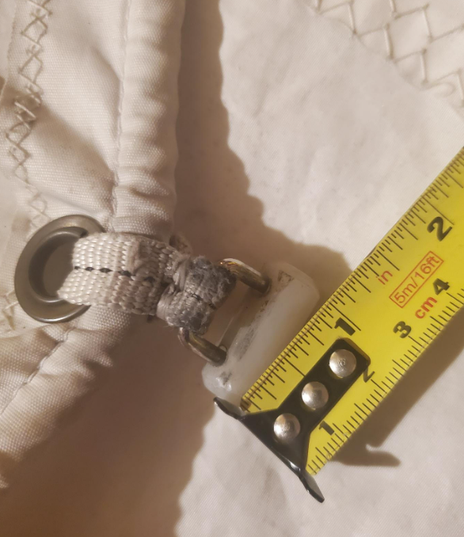
- mast rail width: 4,5mm
- My slug dimensions are 12,5mm radius x 28mm long.
Could you confirm my choice of AO18S?? or do you have slug as my actual one?

