 | - Mainsail - | 7000318 Kyle
M0 | Sail Layout | Not Yet Posted
M1 | Tack Cut Back (Aft face of Mast to center of tack Pin - A) | 2.75” | HELP
M2 | Tack Cut Up (Top of Boom to Center of tack Pin - B) | 2.5” | HELP
M3 | Clew Cut Up (Top of Boom to Center of Tack Pin - X) | Press Ring | HELP
M4 | Clew type (slug, outhaul car or ring with strap) | Press ring with Slug. Slug is 0.5 inches width. 1.23” long | HELP
M5 | Sunbrella clew cover for Furling Mains | na | HELP
M6 | Other Offsets |  | HELP
M7 | Headboard | Yes | HELP
M8 | Leech Line | yes
M9 | Foot Line | No
M10 | Tack Ring Type | Tack Press Ring | HELP
M11 | Tack angle | 88.5 | HELP
M12 | Jack Line | No | HELP
M13 | Mast Bend (Luff Round) | Std | HELP
M14 | Fractional Rig (Yes, No) | No | HELP
M15 | Mast - Keel or Deck Stepped? | n/a
M16 | Number of Reefs | 2 Reefs | HELP
M17 | Intermediate Reefing Diamond Eyes (Yes or No) | Yes | HELP
M18 | Foot Reefing Grommets (next to boom) | N/A | HELP
M19 | Reefing Ring Type | Grommet through sail | HELP
M20 | Luff Length (Max Hoist - P) | 25’ 2.2” Max  (Luff on my old main is approx 22’ 11” not under sail tension)  (Net Finished size day of Delivery) | HELP
M21 | Foot Length (Max Foot - E) | 8’ 4.5” (From mast to max possible outhaul) Max  (Net Finished size day of Delivery) | HELP
M22 | Leech Length (straight line head to clew) | Sailmaker | HELP
M23 | Bimini to Clear (yes or no) | N/A | HELP
M24 | Foot Round | Sailmaker
M25 | Aspect Ratio | Sailmaker | HELP
M26 | Vessel Backstay Measurement | 12’ 7.6”  This is approximate – Mast is not currently on boat. Measured from aft face of mast to where back stay turnbuckle connects. Would likely be shorter according to angle of backstay and height of Boom. | HELP
M27 | Luff Slides (Part Number) | A033 possibly?  Current slug on boat: .482” width  Current slot track opening width: .248”  Opening width (at end of track): .544”  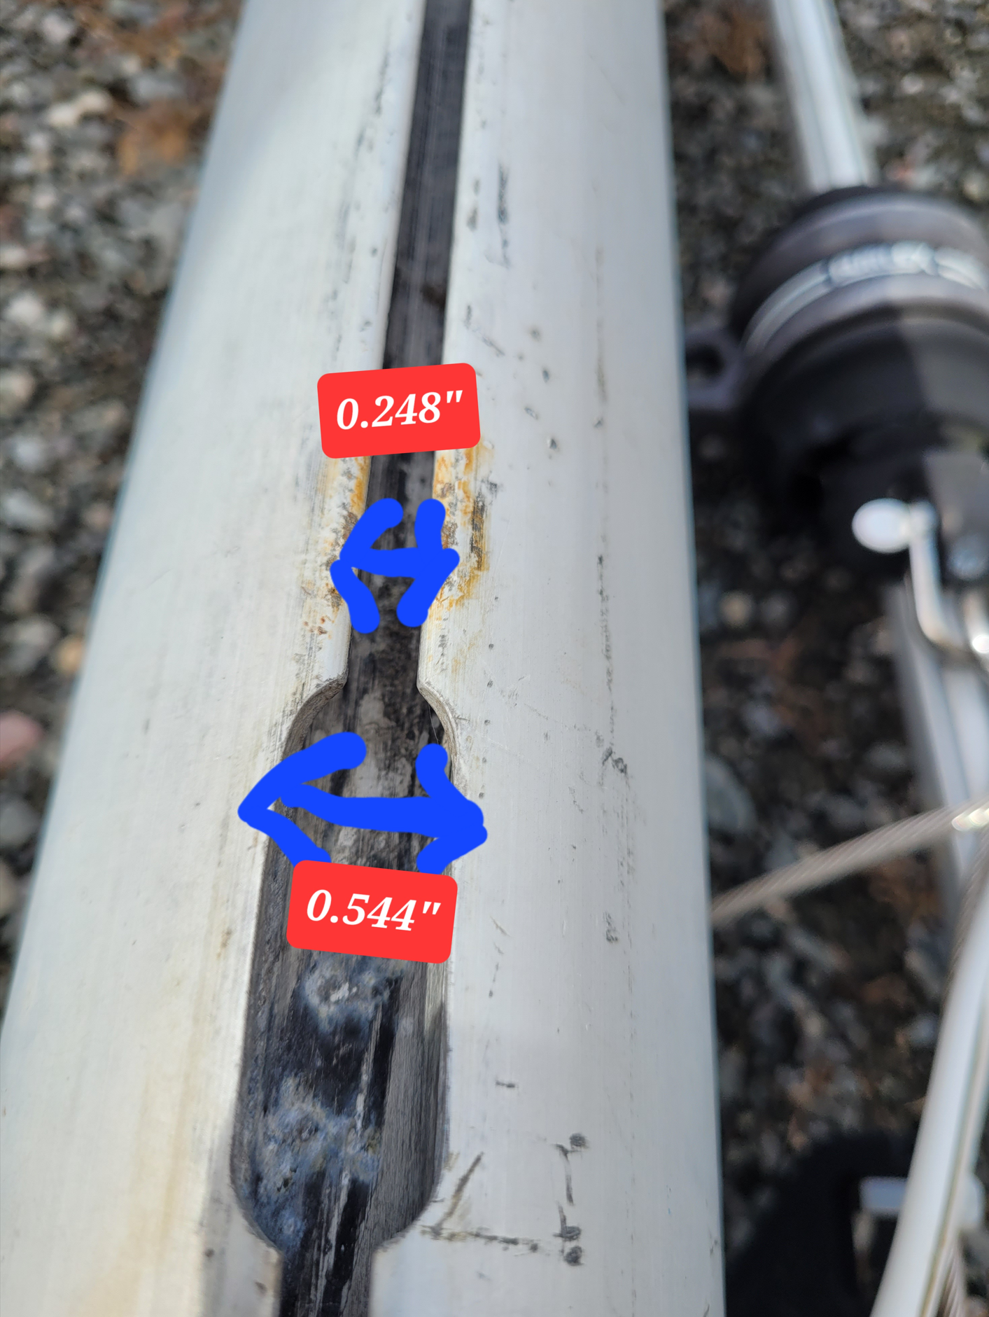  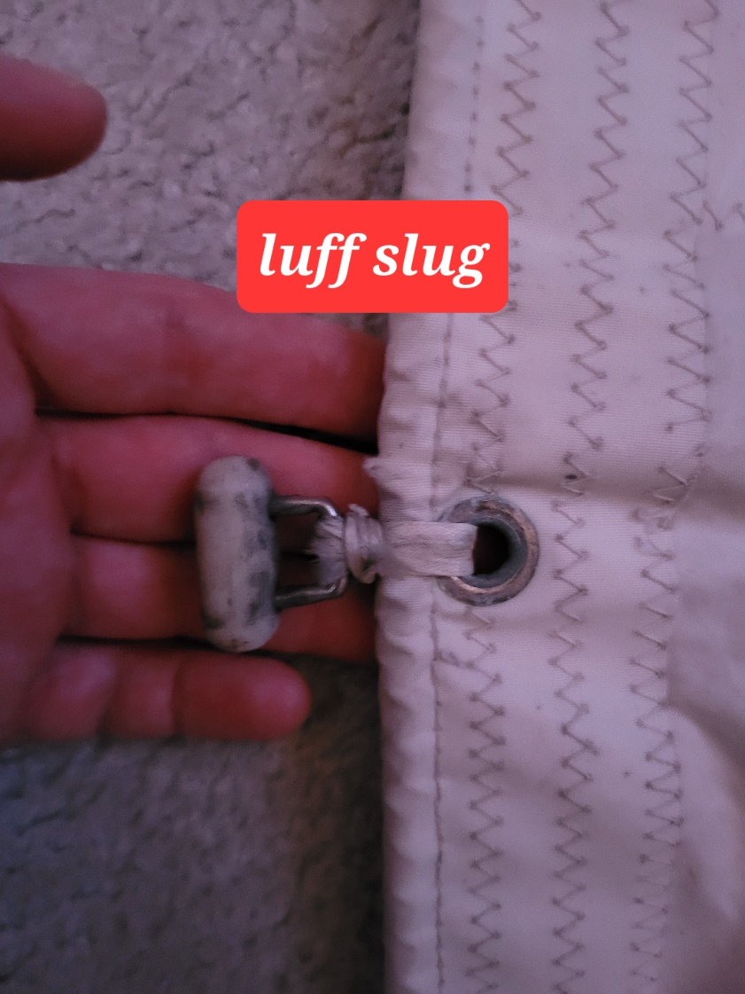 | HELP
M28 | Foot Slides (Part Number) | Bolt Rope on current sail  .28”  Current slot track opening on boom:0.2”  Opening width (at end of track)”: 1.424”  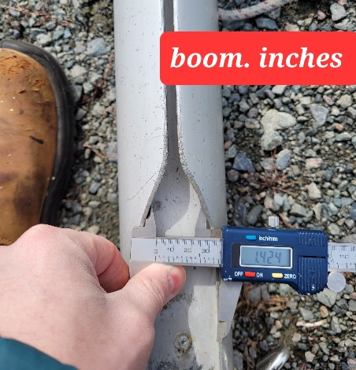  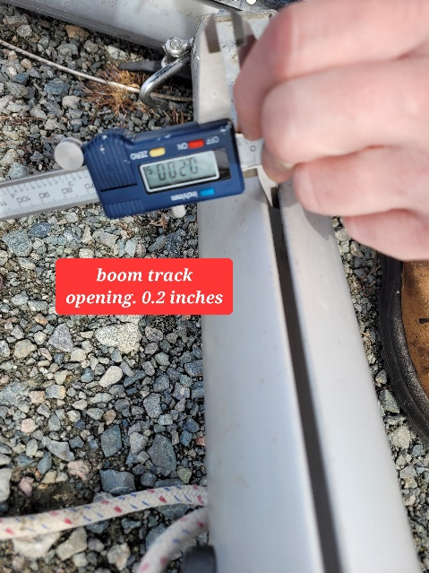  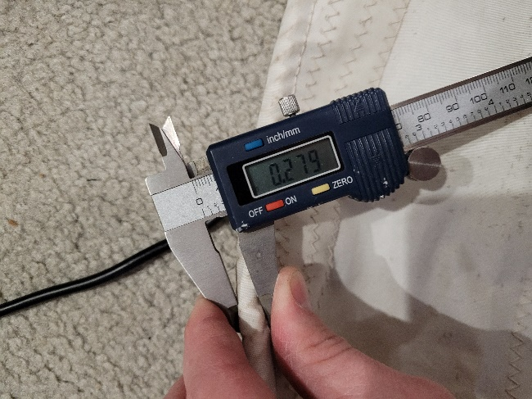 | HELP
M29 | Roach Type | Crusie | HELP
M30 | Roach Factor | 1.07 | HELP
M31 | MGM | Sailmaker | HELP
M32 | MGU | Sailmaker | HELP
M33 | Batten Type (Partial or Full) | 4 Partial | HELP
M34 | Include Battens | YES
M35 | Install Nylon Batten Holders | N/A | HELP
M36 | Intermediate Sliders | YES  1 | HELP
M37 | Cloth Weight | 5.93
M38 | Cut Type | Cross
M39 | Sail Area | Sailmaker
M40 | Cunningham | Yes | HELP
M41 | Telltails | Yes | HELP
M42 | Triple Stitch | Yes
M43 | Sail Logo and Color(red, blue or black) | n/a | HELP
M44 | Sail Logo Artwork | N/A
M45 | Sail Numbers and Color | 297  Black | HELP
M46 | Draft Stripe and Color(red, blue or black) | Yes (Color?) | HELP
M47 | Overhead Leech Line | No
M48 | Specialty Sail | No | HELP
M49 | Boom Cover | Yes - Blue | HELP
M50 | Lazy Bag | No | HELP
