 | - Mainsail - | 7000223 Stephen
M0 | Sail Layout | Not Yet Posted
M1 | Tack Cut Back (Aft face of Mast to center of tack Pin - A) | 3.5in | HELP
M2 | Tack Cut Up (Top of Boom to Center of tack Pin - B) | 0 in  Pin is in line with top edge of boom. | HELP
M3 | Clew Cut Up (Top of Boom to Center of Tack Pin - X) | Boom to shackle pin  1.75in | HELP
M4 | Clew type (slug, outhaul car or ring with strap) | Webbed O-Ring | HELP
M5 | Sunbrella clew cover for Furling Mains | na | HELP
M6 | Other Offsets | D = 10.5in (boom slot cutaway at  gooseneck)  E = sail slides that stack from approx.  top of boom | HELP
M7 | Headboard | Yes | HELP
M8 | Leech Line | yes
M9 | Foot Line | No
M10 | Tack Ring Type | Webbed 0-Ring | HELP
M11 | Tack angle | 82.5 | HELP
M12 | Jack Line | No | HELP
M13 | Mast Bend (Luff Round) | 3.5in | HELP
M14 | Fractional Rig (Yes, No) | YES | HELP
M15 | Mast - Keel or Deck Stepped? | Deck
M16 | Number of Reefs | 2 Reefs  • 1.76m (5ft 9 1/4in) from foot to 1st  reef  • 3.72m (12ft3in) from foot to 2nd reef | HELP
M17 | Intermediate Reefing Diamond Eyes (Yes or No) | Yes | HELP
M18 | Foot Reefing Grommets (next to boom) | N/A | HELP
M19 | Reefing Ring Type | Clew: pressed ring with web  Tack: Webbed D-ring  1st reef tack D-ring starboard  2nd reef tack D-ring port | HELP
M20 | Luff Length (Max Hoist - P) | 37ft 7in Max  (Net Finished size day of Delivery) | HELP
M21 | Foot Length (Max Foot - E) | 12ft 8in Max  (Net Finished size day of Delivery) | HELP
M22 | Leech Length (straight line head to clew) | Sailmaker | HELP
M23 | Bimini to Clear (yes or no) |  | HELP
M24 | Foot Round | Sailmaker
M25 | Aspect Ratio | Sailmaker | HELP
M26 | Vessel Backstay Measurement | No Backstay | HELP
M27 | Luff Slides (Part Number) | A014 | HELP
M28 | Foot Slides (Part Number) | ??? | HELP
M29 | Roach Type | Cruise | HELP
M30 | Roach Factor | See below | HELP
M31 | MGM | 8.5ft | HELP
M32 | MGU | 5.25ft | HELP
M33 | Batten Type (Partial or Full) | 2 Full + 2 Partial | HELP
M34 | Include Battens | YES
M35 | Install Nylon Batten Holders | YES | HELP
M36 | Intermediate Sliders | YES  1 between head and top full batten  1 between two full battens  Currently: 6 below full battens | HELP
M37 | Cloth Weight | 7.45 Newport All Purpose
M38 | Cut Type | Cross
M39 | Sail Area | Sailmaker
M40 | Cunningham | No | HELP
M41 | Telltails | Yes | HELP
M42 | Triple Stitch | Yes
M43 | Sail Logo and Color(red, blue or black) | YES Blue and Red | HELP
M44 | Sail Logo Artwork
M45 | Sail Numbers and Color | 99 (black) | HELP
M46 | Draft Stripe and Color(red, blue or black) | Yes (RED) | HELP
M47 | Spreader patch | YES  From boom to bottom: 17ft7in  Dimensions: 5ft4in x 16in  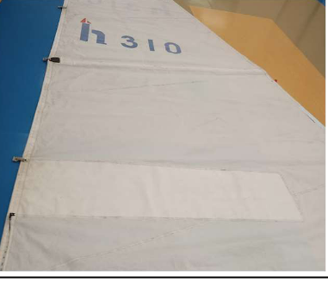
M48 | Specialty Sail | No | HELP
M49 | Boom Cover | No | HELP
M50 | Lazy Bag | No | HELP

