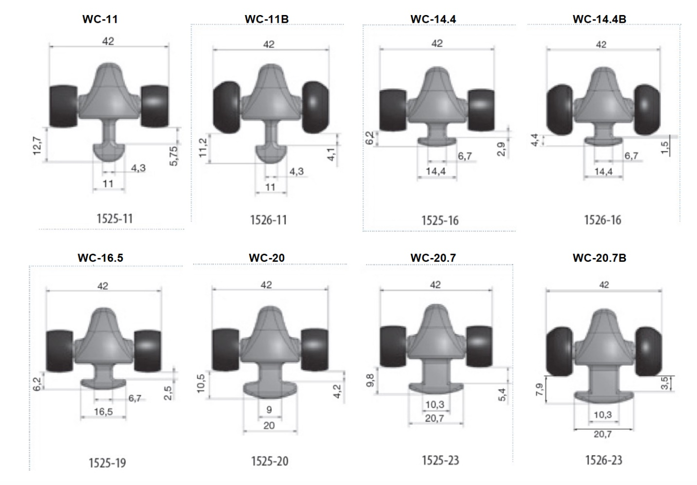

 | - Mainsail - | 6000903 David
M0 | Sail Layout | Not Yet Posted
M1 | Tack Cut Back (Aft face of Mast to center of tack Pin - A) | 50mm | HELP
M2 | Tack Cut Up (Top of Boom to Center of tack Pin - B) | 30mm | HELP
M3 | Clew Cut Up (Top of Boom to Center of Tack Pin - X) | Loose Footed | HELP
M4 | Clew type (slug, outhaul car or ring with strap) | Press with Strap | HELP
M5 | Sunbrella clew cover for Furling Mains | na | HELP
M6 | Other Offsets |  | HELP
M7 | Headboard | Yes | HELP
M8 | Leech Line | Yes  yes at each reef point with jam cleat.
M9 | Foot Line | No
M10 | Tack Ring Type | O ring | HELP
M11 | Tack angle | 88.5 | HELP
M12 | Jack Line | No | HELP
M13 | Mast Bend (Luff Round) | mast bend 150- 200mm | HELP
M14 | Fractional Rig (Yes, No) | No | HELP
M15 | Mast - Keel or Deck Stepped? | Keel
M16 | Number of Reefs | 3 Reefs | HELP
M17 | Intermediate Reefing Diamond Eyes (Yes or No) | Yes | HELP
M18 | Foot Reefing Grommets (next to boom) | N/A | HELP
M19 | Reefing Ring Type | floppy reef ring at tack and pressed eye at clew. | HELP
M20 | Luff Length (Max Hoist - P) | 16.11m Max  (15.948m Net Finished size day of Delivery) | HELP
M21 | Foot Length (Max Foot - E) | 5.54m Max  (5.48m Net Finished size day of Delivery) | HELP
M22 | Leech Length (straight line head to clew) | Sailmaker | HELP
M23 | Bimini to Clear (yes or no) |  | HELP
M24 | Foot Round | Sailmaker
M25 | Aspect Ratio | Sailmaker | HELP
M26 | Vessel Backstay Measurement | 6500mm | HELP
M27 | Luff Slides (Part Number) | 9mm Bolt Rope | HELP
M28 | Foot Slides (Part Number) | Loose Footed | HELP
M29 | Roach Type | MUW 1.210m  MTW 2.100m  MHW 3.540m | HELP
M30 | Roach Factor | Cruise | HELP
M31 | MGM | Sailmaker | HELP
M32 | MGU | Sailmaker | HELP
M33 | Batten Type (Partial or Full) | 4 partial | HELP
M34 | Include Battens | YES
M35 | Install Nylon Batten Holders | N/A | HELP
M36 | Intermediate Sliders | YES  2 | HELP
M37 | Cloth Weight | 9.11 Warp Drive
M38 | Cut Type | Tri Radial
M39 | Sail Area | Sailmaker
M40 | Cunningham | YES – Press Eye | HELP
M41 | Telltails | Yes | HELP
M42 | Triple Stitch | Yes
M43 | Sail Logo and Color(red, blue or black) | No | HELP
M44 | Sail Logo Artwork | N/A
M45 | Sail Numbers and Color | No | HELP
M46 | Draft Stripe and Color(red, blue or black) | Yes (Black) | HELP
M47 | Overhead Leech Line | No
M48 | Specialty Sail | No | HELP
M49 | Boom Cover | No | HELP
M50 | Lazy Bag | No | HELP

