 | - Mainsail - | 6000815 Kunihiko
M0 | Sail Layout | Not Yet Posted
M1 | Tack Cut Back (Aft face of Mast to center of tack Pin - A) | N/A | HELP
M2 | Tack Cut Up (Top of Boom to Center of tack Pin - B) | N/A | HELP
M3 | Clew Cut Up (Top of Boom to Center of Tack Pin - X) | Loose Footed | HELP
M4 | Clew type (slug, outhaul car or ring with strap) | O-ring with velcro | HELP
M5 | Sunbrella clew cover for Furling Mains | na | HELP
M6 | Other Offsets |  | HELP
M7 | Headboard | 150mm | HELP
M8 | Leech Line | yes
M9 | Foot Line | No
M10 | Tack Ring Type | Slide  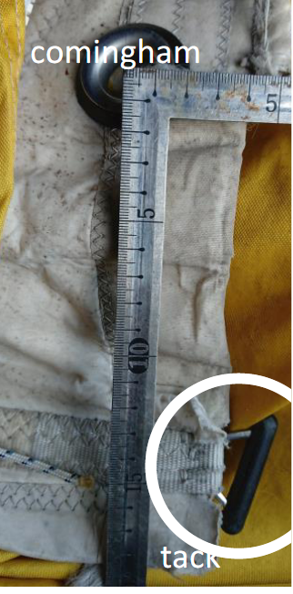 | HELP
M11 | Tack angle | Luff, Leech and Foot | HELP
M12 | Jack Line | No | HELP
M13 | Mast Bend (Luff Round) | Std | HELP
M14 | Fractional Rig (Yes, No) | YES - Fractional Rig | HELP
M15 | Mast - Keel or Deck Stepped? | N/A
M16 | Number of Reefs | - Reef  1400mm above the tack and clew | HELP
M17 | Intermediate Reefing Diamond Eyes (Yes or No) | N/A | HELP
M18 | Foot Reefing Grommets (next to boom) | N/A | HELP
M19 | Reefing Ring Type | Webbed 0 ring Luff  Press Ring Leech | HELP
M20 | Luff Length (Max Hoist - P) | 12.360m Max  (Net Finished size day of Delivery) | HELP
M21 | Foot Length (Max Foot - E) | 4.440m Max  (Net Finished size day of Delivery) | HELP
M22 | Leech Length (straight line head to clew) | 13.050m Max | HELP
M23 | Bimini to Clear (yes or no) | N/A | HELP
M24 | Foot Round | Sailmaker
M25 | Aspect Ratio | Sailmaker | HELP
M26 | Vessel Backstay Measurement | N/A | HELP
M27 | Luff Slides (Part Number) | ??? | HELP
M28 | Foot Slides (Part Number) | Loose Footed | HELP
M29 | Roach Type | 7/8 Girth = 1110mm  ¾ Girth = 1960mm  ½ Grith = 3170mm  ¼ Girth = 3950mm  See sail plan | HELP
M30 | Roach Factor | See above | HELP
M31 | MGM | Sailmaker | HELP
M32 | MGU | Sailmaker | HELP
M33 | Batten Type (Partial or Full) | 1 Full  3 Partial  1 Full  Partial = 1600mm  See sail plan | HELP
M34 | Include Battens | YES
M35 | Install Nylon Batten Holders | YES | HELP
M36 | Intermediate Sliders | YES  2 | HELP
M37 | Cloth Weight | 4D Polyester Membrane with Taffeta
M38 | Cut Type | 4D Polyester Membrane with Taffeta
M39 | Sail Area | Sailmaker
M40 | Cunningham | Yes  80cm from tack | HELP
M41 | Telltails | Yes | HELP
M42 | Triple Stitch | Yes
M43 | Sail Logo and Color(red, blue or black) | No | HELP
M44 | Sail Logo Artwork | N/A
M45 | Sail Numbers and Color | No | HELP
M46 | Draft Stripe and Color(red, blue or black) | Yes (RED) | HELP
M47 | Overhead Leech Line | No
M48 | Specialty Sail | No | HELP
M49 | Boom Cover | No | HELP
M50 | Lazy Bag | No | HELP

 | - Headsail - | 6000815 Kunihiko
H0 | Sail Layout | Not Yet Posted
H1 | Size of Headsail (110, 135, 150 etc.)" | See below | HELP
H2 | Luff Length, Max Hoist, B measurement | 11.250m Max  (Net Finished size day of delivery)  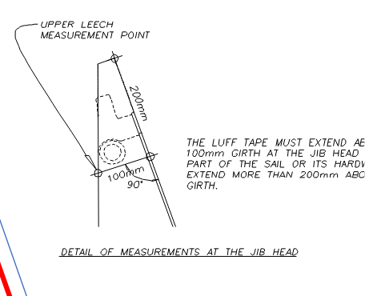 | HELP
H3 | Leech Length | See LP | HELP
H4 | Foot Length | See LP | HELP
H5 | Tack and Head Fittings (Press ring or 0-Ring) | Head = Webbing  Tack = clip on
H6 | Clew Type (Press ring or 0-Ring) | O ring | HELP
H7 | Leech Line | Yes
H8 | Reefs for Hank on Sail (specify Qty of tiedowns) | No Manual Reefs
H9 | Foot Line | Yes
H10 | Track 1 (Tack to Genoa Track Beginning) | N/A | HELP
H11 | Track 2 (Tack to Genoa Track Ending) | N/A | HELP
H12 | Vessel "I" Measurement | 11.670 | HELP
H13 | Vessel "J" Measurement | 3.320m | HELP
H14 | Calculated Forestay Length | Sailmaker
H15 | Mid Girth | Top Girth = 840mm Max  Mid Girth = 2145mm Max  3 battens
H16 | LP | 3.450m | HELP
H17 | Color of Suncover | N/A | HELP
H18 | Side of Sail for Suncover (port or Stbd) | N/A
H19 | Luff Tape Size (such as #6) | 5mm finished | HELP
H20 | Furler Manufacturer | N/A
H21 | Foam Luff | N/A | HELP
H22 | Cut Type | 4D Polyester Membrane with Taffeta
H23 | Sail Area | Sailmaker
H24 | Telltails | Yes | HELP
H25 | Telltail Window | No
H26 | Triple Stitch | YES
H27 | Logo | No | HELP
H28 | Cloth Weight | 4D Polyester Membrane with Taffeta
H29 | Sail Numbers and Color (red, blue or black) | No | HELP
H30 | Sheeting Stripe (red, blue, black) | No | HELP
H31 | Draft Stripe Color (red, blue or black) | Yes (RED) | HELP
H32 | Clew Height off Deck | sailmaker | HELP
H33 | Tack Height off Deck | Deck | HELP
H34 | Luff tape starts 700mm up from Tack | 700mm | HELP
H35 | Specialty Sail | No | HELP
 | Customer Note: All details we can check as sailmakers are based on accurate vessel I and J Measurements |  | HELP

