 | - Mainsail - | 6000529 Michela
M0 | Sail Layout | Not Yet Posted
M1 | Tack Cut Back (Aft face of Mast to center of tack Pin - A) | cm 5 | HELP
M2 | Tack Cut Up (Top of Boom to Center of tack Pin - B) | cm 5 | HELP
M3 | Clew Cut Up (Top of Boom to Center of Tack Pin - X) | Loose Footed | HELP
M4 | Clew type (slug, outhaul car or ring with strap) | #1 O-ring with slug  SLUG: B012  O-Ring: 33 cm | HELP
M5 | Sunbrella clew cover for Furling Mains | na | HELP
M6 | Other Offsets | C (reefs cut back): cm 7  D: I can’t understand what it is, may you please explain?)  E: it depends on where we place the boom, with a 750 luff should be around 15 cm), if you have any advise please tell us  F (Aft face of mast to exit of reefs lines):  cm 187 | HELP
M7 | Headboard | Yes | HELP
M8 | Leech Line | yes
M9 | Foot Line | No
M10 | Tack Ring Type | #1 - Webbed tack o-ring (with shackle) | HELP
M11 | Tack angle | 88.5 | HELP
M12 | Jack Line | No | HELP
M13 | Mast Bend (Luff Round) | Std | HELP
M14 | Fractional Rig (Yes, No) | No | HELP
M15 | Mast - Keel or Deck Stepped? | Deck stepped
M16 | Number of Reefs | 2 Reefs | HELP
M17 | Intermediate Reefing Diamond Eyes (Yes or No) | Yes  (but we need your advise: will they interfere with the lazy bag?) | HELP
M18 | Foot Reefing Grommets (next to boom) | N/A (what does that mean?) | HELP
M19 | Reefing Ring Type | We presently have a WEBBED O-RING (not a D-RING, is there any difference?) at tack and a PRESS RING (grommet through sail) at clew | HELP
M20 | Luff Length (Max Hoist - P) | cm 750 Max  (Net Finished size day of Delivery) | HELP
M21 | Foot Length (Max Foot - E) | cm 250 Max  (Net Finished size day of Delivery) | HELP
M22 | Leech Length (straight line head to clew) | Sailmaker  (we send you the design of the original sail, in case it helps; just to compare,leech is 790 there) | HELP
M23 | Bimini to Clear (yes or no) | NO | HELP
M24 | Foot Round | Sailmaker
M25 | Aspect Ratio | Sailmaker | HELP
M26 | Vessel Backstay Measurement | cm 317 | HELP
M27 | Luff Slides (Part Number) | Need your advise again :)we presently have a luff tape (Diameter 11 mm)  Do you think slides would be better, and why? In case, I would choose plastic A017 type, would they be ok? | HELP
M28 | Foot Slides (Part Number) | Loose Footed | HELP
M29 | Roach Type | cruise | HELP
M30 | Roach Factor | 1.07 | HELP
M31 | MGM | Sailmaker (again, maybe the attached design can help… maybe not, it’s a 50 years old design :D) | HELP
M32 | MGU | Sailmaker (same as above) | HELP
M33 | Batten Type (Partial or Full) | 4 partial | HELP
M34 | Include Battens | YES
M35 | Install Nylon Batten Holders | N/A | HELP
M36 | Intermediate Sliders | N/A | HELP
M37 | Cloth Weight | 6.68 FASTNET (Do you think it’s too heavy in light winds? Hope not, we choose it because it seems to be more durable)
M38 | Cut Type | Cross
M39 | Sail Area | Sailmaker
M40 | Cunningham | No (Why not? We have it now… well… never used it :/ actually) | HELP
M41 | Telltails | Yes | HELP
M42 | Triple Stitch | Yes
M43 | Sail Logo and Color(red, blue or black) | Wait :)… how much would it be a small logo? | HELP
M44 | Sail Logo Artwork | N/A (I put the logo on the attached file, just in case)
M45 | Sail Numbers and Color | No | HELP
M46 | Draft Stripe and Color(red, blue or black) | Yes (RED) | HELP
M47 | Overhead Leech Line | No
M48 | Specialty Sail | No | HELP
M49 | Boom Cover | No | HELP
M50 | Lazy Bag - TO BE TAKEN LATER  No (Why? We said YES!)  These are the measurements according to the “Help”Page:  - MAST CIRCUMFERENCE: about 30 cm for the mast alone, 35 cm for the mast and the spi cart and about 42 cm including the mast, the spi cart and the 2 cleats on the mast - please see the attached photo)  - Distance from end of the boom to the mast: cm 275  We can’t supply the circumferences of the main when folded up of course)  BOLT OR SLUG SLIDERS: What do you think it’s more practical? (If plastic slides: I think the same as the luff would be ok)  M: It’s a loose footed main |  | HELP
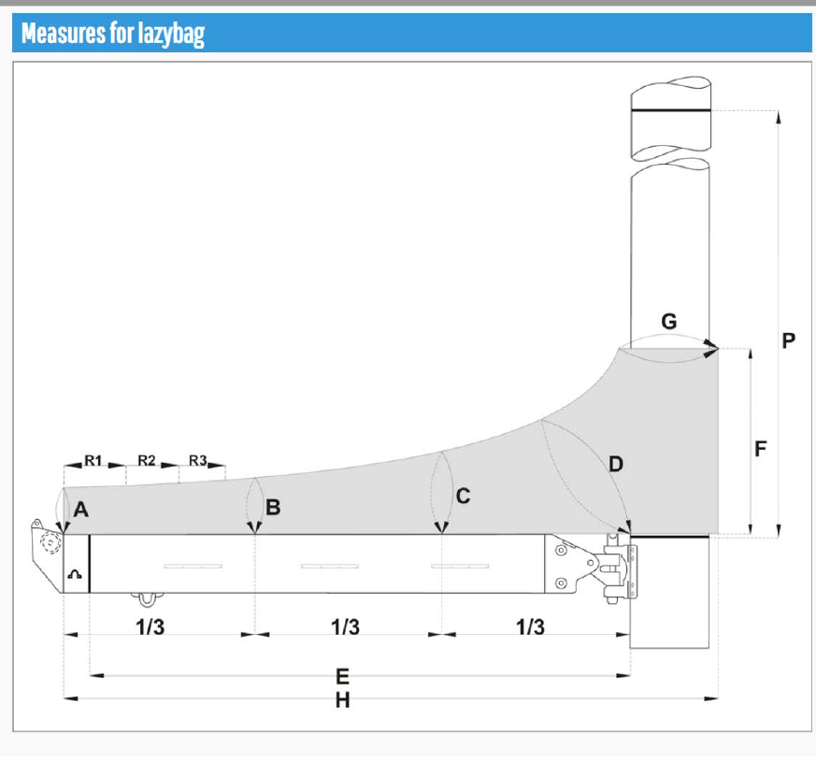
 | - Headsail - | 6000529 Michela
H0 | Sail Layout | Not Yet Posted
H1 | Size of Headsail (110, 135, 150 etc.)" | 150 | HELP
H2 | Luff Length, Max Hoist, B measurement | 8.70m  webbing loop tip to webbing loop tip (Max)  (Net Finished size day of delivery) | HELP
H3 | Leech Length | sailmaker | HELP
H4 | Foot Length | sailmaker | HELP
H5 | Tack and Head Fittings | Webbing Loops
H6 | Clew Type (Press ring or 0-Ring) | O-ring | HELP
H7 | Leech Line | Yes
H8 | Reefs for Hank on Sail (specify Qty of tiedowns) | No Manual Reefs
H9 | Foot Line | Yes
H10 | Track 1 (Tack to Genoa Track Beginning) | 435 cm (L:100 cm) | HELP
H11 | Track 2 (Tack to Genoa Track Ending) | 484 cm (M:105 cm) | HELP
H12 | Vessel "I" Measurement | 8.60m | HELP
H13 | Vessel "J" Measurement | 3.00m | HELP
H14 | Calculated Forestay Length | Sailmaker
H15 | Reef | N/A
H16 | LP | Sailmaker | HELP
H17 | Color of Suncover | ??? To decide later | HELP
H18 | Side of Sail for Suncover (port or Stbd) | Starboard
H19 | Luff Tape Size (such as #6) | 7mm finished | HELP
H20 | Furler Manufacturer | Nemo - Italy
H21 | Foam Luff | Yes | HELP
H22 | Cut Type | Cross
H23 | Sail Area | Sailmaker
H24 | Telltails | Yes | HELP
H25 | Telltail Window | No
H26 | Triple Stitch | YES
H27 | Logo | No | HELP
H28 | Cloth Weight | 6.68
H29 | Sail Numbers and Color (red, blue or black) | No | HELP
H30 | Sheeting Stripe (red, blue, black) | No | HELP
H31 | Draft Stripe Color (red, blue or black) | Yes (red) | HELP
H32 | Clew Height off Deck | sailmaker | HELP
H33 | Tack Height off Deck | 30cm | HELP
H34 | Luff tape starts 42cm up from Tack | 42cm | HELP
H35 | Specialty Sail | No | HELP
 | Customer Note: All details we can check as sailmakers are based on accurate vessel I and J Measurements |  | HELP

