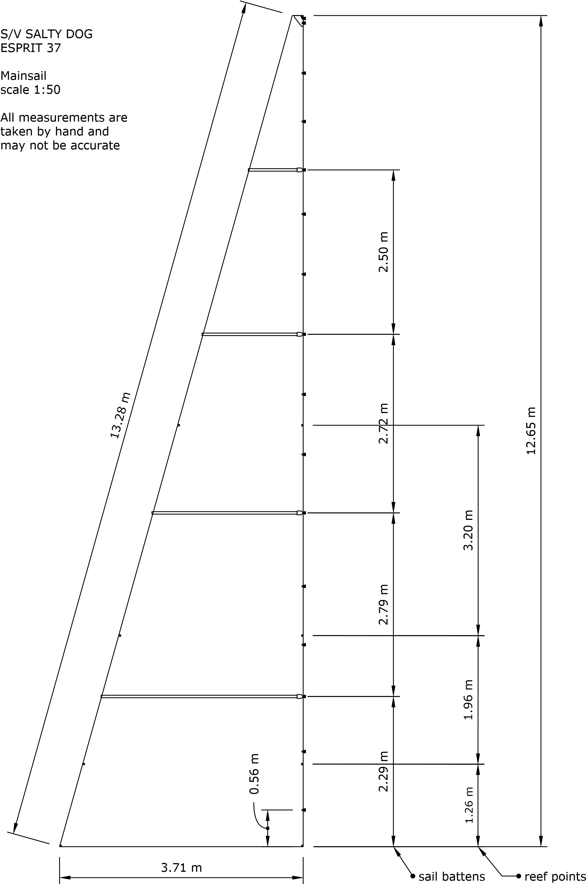
EXISTING MAINSAIL

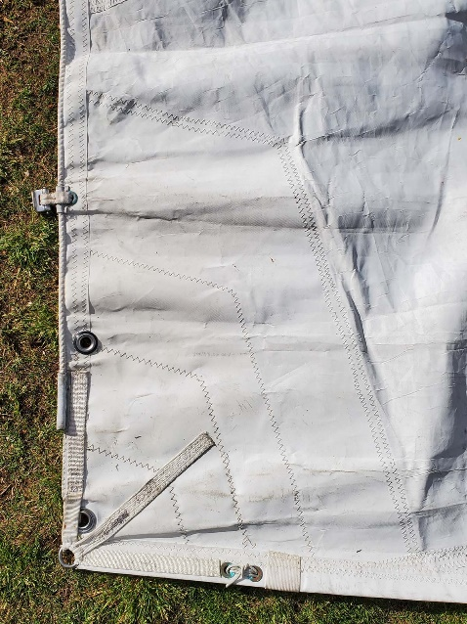
Photo 1
Mainsail Tack with pressed eyes for Cunningham or downhaul. Luff rope is not used.

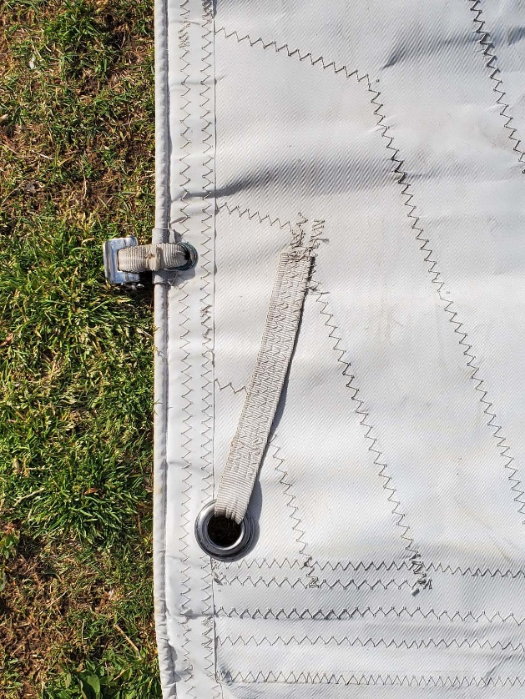
Photo 2
First Reef Point and sail slide (Strong SH-600)
For sail slides and full batten hardware systems please visit:
https://ultrafurl.com/products/strong-sail-track/track-and-slide-system/
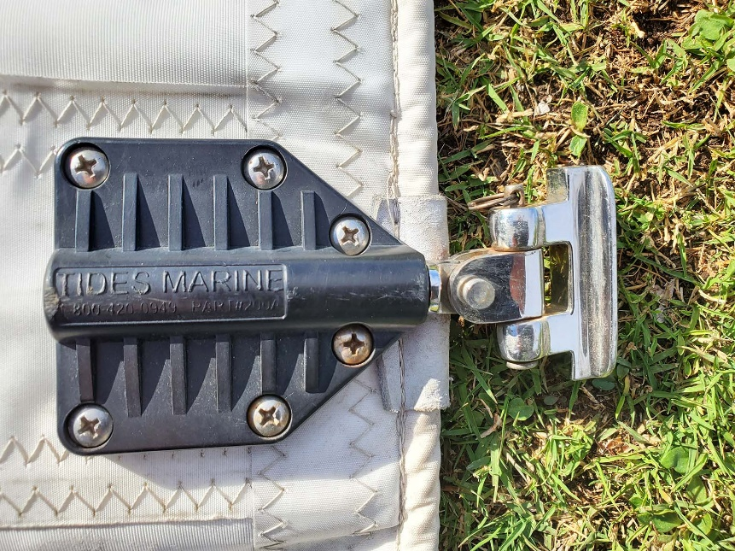
Photo 3

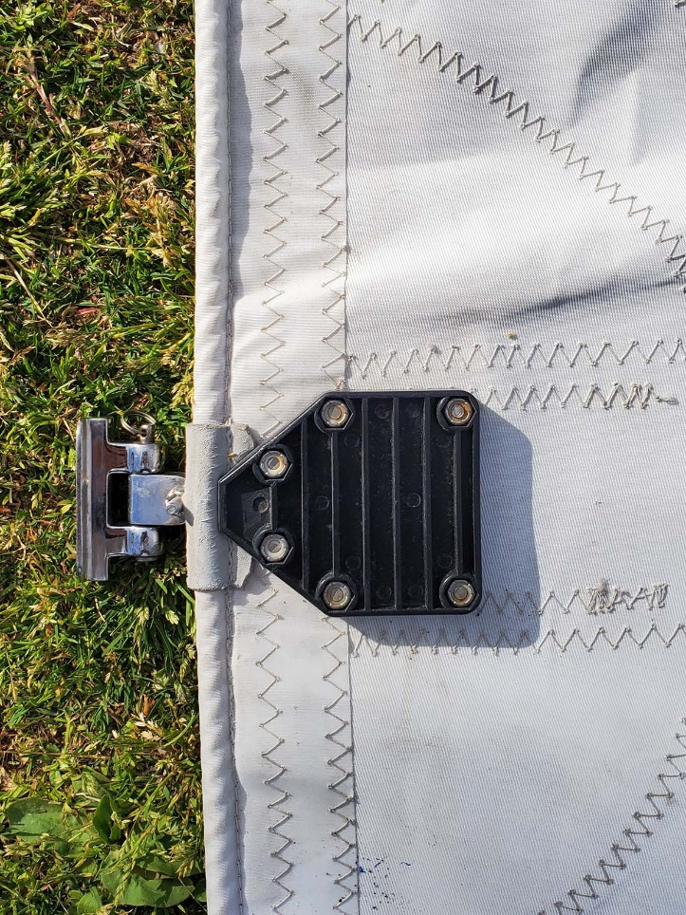
Photo 4
Full Batten Hardware (Strong SH-200A) plus Slide (Strong SH-400)
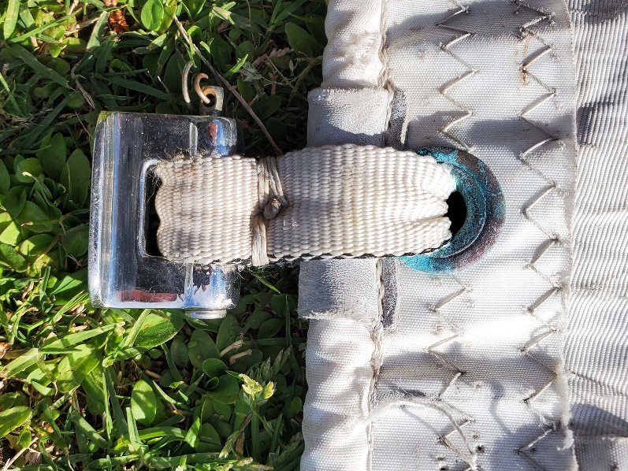
Photo 5
Detail SH-600 Slide

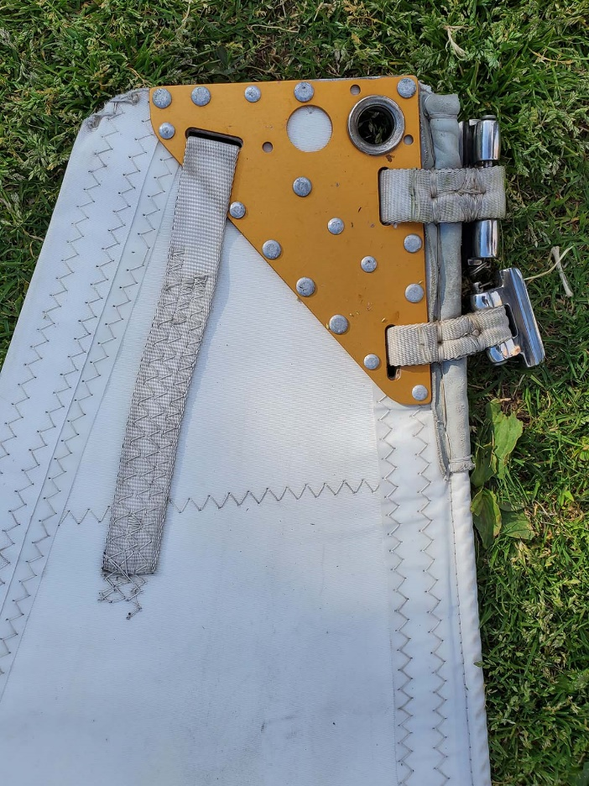
Photo 6
Headboard with one SH-600 slide and one SH-401 Slide
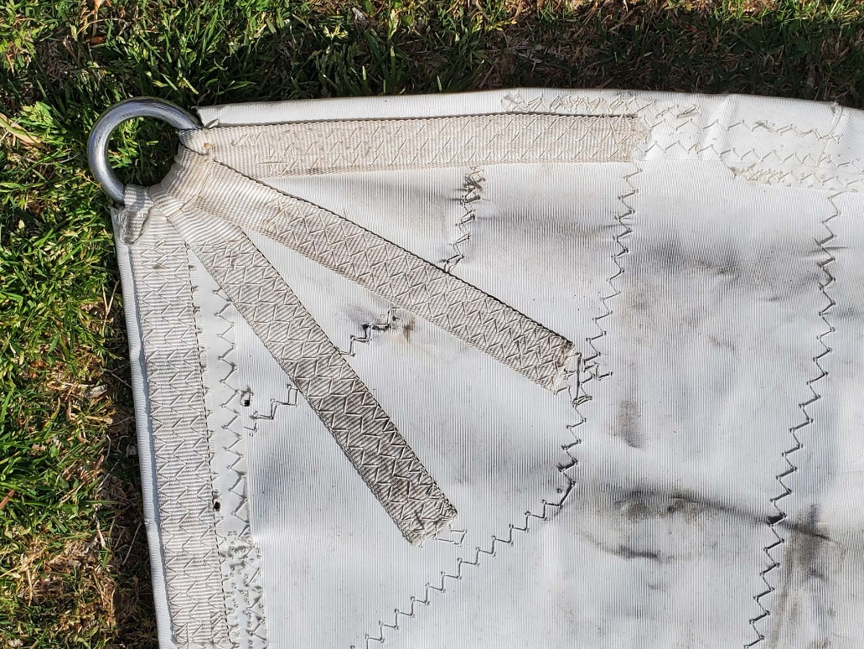
Photo 7
Clew

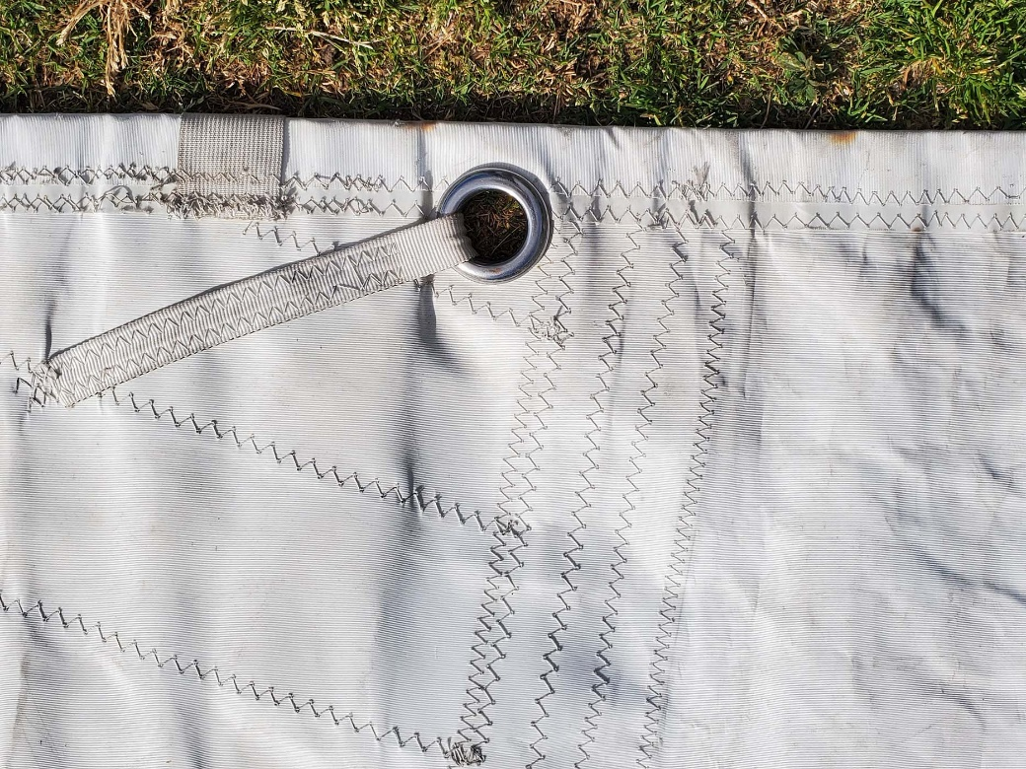
Photo 8
Reef Point in Leech
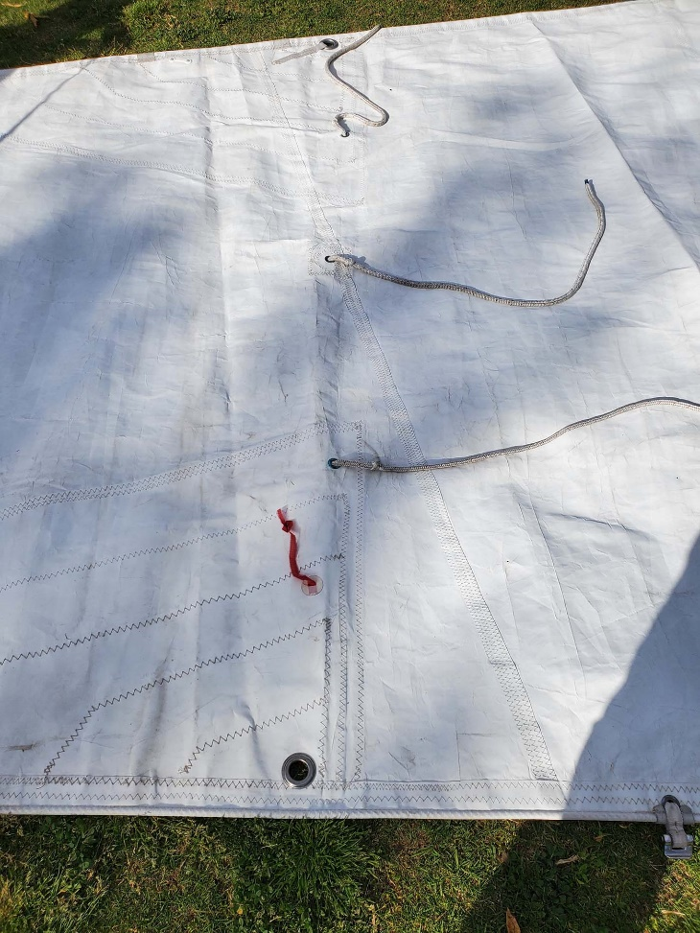
Photo 9
reefing pennants or cringles

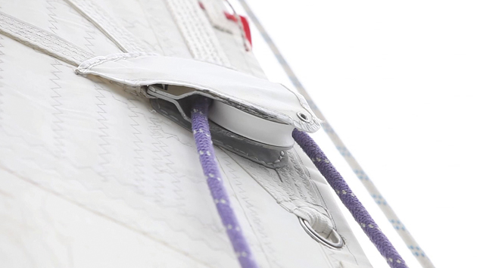
Photo 10
Suggestion of having webbing for reefing block attachment (both luff and leach) AND a pressed eye just below in case block fails. (photo is not my old sail)
MAINSAIL HARDWARE AND RIGGING

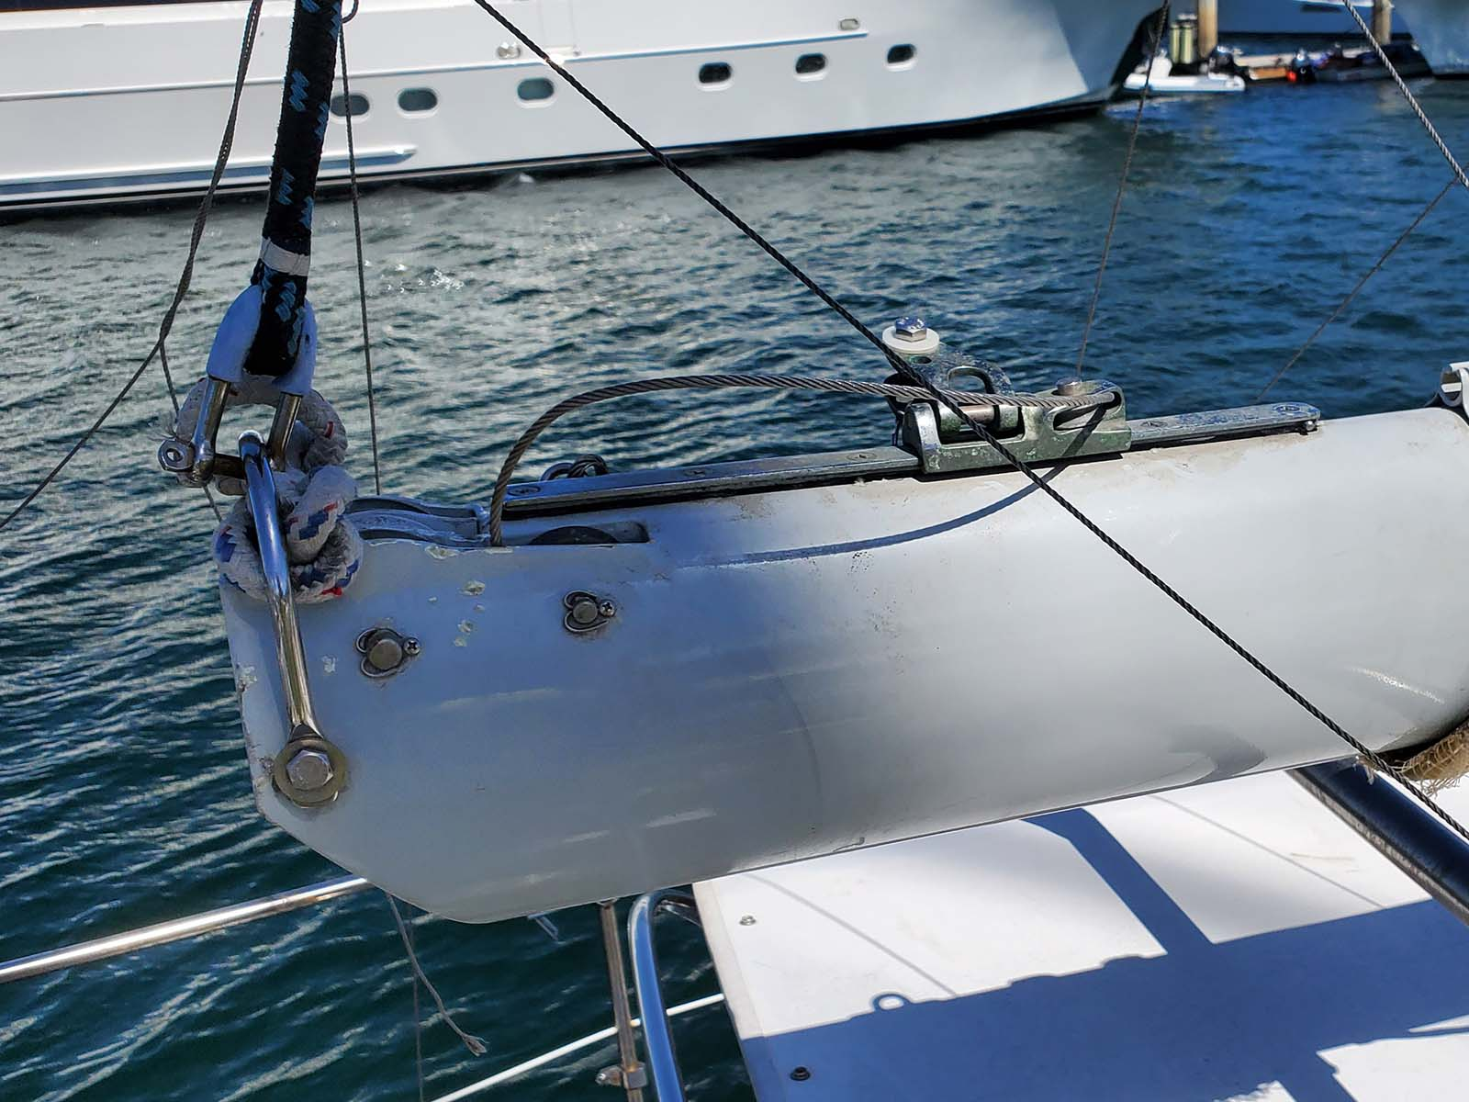
Photo 11
Outhaul Car (Moves 10”)
Both Max Leech and E are measured in the furthest position)

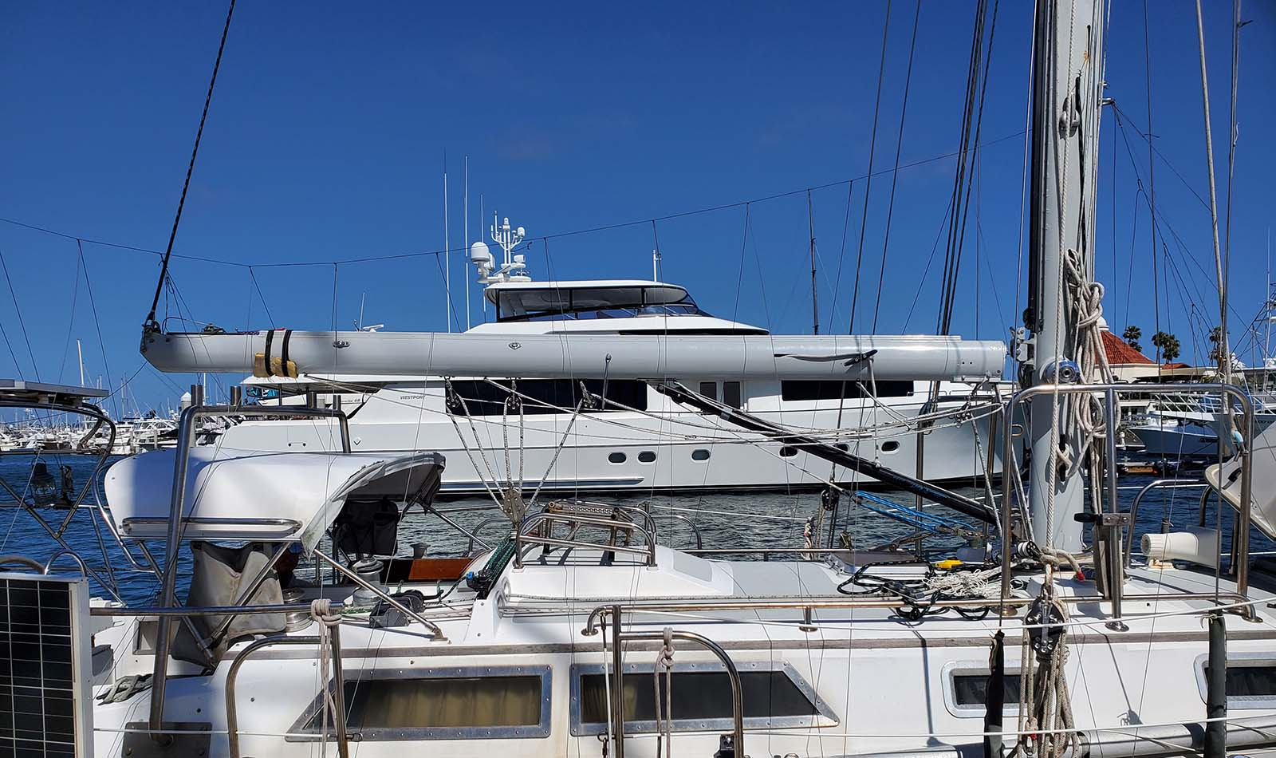
Photo 12
Boom (in position that measurements are taken)
Rigid Boom Vang. Topping Lift is not rigged in normal conditions.
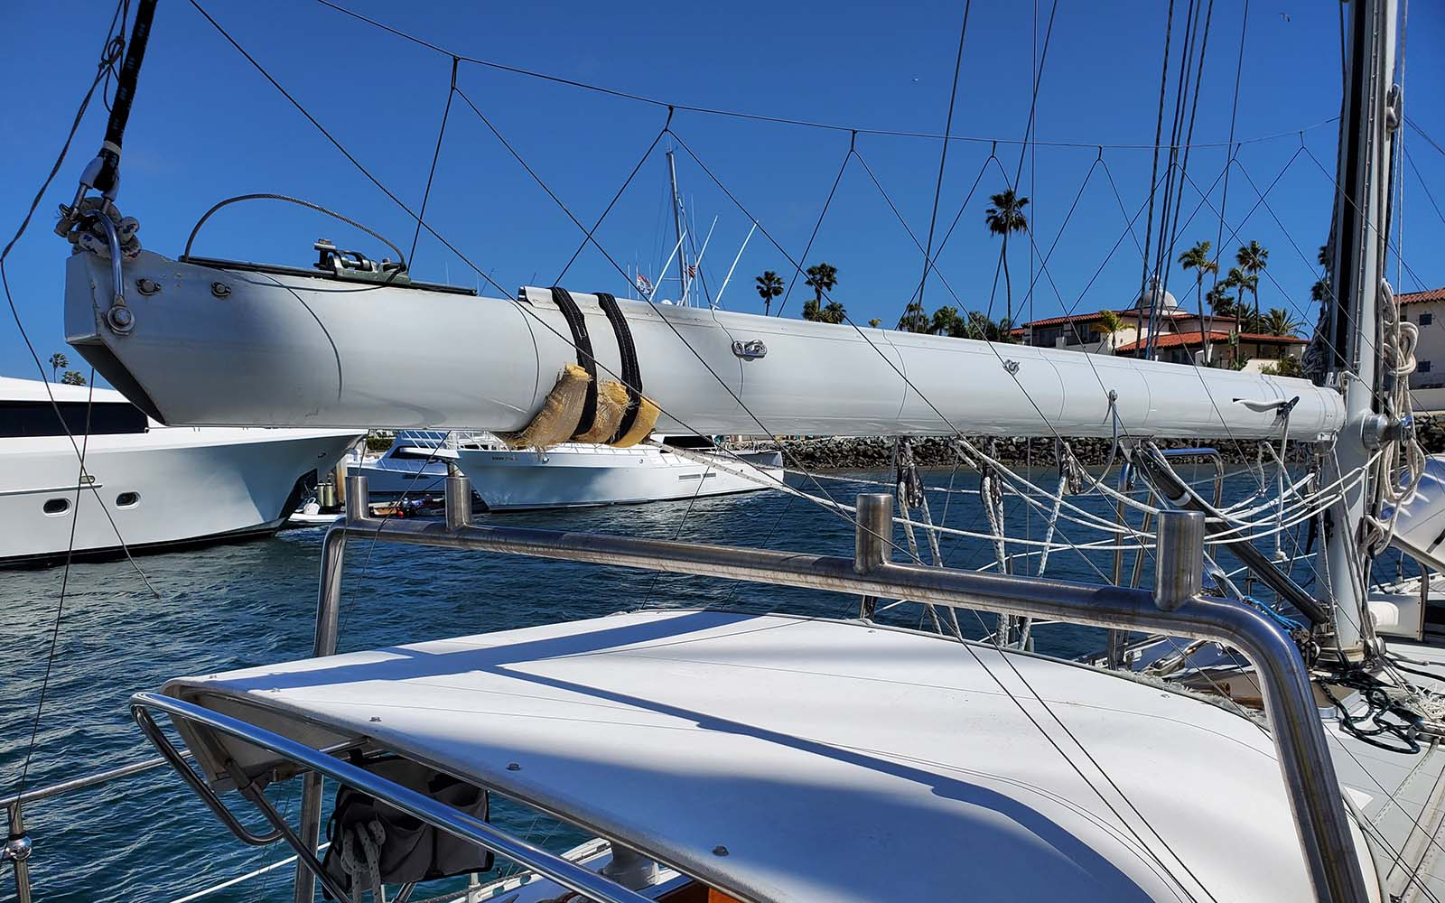
Photo 13
Boom clearance over Gallows

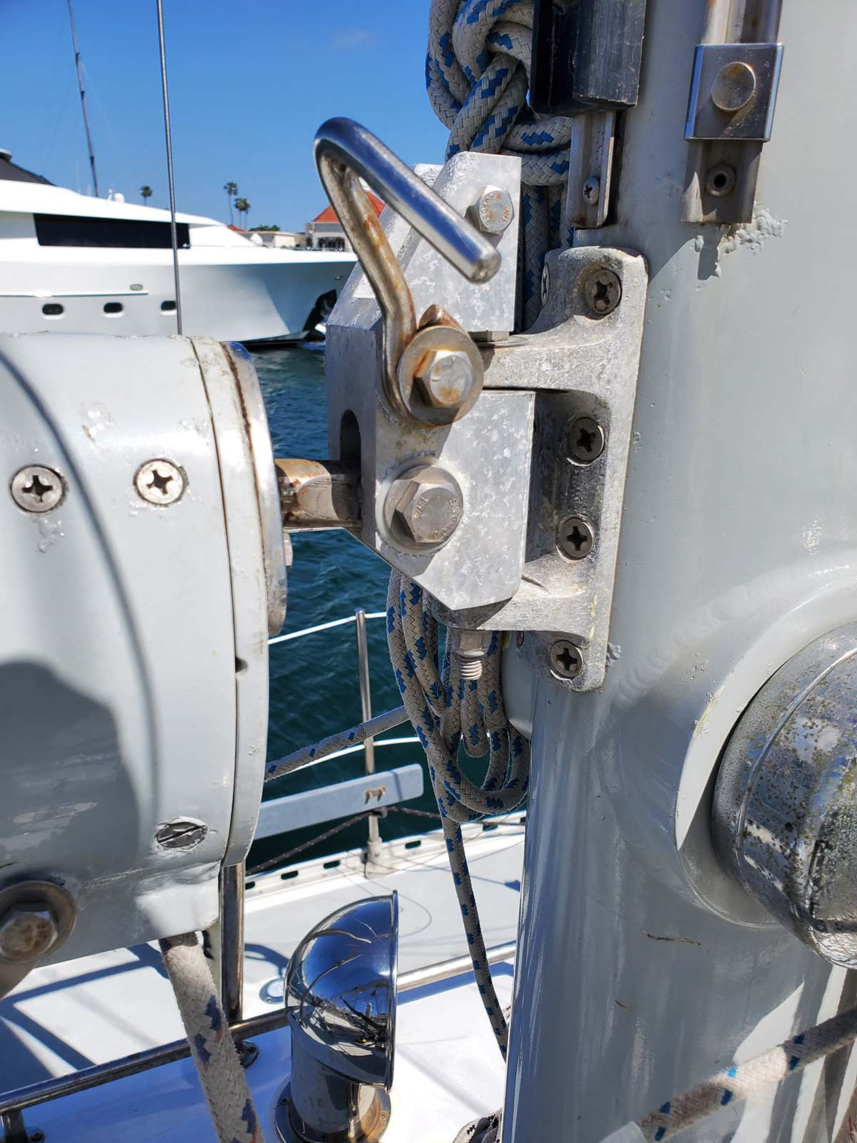
Photo 14
Gooseneck and Reef Hook
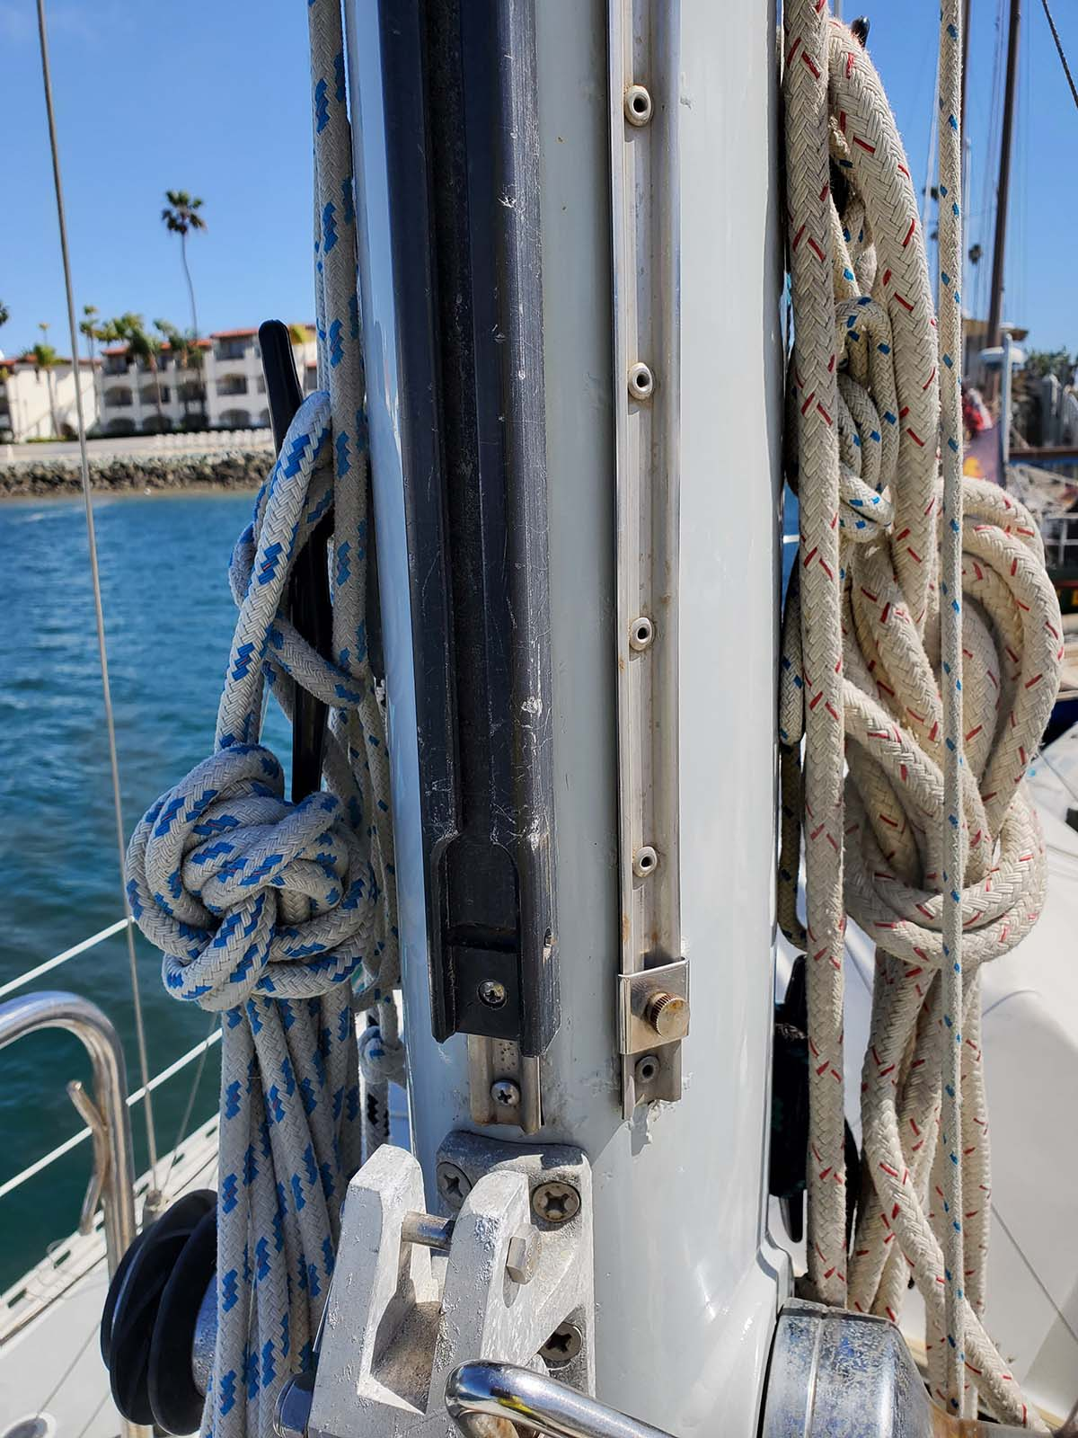
Photo 15
Sail Track
(Small track on the right is for Trisail)

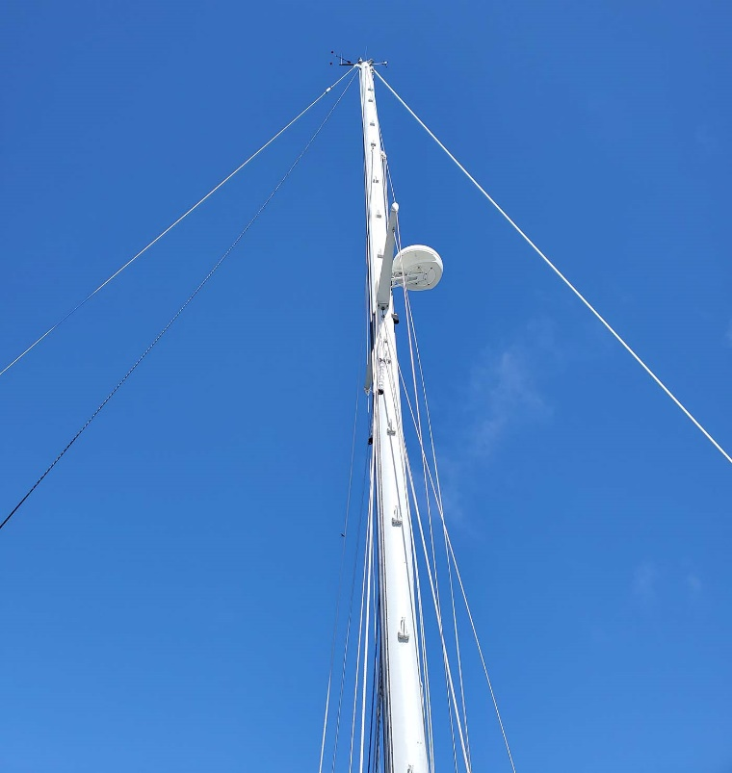
Photo 16
Masthead
EXISTING HEADSAIL
S/V SALTY DOG
ESPRIT 37
Headsail
scale 1:50
All measurements are
taken by hand and
may not be accurate
8
5
°
6
5
°
3
0
°
7.00
m
1
3
.
8
4

m
1
2
.
6
2

m
TACK
CLEW

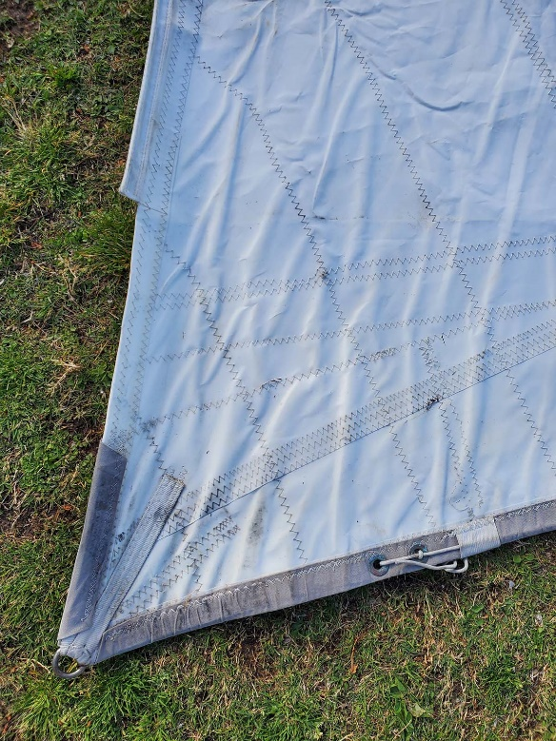
Photo 17
Tack

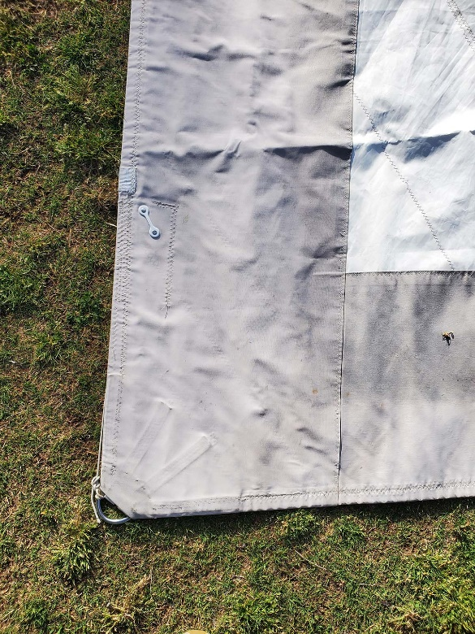
Photo 18
Clew
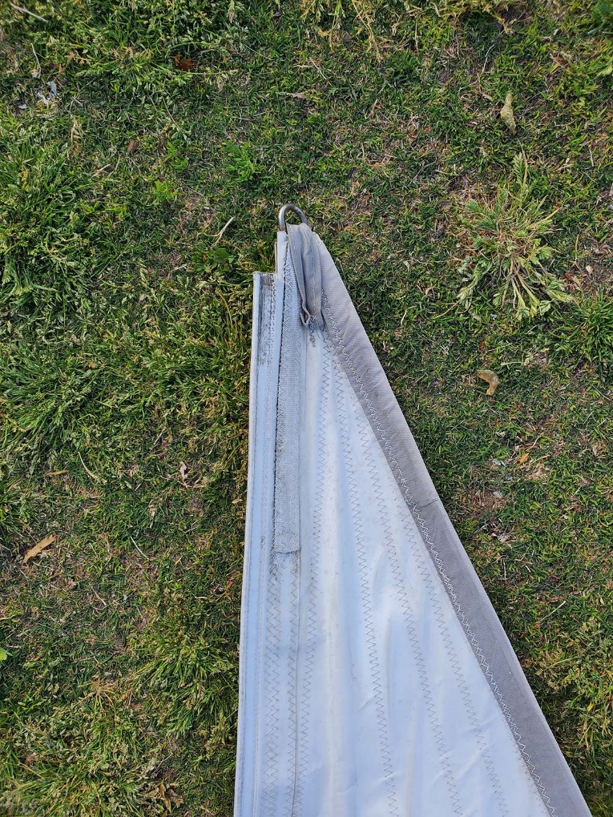
Photo 19
head

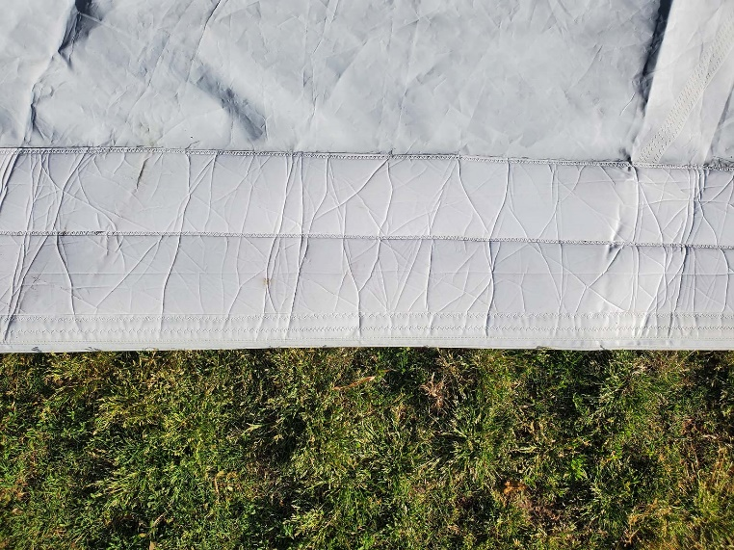
Photo 20
Luff

HEADSAIL HARDWARE AND RIGGING

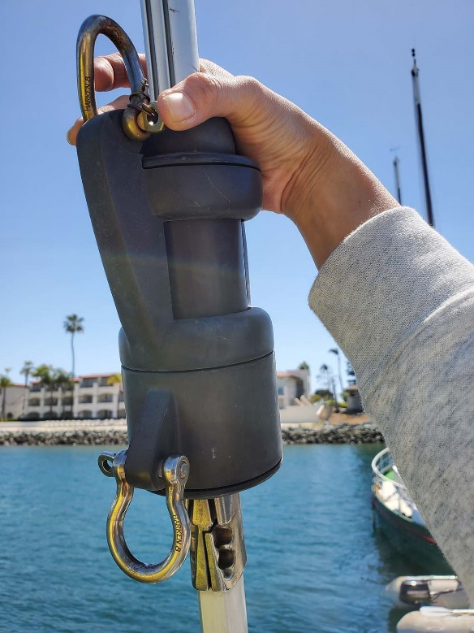’
Photo 21
Halyard and Head attachment

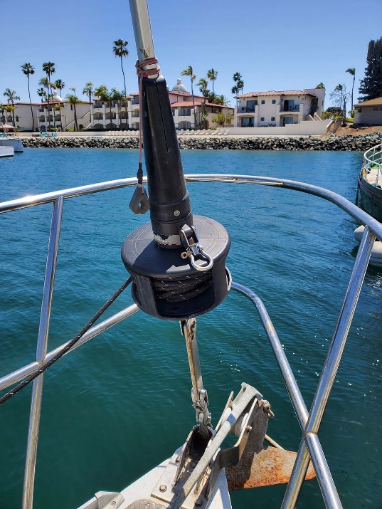
Photo 22
Harken Furler

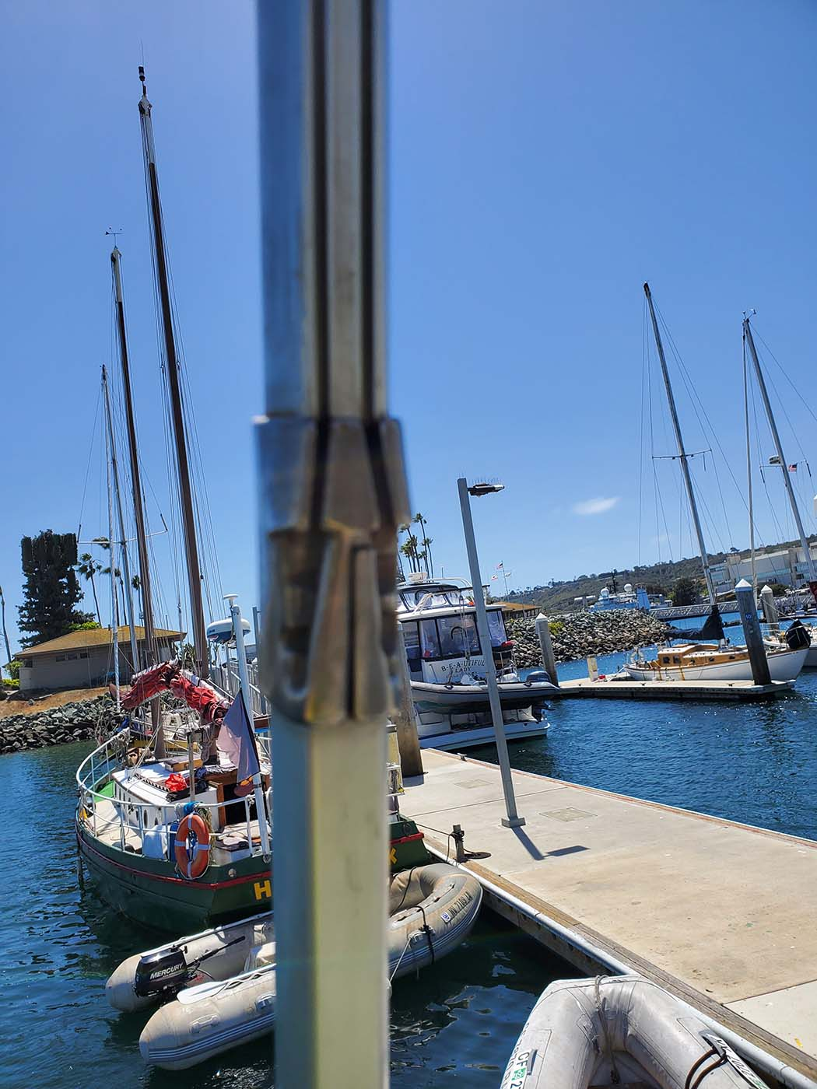
Photo 23
Sail Insertion point

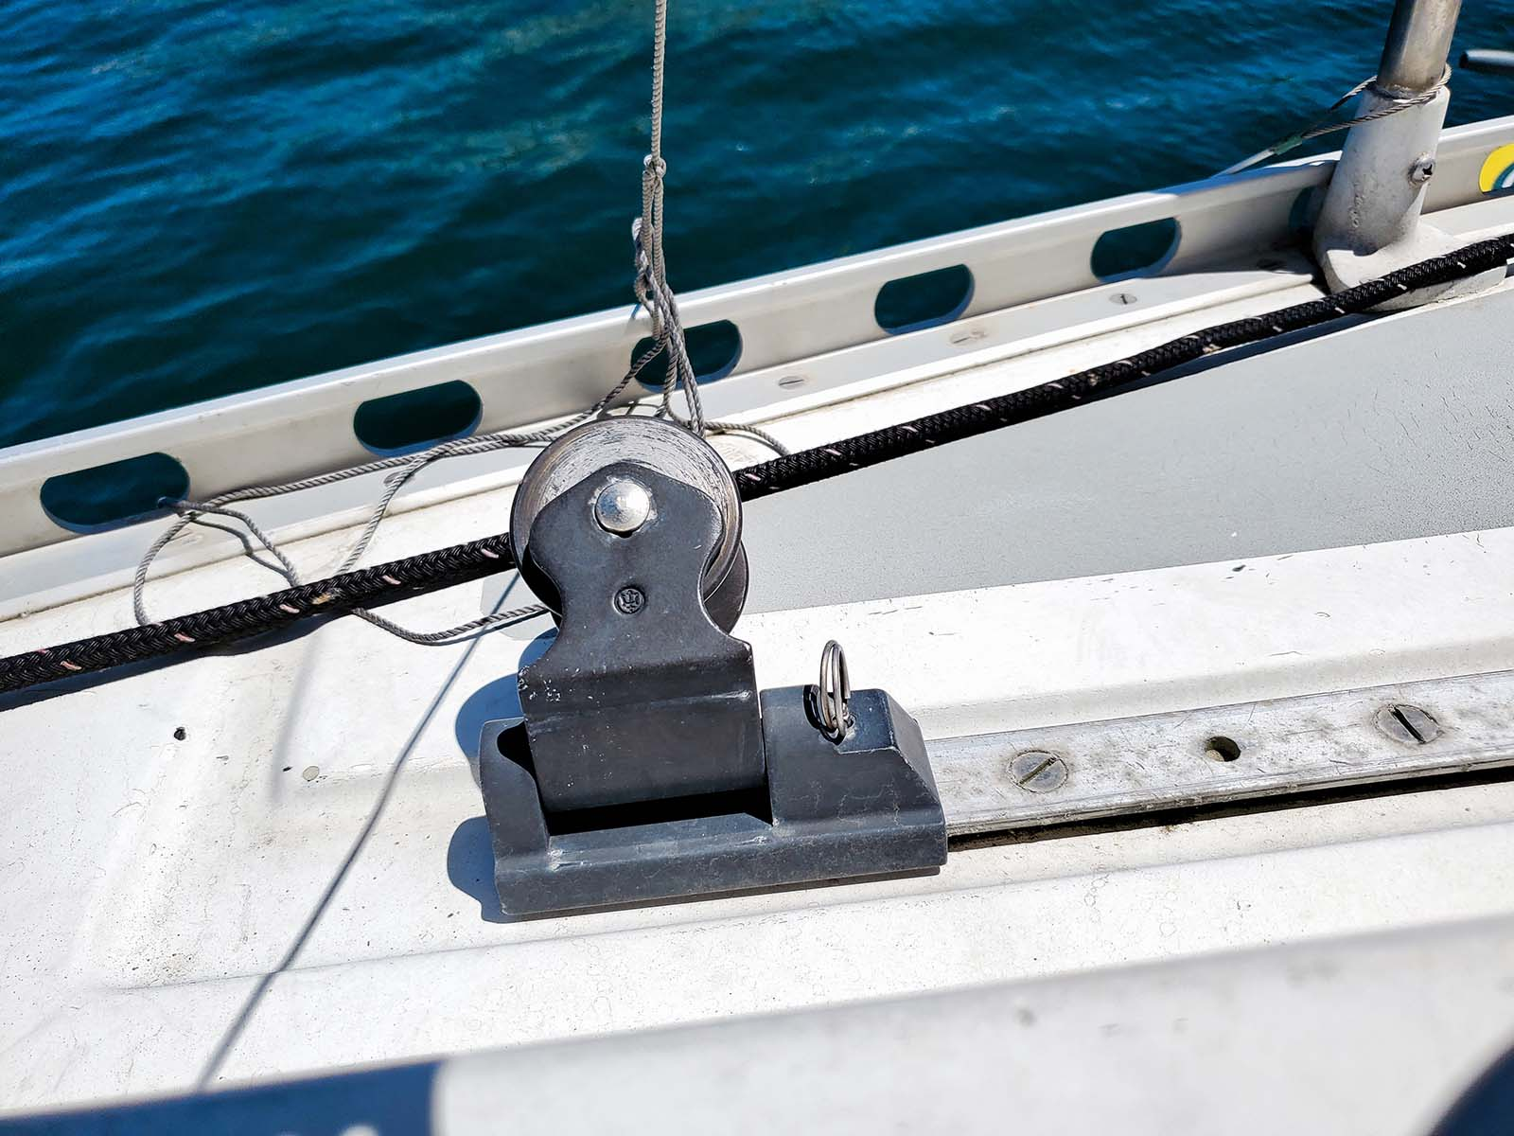
Photo 24
Sheet Track

