 | - Headsail - | 5000923 Michael
H0 | Sail Layout | Not Yet Posted
H1 | Size of Headsail (110, 135, 150 etc.)" | Cutter Staysail | HELP
H2 | Luff Length, Max Hoist, B measurement | 32'11 (Max tack to top. Measured top of top ring to bottom of tack ring)  (32.5 ft Net Finished size day of delivery) | HELP
H3 | Leech Length | 29'8" | HELP
H4 | Foot Length | 9'3" finished net | HELP
H5 | Tack | Press Ring Per picture
H6 | Clew Type (Press ring or 0-Ring) | Press Ring | HELP
H7 | Leech Line | Yes
H8 | Reefs for Hank on Sail (specify Qty of tiedowns) | No Manual Reefs
H9 | Foot Line | Yes
H10 | Track 1 (Tack to Genoa Track Beginning) | N/A | HELP
H11 | Track 2 (Tack to Genoa Track Ending) | N/A | HELP
H12 | Vessel "I" Measurement | NA to a cutter | HELP
H13 | Vessel "J" Measurement | NA to a cutter | HELP
H14 | Calculated Forestay Length | Sailmaker
H15 | Reef | Yes  2 reefs with eyelets
H16 | LP | Sailmaker | HELP
H17 | Color of Suncover | N/A | HELP
H18 | Side of Sail for Suncover (port or Stbd) | N/A
H19 | Luff Tape Size (such as #6)  Foot has slot bolt rope in a ¼” slot. Rope is on the Tack like attached pic. Bolt rope is fed from the clew to the tack.  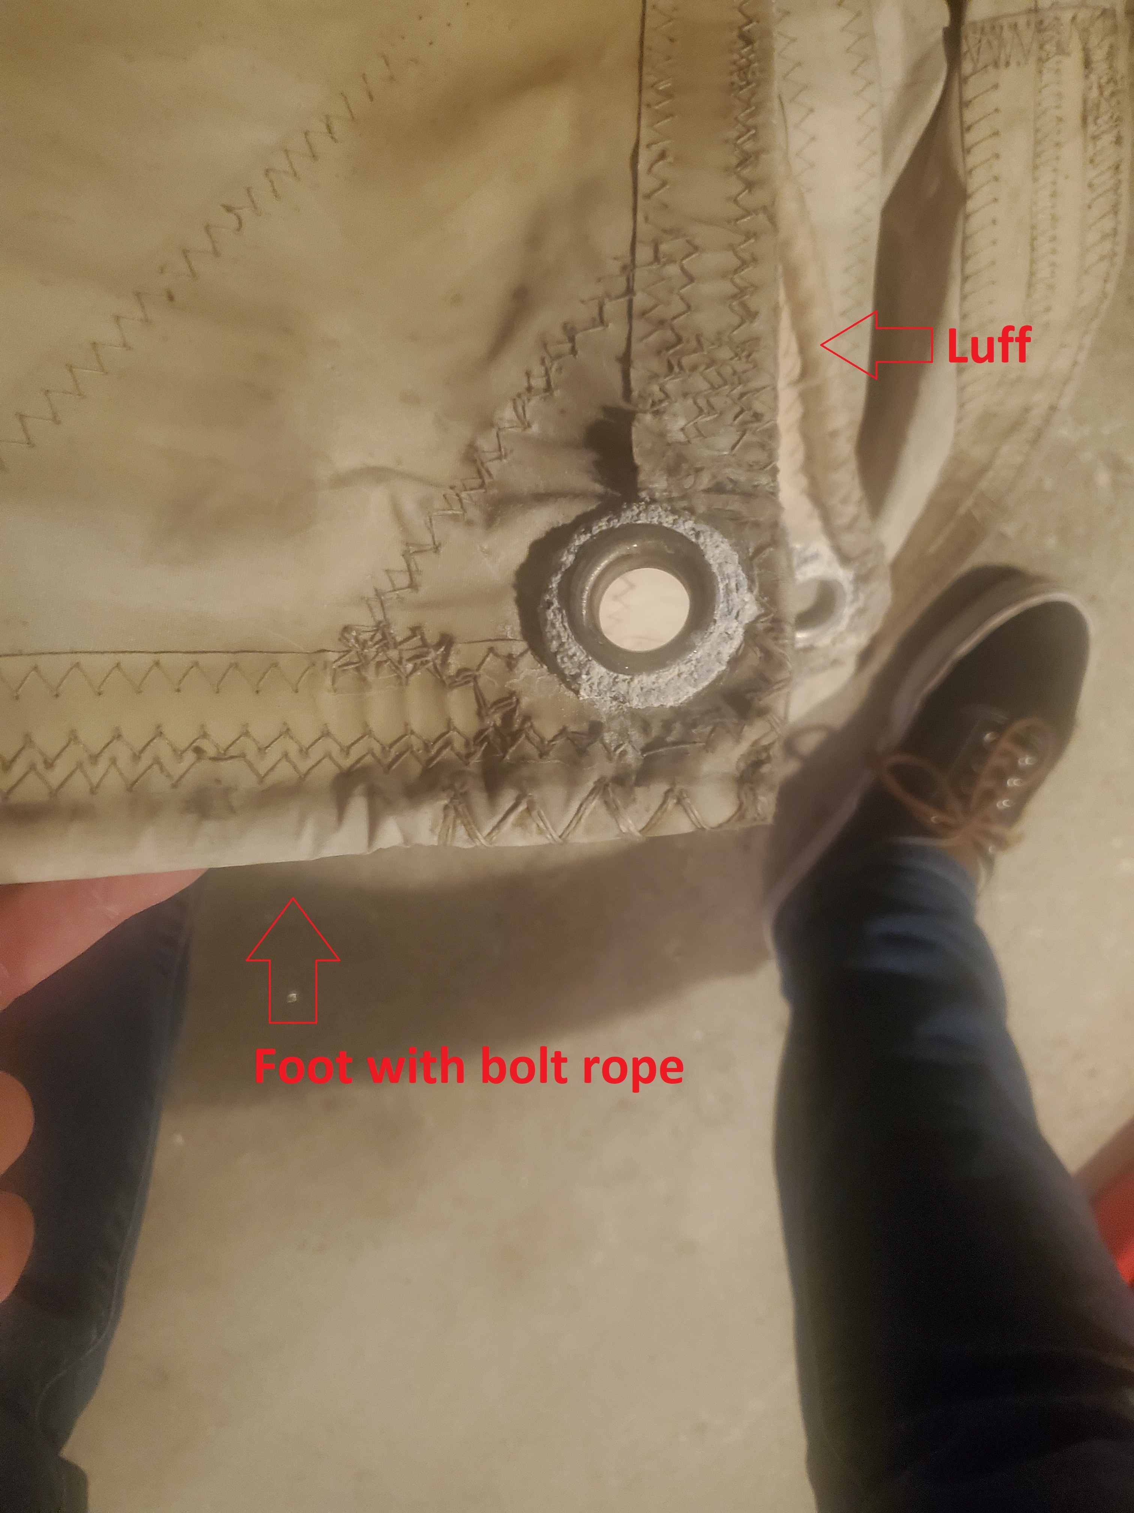 | Luff: Piston Hanks  Foot: HR4 (1/4in) bolt rope  Foot slides into boom in ¼” slot | HELP
H20 | Furler Manufacturer | N/A
H21 | Foam Luff | N/A | HELP
H22 | Cut Type | Cross
H23 | Sail Area | Sailmaker
H24 | Telltails | Yes | HELP
H25 | Telltail Window | No
H26 | Triple Stitch | YES
H27 | Logo | No | HELP
H28 | Cloth Weight | 8.18oz Challenge Performance Cruise
H29 | Sail Numbers and Color (red, blue or black) | No | HELP
H30 | Sheeting Stripe (red, blue, black) | No | HELP
H31 | Draft Stripe Color (red, blue or black) | Yes (Blue) | HELP
H32 | Clew Height off Deck | sailmaker | HELP
H33 | Tack Height off Deck | NA | HELP
H34 | Luff tape starts N/A up from Tack | N/A | HELP
H35 | Specialty Sail | No | HELP
 | Customer Note: All details we can check as sailmakers are based on accurate vessel I and J Measurements |  | HELP

