|  |  |  |  |
| --- | --- | --- | --- |
|  | - Mainsail - | 5000721 Rod |  |
| M0 | Sail Layout | Not Yet Posted |  |
| M1 | Tack Cut Back (Aft face of Mast to center of tack Pin - A) | 50mm  Press Ring type | [HELP](http://www.fareastsails.info/orderimages/Tack%20Cut%20Up%20and%20Cut%20Back.html) |
| M2 | Tack Cut Up (Top of Boom to Center of tack Pin - B) | 45mm  Press Ring type | [HELP](http://www.fareastsails.info/orderimages/Tack%20Cut%20Up%20and%20Cut%20Back.html) |
| M3 | Clew Cut Up (Top of Boom to Center of Tack Pin - X) | Loose Footed | [HELP](http://www.fareastsails.info/orderimages/Clew%20X%20and%20Y.jpg) |
| M4 | Clew type (slug, outhaul car or ring with strap) | “O” ring with 1,500mm long Velcro strap wraps around the boom 3 times | [HELP](http://www.fareastsails.info/orderimages/Clew_Types_Fareastsails.html) |
| M5 | Sunbrella clew cover for Furling Mains | na | [HELP](http://www.fareastsails.info/orderimages/weathermax_colors.html) |
| M6 | Other Offsets |  | [HELP](http://www.fareastsails.info/orderimages/Boom_offsets.html) |
| M7 | Headboard | Yes | [HELP](http://www.fareastsails.info/orderimages/Head_Board_Types.jpg) |
| M8 | Leech Line | yes |  |
| M9 | Foot Line | No |  |
| M10 | Tack Ring Type | Press Ring | [HELP](http://www.fareastsails.info/orderimages/Tack_Ring_Type.html) |
| M11 | Tack angle | 88.5 (not checked) | [HELP](http://www.fareastsails.info/orderimages/Tack_Angle.html) |
| M12 | Jack Line | No | [HELP](http://www.fareastsails.info/orderimages/Jack_Line.jpg) |
| M13 | Mast Bend (Luff Round) | Std | [HELP](http://www.fareastsails.info/orderimages/mastbend.jpg) |
| M14 | Fractional Rig (Yes, No) | 7/8th rig | [HELP](http://www.fareastsails.info/orderimages/Fractional%20Rig.jpg) |
| M15 | Mast - Keel or Deck Stepped? | Deck |  |
| M16 | Number of Reefs | 2  Reefs  1st Reef 1,400mm high above boom  2nd reef 2,800mm high above boom | [HELP](http://www.fareastsails.info/orderimages/Reefs.html) |
| M17 | Intermediate Reefing Diamond Eyes (Yes or No) | No | [HELP](http://www.fareastsails.info/orderimages/Intermediate_Reefing_Tie_Downs.html) |
| M18 | Foot Reefing Grommets (next to boom) | N/A | [HELP](http://www.fareastsails.info/orderimages/Intermediate_Reefing_Tie_Downs.html) |
| M19 | Reefing Ring Type | Luff: Press Ring  Leech: Webbing as with attached photo to accept shackled on block at aft end | [HELP](http://www.fareastsails.info/orderimages/Reefing_Ring_Types.html) |
| M20 | Luff Length (Max Hoist - P) | 12,140mm. Measured top Boom to underside Black Band (max hoist, P)   Max  (12.01m Net Finished size day of Delivery) | [HELP](http://www.Fareastsails.info/orderimages/Mainsail%20Luff%20Measurement.html) |
| M21 | Foot Length (Max Foot - E) | 3,980mm. Measured back of Mast to inside Boom Black Band (Max foot, E)   Max  (3.94m Net Finished size day of Delivery) | [HELP](http://www.Fareastsails.info/orderimages/Mainsail_Foot_Measurement.html) |
| M22 | Leech Length (straight line head to clew) | 12,600mm Max measured Leach, from underside Mast Black Band to Inside Boom Black Band with boom strapped into lowest boom sailing position to ensure the boom clears fixed mainsheet cockpit arch and cockpit bimini.  Sailmaker 2 ply on whole leech | [HELP](http://www.Fareastsails.info/orderimages/Mainsail_Leech_Measurement_Check.html) |
| M23 | Bimini to Clear (yes or no) | N/A | [HELP](http://www.Fareastsails.info/orderimages/Mainsail_Bimini_Check.html) |
| M24 | Foot Round | Sailmaker |  |
| M25 | Aspect Ratio | Sailmaker | [HELP](http://www.fareastsails.info/orderimages/Aspect%20Ratio.html) |
| M26 | Vessel Backstay Measurement | 4,700mm measured | [HELP](http://www.fareastsails.info/orderimages/BoomArt2.jpg) |
| M27 | Luff Slides (Part Number) | A014 – for intermediate sliders  A117 – for full length battens sliders  See photos attached below | [HELP](http://www.fareastsails.info/orderimages/sailslides3.html) |
| M28 | Foot Slides (Part Number) | Loose Footed | [HELP](http://www.fareastsails.info/orderimages/sailslides3.html) |
| M29 | Roach Type | Cruise | [HELP](http://www.fareastsails.info/orderimages/roach.jpg) |
| M30 | Roach Factor | 1.1 | [HELP](http://www.fareastsails.info/orderimages/Roach-Factor.html) |
| M31 | MGM | Sailmaker | [HELP](http://www.fareastsails.info/orderimages/Design%20MGM%20and%20MGU.html) |
| M32 | MGU | Sailmaker | [HELP](http://www.fareastsails.info/orderimages/Design%20MGM%20and%20MGU.html) |
| M33 | Batten Type (Partial or Full) | 4 Full | [HELP](http://www.fareastsails.info/orderimages/Full%20Batten%20Options.html) |
| M34 | Include Battens | N/A |  |
| M35 | Install Nylon Batten Holders | Yes | [HELP](http://www.fareastsails.info/orderimages/Fareastsails.com%20Full%20Batten%20Holder%20Options.html) |
| M36 | Intermediate Sliders | Yes  2 | [HELP](http://www.fareastsails.info/orderimages/Fareastsails.com_Intermediate_Full_Batten_Sliders.html) |
| M37 | Cloth Weight | 7.88 Contender Pro Warp Tech- Tri Radial |  |
| M38 | Cut Type | Tri Radial |  |
| M39 | Sail Area | N/A |  |
| M40 | Cunningham | Yes,Press Ring Type | [HELP](http://www.fareastsails.info/orderimages/cunningham.jpg) |
| M41 | Telltails | Yes | [HELP](http://www.fareastsails.info/orderimages/telltails.html) |
| M42 | Triple Stitch | Yes |  |
| M43 | Sail Logo and Color(red, blue or black) | YES, Beneteau, Black | [HELP](http://www.fareastsails.info/orderimages/snlogos.html) |
| M44 | Sail Logo Artwork | YES |  |
| M45 | Sail Numbers and Color | YES Numbers= 9825  Black | [HELP](http://www.fareastsails.info/orderimages/snlogos.html) |
| M46 | Draft Stripe and Color(red, blue or black) | Yes Black | [HELP](http://www.fareastsails.info/Draft%20Stripe.html) |
| M47 | Overhead Leech Line | No |  |
| M48 | Specialty Sail | No | [HELP](http://www.fareastsails.info/orderimages/Specialty%20Sails.html) |
| M49 | Boom Cover | No | [HELP](http://www.fareastsails.info/orderimages/Boom_Cover.html) |
| M50 | Lazy Bag | Yes –  Sunbrella 4684 Slate.  Measurements as follows | [HELP](http://www.fareastsails.info/orderimages/Lazy_Bag.html) |

Lazy Bag Dimensions measured with existing sail:

A = 480mm

B = 4,160mm = Boom Length. (Max foot length, E to inside Boom Black Band is 3,980mm)

C = 900mm

D = 850mm

E = 1,100mm

F = 1,300mm

G = 1,750mm

H = 200mm

I = 1,600mm

J = 1,600mm

K = Bolt along the bottom from in-board end until last 1400mm, then to have Slug Sliders to allow reefing lines to attach around the end of the boom

L = Slot width = 6.5mm and internal cavity circa 25mm wide. Bainbridge A117 type slug slider will suit as is same as for Mast track sliders.

M = Closed bag with bolt to suit Loose Footed Main, but Open with slides only for the last 1,400mm to enable reef lines to pass around the boom

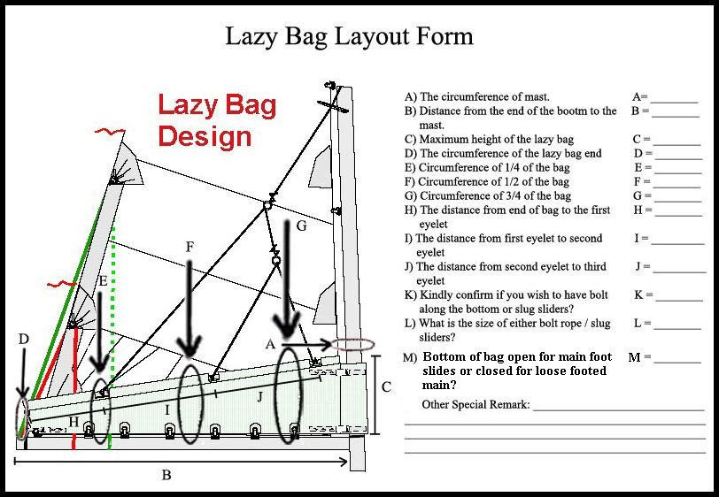

|  |  |  |  |
| --- | --- | --- | --- |
|  | - Headsail - | 5000721 Rod |  |
| H0 | Sail Layout | Not Yet Posted |  |
| H1 | Size of Headsail (110, 135, 150 etc.)" | Beneteau specification Sheets note sail as 110%, (I have fully dimensioned by pulling out on a calm day with no wind pressure. The existing sail fits very well on the boat) | [HELP](http://www.fareastsails.info/orderimages/gen123.jpg) |
| H2 | Luff Length, Max Hoist, B measurement | 12,420mm measured max. No wind pressure, sail hoisted and sheeted in firm webbing loop tip to webbing loop tip (Max)  (12.29m Net Finished size day of delivery) | [HELP](http://www.fareastsails.info/orderimages/Furler_Luff_Measurement.html) |
| H3 | Leech Length | 11,870mm measured max. No wind pressure, sail hoisted and sheeted in firm  sailmaker  2 ply on the leech | [HELP](http://www.fareastsails.info/orderimages/Leech%20Length.jpg) |
| H4 | Foot Length | 4,900 measured max No wind pressure, sail hoisted and sheeted in firm sailmaker | [HELP](http://www.fareastsails.info/orderimages/Foot%20Length.jpg) |
| H5 | Tack and Head Fittings | Webbing Loops |  |
| H6 | Clew Type (Press ring or 0-Ring) | “O” Ring | [HELP](http://www.fareastsails.info/orderimages/genoa%20clew%20types.jpg) |
| H7 | Leech Line | Yes |  |
| H8 | Reefs for Hank on Sail (specify Qty of tiedowns) | No Manual Reefs |  |
| H9 | Foot Line | Yes |  |
| H10 | Track 1 (Tack to Genoa Track Beginning) | 3,950mm max. Works well with measured Luff, Foot, Leach dimensions provided | [HELP](http://www.fareastsails.info/orderimages/Genoa%20Track.pdf) |
| H11 | Track 2 (Tack to Genoa Track Ending) | 5,200mm max. Works well with measured Luff, Foot, Leach dimensions provided | [HELP](http://www.fareastsails.info/orderimages/Genoa%20Track.pdf) |
| H12 | Vessel "I" Measurement | 12.44m | [HELP](http://www.fareastsails.info/orderimages/Vessel%20I%20measurement.html) |
| H13 | Vessel "J" Measurement | 4.29m | [HELP](http://www.fareastsails.info/orderimages/LP+I+J.html) |
| H14 | Calculated Forestay Length | Sailmaker. |  |
| H15 | Reef | N/A |  |
| H16 | LP | Sailmaker.  4,635mm measured. No Wind pressure with Sail hoisted and sheeted in firm. | [HELP](http://www.fareastsails.info/orderimages/LP.jpg) |
| H17 | Color of Suncover | White - subrella | [HELP](http://www.fareastsails.info/orderimages/weathermax_colors.html) |
| H18 | Side of Sail for Suncover (port or Stbd) | Starboard |  |
| H19 | Luff Tape Size (such as #6) | HL6 Tape #6 finished Size 5.5mm | [HELP](http://www.fareastsails.info/orderimages/Furler_Luff_Tape.html) |
| H20 | Furler Manufacturer | Facnor LS130 headsail furler |  |
| H21 | Foam Luff | Yes | [HELP](http://www.fareastsails.info/orderimages/Foam_Luff.html) |
| H22 | Cut Type | Tri Radial |  |
| H23 | Sail Area | Sailamker |  |
| H24 | Telltails | Yes | [HELP](http://www.fareastsails.info/orderimages/telltails.html) |
| H25 | Telltail Window | No |  |
| H26 | Triple Stitch | YES |  |
| H27 | Logo | YES, Beneteau, Black | [HELP](http://www.fareastsails.info/orderimages/snlogos.html) |
| H28 | Cloth Weight | 7.88 Contender Pro Warp Tech - Tri Radial |  |
| H29 | Sail Numbers and Color (red, blue or black) | YES Numbers= 9825  Black | [HELP](http://www.fareastsails.info/orderimages/snlogos.html) |
| H30 | Sheeting Stripe (red, blue, black) | No | [HELP](http://www.fareastsails.info/orderimages/Sheeting%20Stripe.jpg) |
| H31 | Draft Stripe Color  (red, blue or black) | YES  Black | [HELP](http://www.fareastsails.info/orderimages/Draft%20Stripe.html) |
| H32 | Clew Height off Deck | Sailmaker.  (475mm measured) | [HELP](http://www.fareastsails.info/orderimages/clewheight.jpg) |
| H33 | Tack Height off Deck | 420mm | [HELP](http://www.fareastsails.info/orderimages/clewheight.jpg) |
| H34 | Luff tape starts  up from Tack | 450mm | [HELP](http://www.fareastsails.info/orderimages/Luff%20tape%20start.jpg) |
| H35 | Specialty Sail | No | [HELP](http://www.fareastsails.info/orderimages/Specialty%20Sails.html) |
|  | Customer Note: All details we can check as sailmakers are based on accurate vessel I and J Measurements |  | [HELP](http://www.fareastsails.info/orderimages/LP.jpg) |

|  |  |  |  |
| --- | --- | --- | --- |
|  | -  - | 5000721 Rod |  |
| S0 | Sail Layout | Not Yet Posted |  |
| S1 | Size of Headsail (110, 135, 150 etc.)" | 81.65m2 Asymmetric Spinnakers |  |
| S2 | Luff Length, Max Hoist, B measurement | sailmaker  13,900mm  Measured halyard hoist from block to masthead sheave | [HELP](http://www.fareastsails.info/orderimages/Gennaker%20Furler%20Luff%20Measurement.html) |
| S3 | Leech Length | sailmaker |  |
| S4 | Foot Length | sailmaker |  |
| S5 | Tack and Head Fittings | O-Rings |  |
| S6 | Vessel "I" Measurement | 12.44m | [HELP](http://www.fareastsails.info/orderimages/Vessel%20I%20measurement.html) |
| S7 | Vessel "J" Measurement | 4.29m | [HELP](http://www.fareastsails.info/orderimages/LP+I+J.html) |
| S8 | Calculated Forestay Length | Sailamker |  |
| S9 | Masthead or Fractional Spinnaker ? | Fractional |  |
| S10 | Tack up for Code 0's | N/A |  |
| S11 | Correct Size for A/Spin or S/Spin | N/A |  |
| S12 | LP | N/A | [HELP](http://www.fareastsails.info/orderimages/LP.jpg) |
| S13 | Cut Type | Full Radial |  |
| S14 | U/V Cover | N/A |  |
| S15 | Luff Type | Free |  |
| S16 | Furler Name | None |  |
| S17 | Sail Area | 81.65m2 |  |
| S18 | Cloth Weight | Nylite 150 |  |
| S19 | Sail Colors | Orange | [HELP](http://www.fareastsails.info/orderimages/Spinnaker_Colors.html) |
| S20 | Sail Numbers and Color (red, blue or black) | No | [HELP](http://www.fareastsails.info/orderimages/snlogos.html) |
| S21 | Sail Logo | No |  |
| S22 | Sail Sock (White is std Color) | Yes |  |
| S23 | Sail Sock Length | Sailmaker |  |
| S24 | Wire Size | N/A |  |
| S25 | Sail Sock Color | Black | [HELP](http://www.fareastsails.info/orderimages/Fareastsails_Spinnaker_Sock_Colors.html) |
| S26 | Specialty Sail |  | [HELP](http://www.fareastsails.info/orderimages/Specialty%20Sails.html) |
| S27 | Score |  | [HELP](http://www.fareastsails.info/orderimages/Score.html) |
|  | Customer Note: All details we can check as sailmakers are based on accurate vessel I and J Measurements |  | [HELP](http://www.fareastsails.info/orderimages/LP.jpg) |

Full length sail battens, existing mainsail.

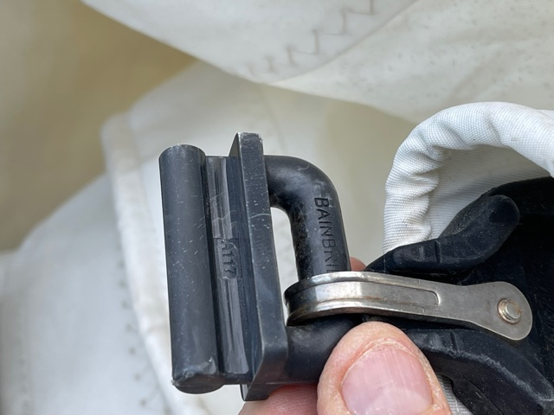

Intermediate Battens, existing mainsail

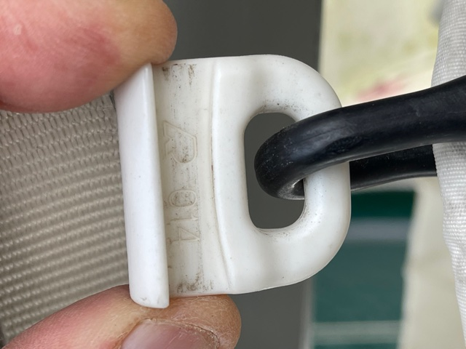

Leech reef lines existing mainsail attach with webbing to suit shackle on block as below. Luff reef points press ring type

