 | - Mainsail - Leopard 45 | 5000607 Isabel
M0 | Sail Layout | Not Yet Posted
M1 | Tack Cut Back (Aft face of Mast to center of tack Pin - A) | We have no way of ascertaining these values as the boat is not here. We send you photos of the tack & clew and use your best judgement.  See photo below | HELP
M2 | Tack Cut Up (Top of Boom to Center of tack Pin - B) | The same that M1.  See photo below | HELP
M3 | Clew Cut Up (Top of Boom to Center of Tack Pin - X) | See photo M3 below | HELP
M4 | Clew type (slug, outhaul car or ring with strap) | O Ring | HELP
M5 | Sunbrella clew cover for Furling Mains | na | HELP
M6 | Other Offsets |  | HELP
M7 | Headboard | Yes,You install. The same type it has.  See photo below | HELP
M8 | Leech Line | yes
M9 | Foot Line | No
M10 | Tack Ring Type | #1 Webbed O Ring | HELP
M11 | Tack angle | The tack angle of the sail as it lays flat on the table is approx.82 degrees.  See photo below | HELP
M12 | Jack Line | No | HELP
M13 | Mast Bend (Luff Round) | Std | HELP
M14 | Fractional Rig (Yes, No) | No | HELP
M15 | Mast - Keel or Deck Stepped? | N/A
M16 | Number of Reefs | 2 Reefs | HELP
M17 | Intermediate Reefing Diamond Eyes (Yes or No) | yes | HELP
M18 | Foot Reefing Grommets (next to boom) | N/A | HELP
M19 | Reefing Ring Type | 35mm Press Ring | HELP
M20 | Luff Length (Max Hoist - P) | 56.8ft  (Net Finished size day of Delivery) | HELP
M21 | Foot Length (Max Foot - E) | 21.66ft Max  (Net Finished size day of Delivery) | HELP
M22 | Leech Length (straight line head to clew) | 57.5ft | HELP
M23 | Bimini to Clear (yes or no) |  | HELP
M24 | Foot Round | The existing sail has a very flat foot. Probably could use a few inches on round
M25 | Aspect Ratio | Sailmaker | HELP
M26 | Vessel Backstay Measurement | N/A | HELP
M27 | Luff Slides (Part Number) | Luff you install  6 intermediate 8mm dia hole  See photo below | HELP
M28 | Foot Slides (Part Number) | Loose Footed | HELP
M29 | Roach Type | Cruise CAT | HELP
M30 | Roach Factor | 1.35 | HELP
M31 | MGM | Sailmaker | HELP
M32 | MGU | Sailmaker | HELP
M33 | Batten Type (Partial or Full) | 5 Full round | HELP
M34 | Include Battens | N/A
M35 | Install Nylon Batten Holders | N/A Client will install luff and leech holder. Leave space  Please minimize the gap between the batten sleeves and the NBH to allow for maximum overlap of sleeves onto the NBH reinforcement patches.  See photo below | HELP
M36 | Intermediate Sliders | Yes - Eyelets  1 between each batten | HELP
M37 | Cloth Weight | 9.18oz Challenge Sailcloth
M38 | Cut Type | Cross
M39 | Sail Area | Sailmaker
M40 | Cunningham | No | HELP
M41 | Telltails | Yes | HELP
M42 | Triple Stitch | Yes
M43 | Sail Logo and Color(red, blue or black) | No | HELP
M44 | Sail Logo Artwork | N/A
M45 | Sail Numbers and Color | No | HELP
M46 | Draft Stripe and Color(red, blue or black) | Yes (black) | HELP
M47 | Overhead Leech Line | No
M48 | Specialty Sail | No | HELP
M49 | Boom Cover | No | HELP
M50 | Lazy Bag | No | HELP

PHOTOS

M1 TACK
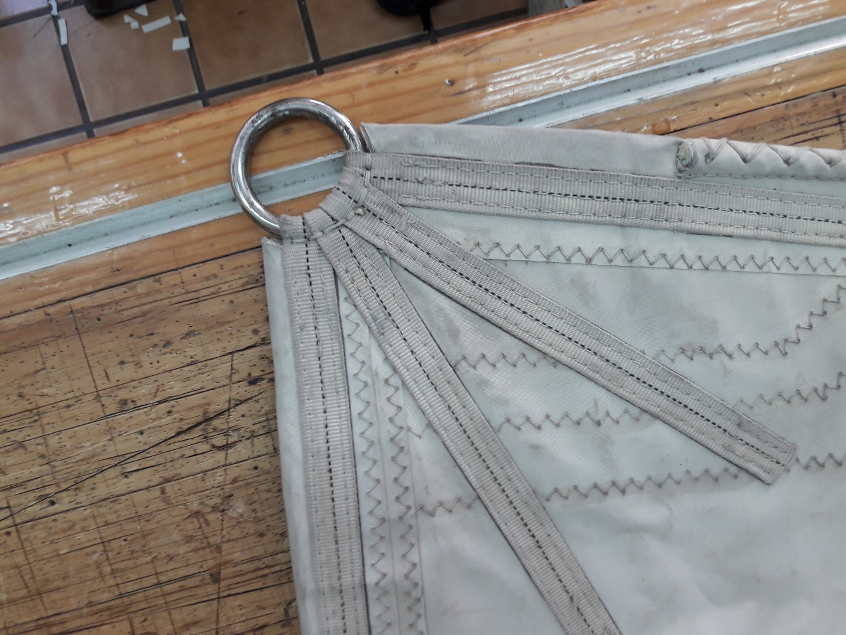

M3 CLEW
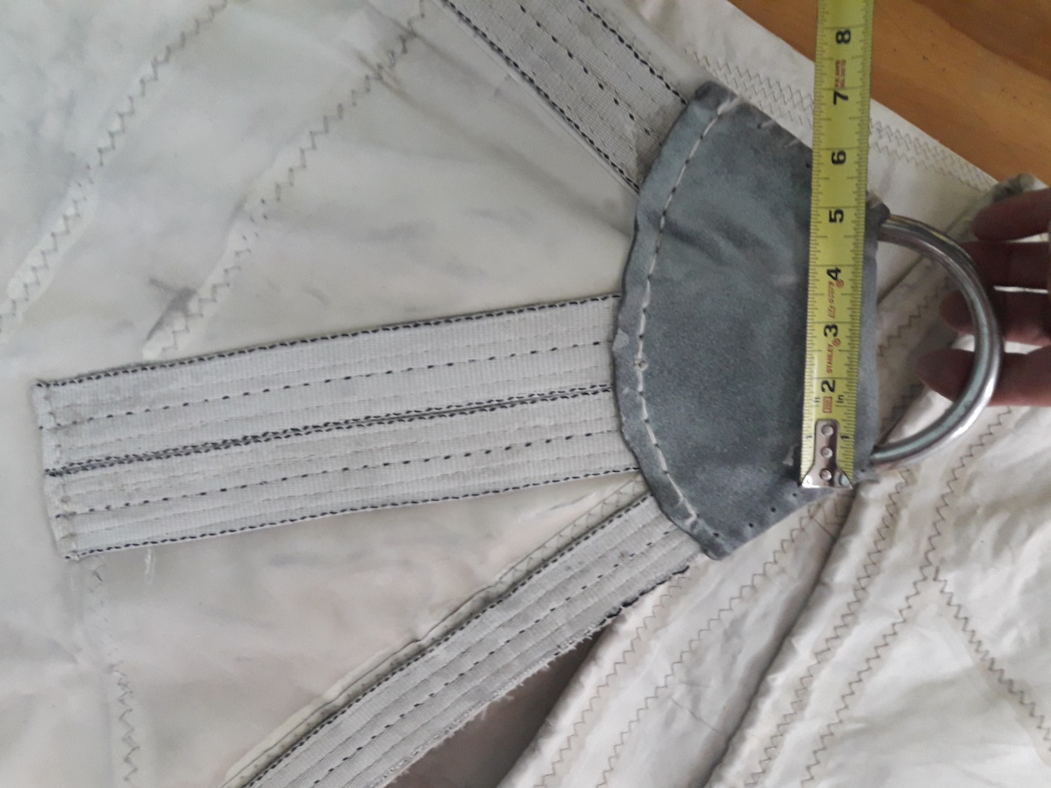

M7 HEADBOARD
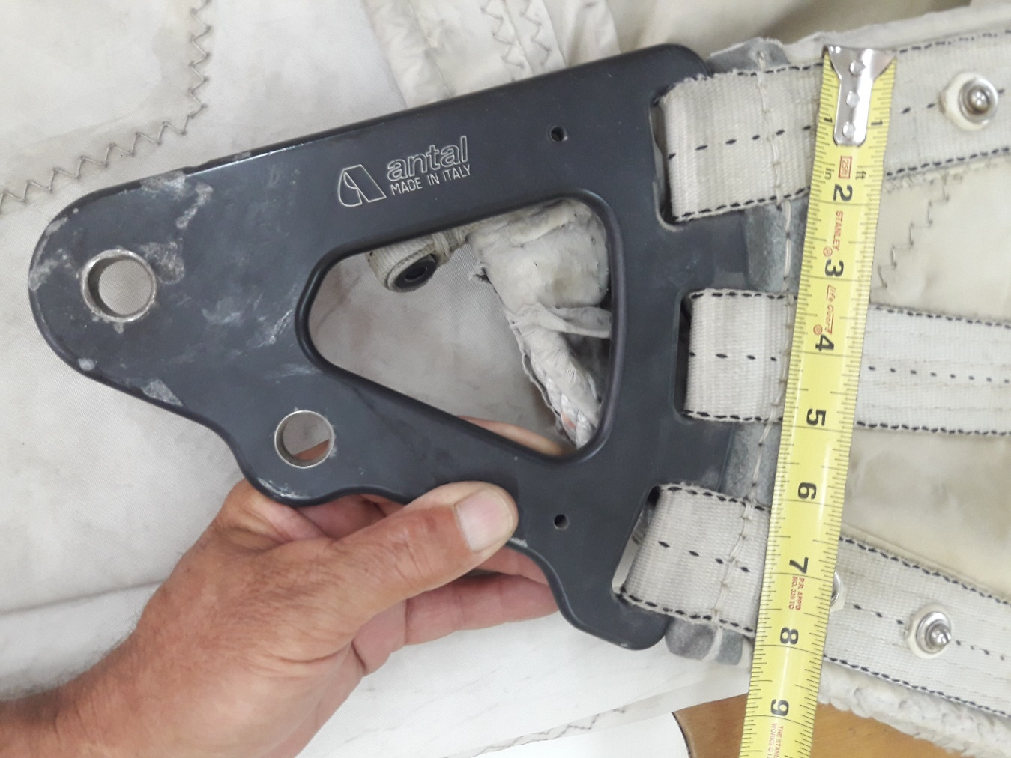

M11 TACK ANGLE
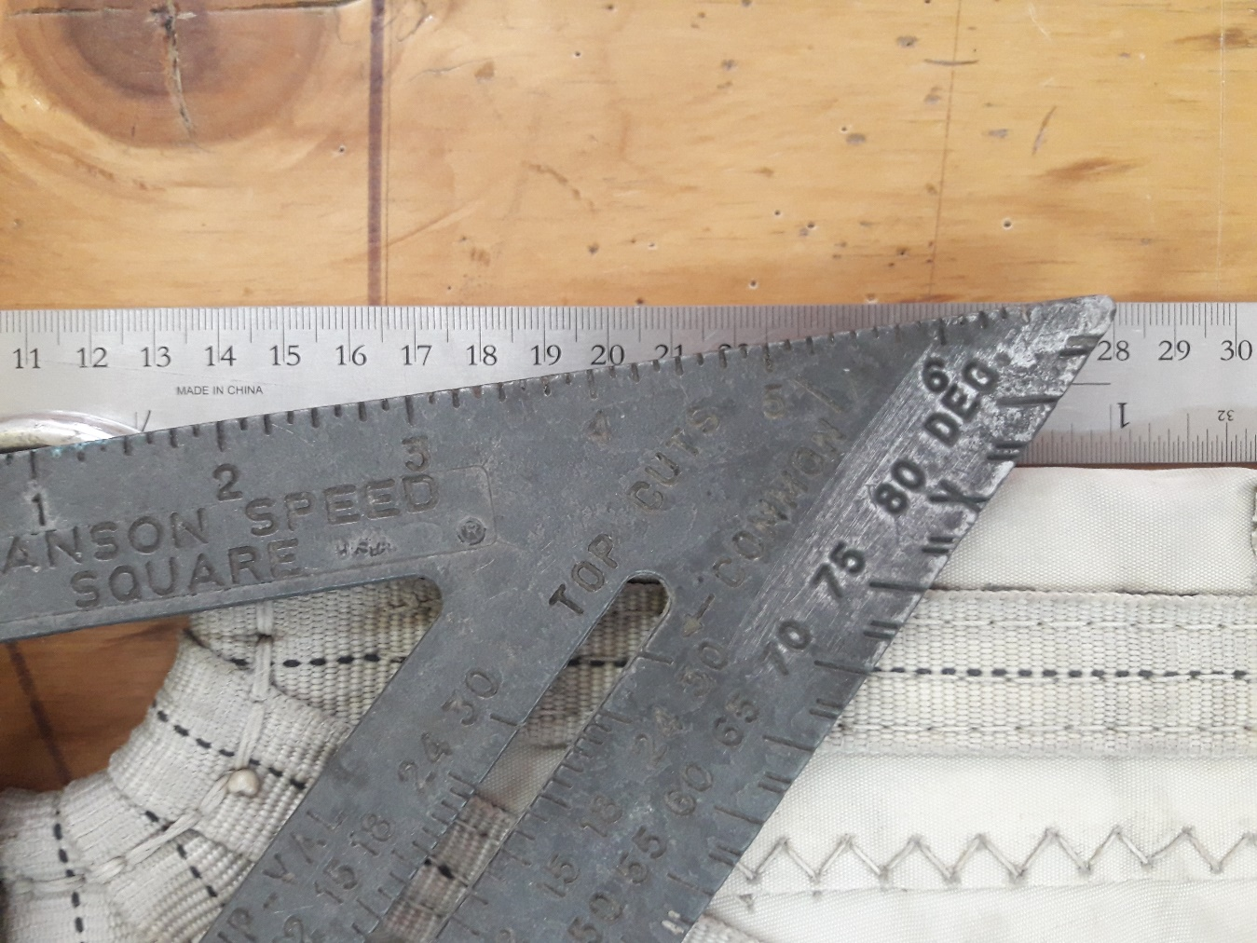

M24 FOOT ROUND
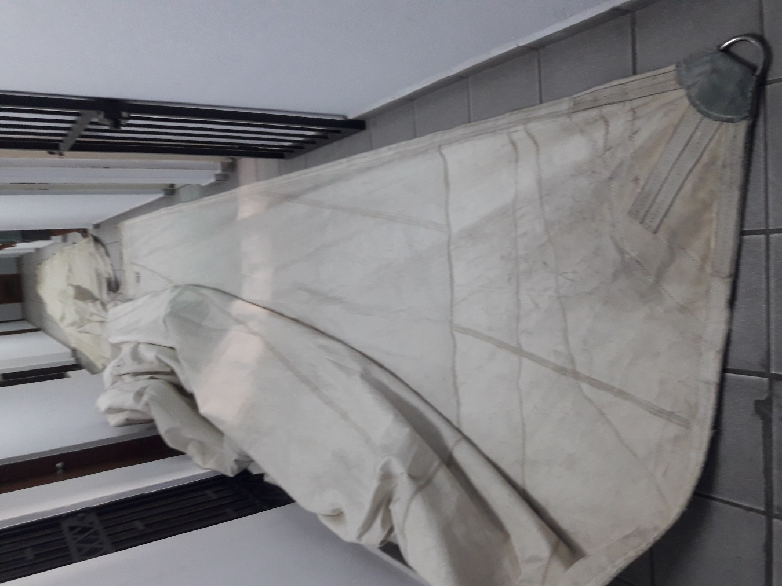

M27 LUFF SLIDES (6 slides) 8mm dia hole
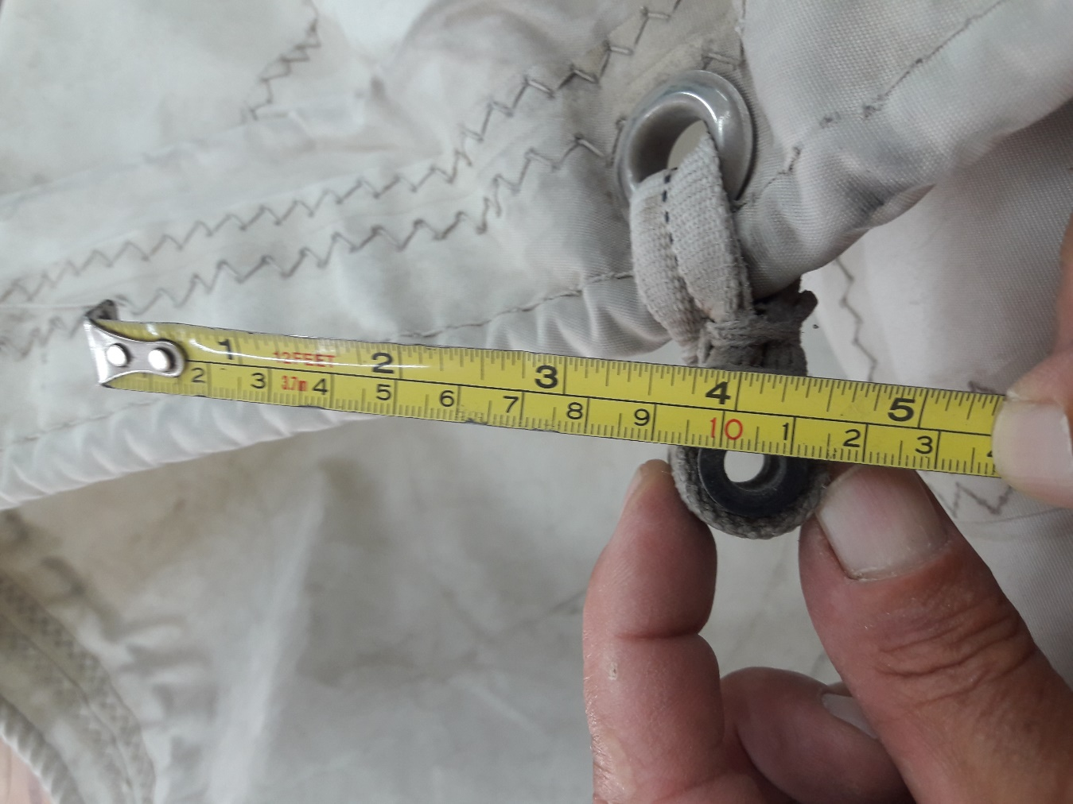

M35 NYLON BATTEN HOLDERS (NBH) SPACE
(Photo shows a very small overlap, creating a weak point in the sail. In my opinion, the overlap of the sleeve onto the reinforcement patch should be as much as possible.)
