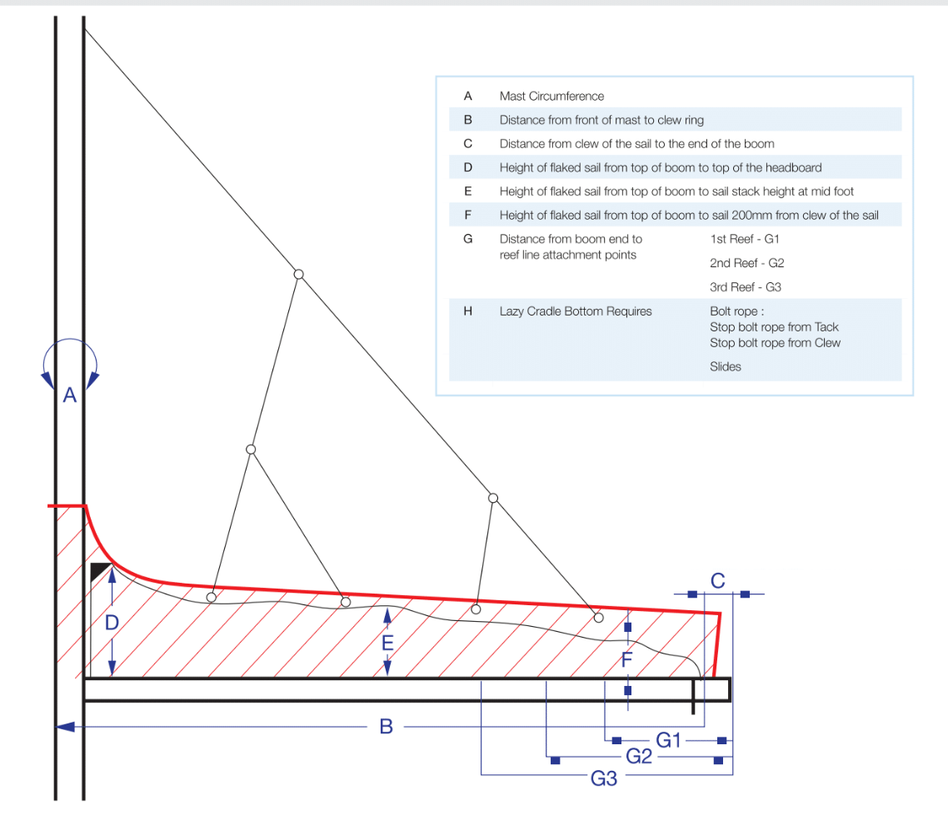
A: 700
B: 5980
C: 250
D: 860
E: 400
F: 250
G1: 930
G2: 1600
G3: Not Applicable (My Main sail has reef-1 & 2 only)

 | - Headsail - | 5000505 Hiroshi
H0 | Sail Layout | Not Yet Posted
H1 | Size of Headsail (110, 135, 150 etc.)" | LP = 5.02m | HELP
H2 | Luff Length, Max Hoist, B measurement | Maxluff is 15.69m which is shackle top of furling drum at bottom to shackle top of halyard swivel.  Netluff 15.49m is calculated to have 200mm luff stretch which is about 1.3%. I understand your suggestion for luff stretch assumption is 1.5%. I am OK to follow your suggestion.  I have attached my measurements “5000505 Hiroshi Salona41 measurements.pptx”. Please refer slide-1.  webbing loop tip to webbing loop tip (Max)  (Net Finished size day of delivery) | HELP
H3 | Leech Length | sailmaker | HELP
H4 | Foot Length | sailmaker | HELP
H5 | Tack and Head Fittings | Webbing Loops
H6 | Clew Type (Press ring or 0-Ring) | Press Ring | HELP
H7 | Leech Line | Yes
H8 | Reefs for Hank on Sail (specify Qty of tiedowns) | No Manual Reefs
H9 | Foot Line | Yes
H10 | Track 1 (Tack to Genoa Track Beginning) | I discussed with my partner. Our head sail is non-overlap. We believe sail crew position will be determined from LP and LuffLength so that Jib leader position is not required. I attached photo with our jib leader position.  We have tried our Heavy weather head sail which is smallest head sail for the test of this furling system. We were able to trim the head sail without any problem. | HELP
H11 | Track 2 (Tack to Genoa Track Ending) | Ditto | HELP
H12 | Vessel "I" Measurement | 15.80m | HELP
H13 | Vessel "J" Measurement | 4.80m | HELP
H14 | Calculated Forestay Length | Sailmaker
H15 | Reef | N/A
H16 | LP | 5.02m | HELP
H17 | Color of Suncover | Oyster | HELP
H18 | Side of Sail for Suncover (port or Stbd) | starboard
H19 | Luff Tape Size (such as #6) | #6 (Harken MKIV Unit2 installation manual page-6 says #6 luff tape. Installation manual is 6MB. Pls download from this url https://www.harken.com/gallery/08bc6cea-bc50-4a63-9762-d3d6a84c0ec8.pdf) | HELP
H20 | Furler Manufacturer | HARKEN
H21 | Foam Luff | Yes | HELP
H22 | Cut Type | Cross
H23 | Sail Area | Sailmaker
H24 | Telltails | Yes | HELP
H25 | Telltail Window | No
H26 | Triple Stitch | YES
H27 | Logo | No | HELP
H28 | Cloth Weight | 9.3oz Challenge Premium High Modulus Dacron
H29 | Sail Numbers and Color (red, blue or black) | No | HELP
H30 | Sheeting Stripe (red, blue, black) | No | HELP
H31 | Draft Stripe Color (red, blue or black) | Yes (Black) | HELP
H32 | Clew Height off Deck | sailmaker | HELP
H33 | Tack Height off Deck | 240 | HELP
H34 | Luff tape starts ??? up from Tack | I will follow your suggestion 18” before the tack | HELP
H35 | Specialty Sail | No | HELP
 | Customer Note: All details we can check as sailmakers are based on accurate vessel I and J Measurements |  | HELP

