H1 Size of Headsail (110, 135, 150 etc.): 105%
H2 Luff Length, Max Hoist, B measurement:
CAN'T MEASURE YET. WILL HAVE TO CLIMB TO THE MAST. TODAY I CAN INFORM THE FURLING BRAND AND MODEL.
H6 Clew Type (Press ring or 0-Ring): O-RING
H10 Track 1 (Tack to Genoa Track Beginning): 4.45 MT
H11 Track 2 (Tack to Genoa Track Ending) 4.80 MT

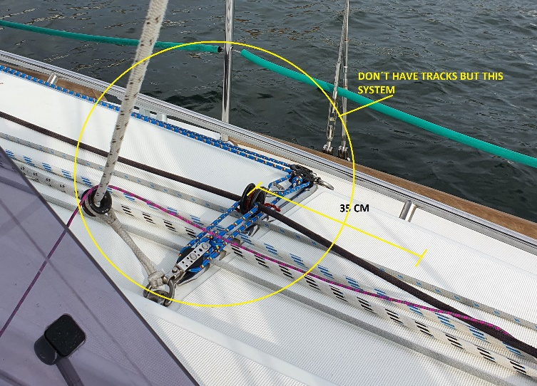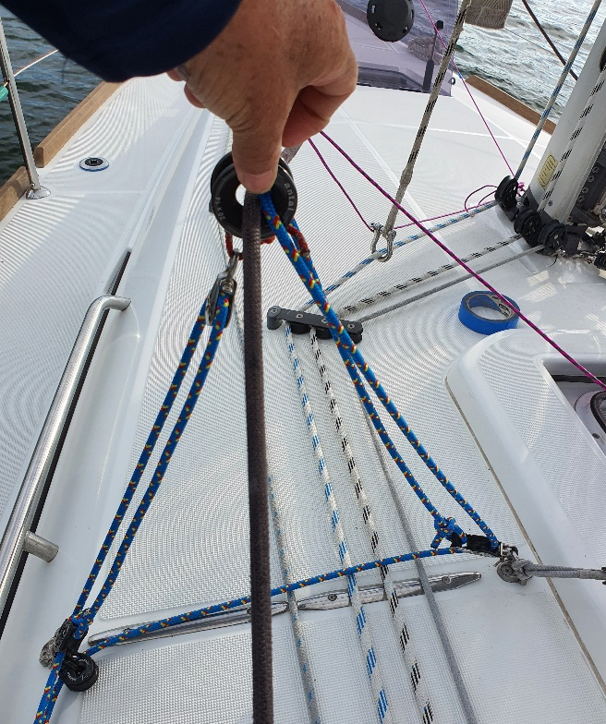

H17 Color of Sun cover: WHITE
H18 Side of Sail for Sun cover (port or Stbd): STBD (PHOTO)
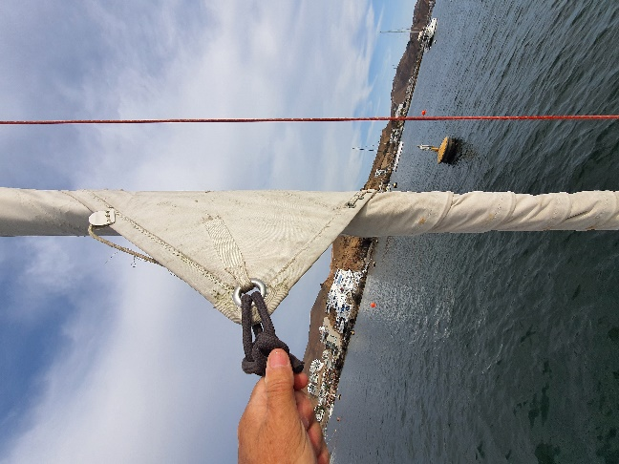

H19 Luff Tape Size (such as #6): YOUR STANDARD.
H20 Furler Manufacturer: FACNOR LS 130
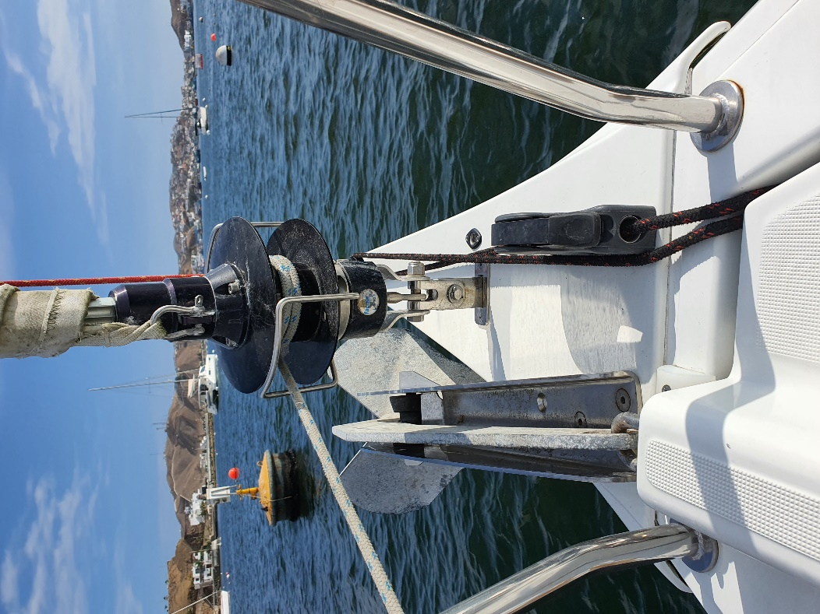

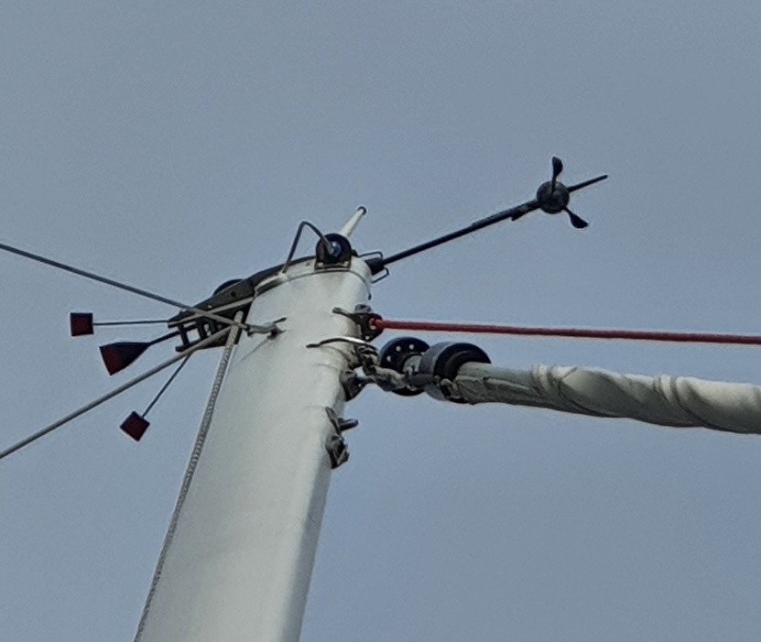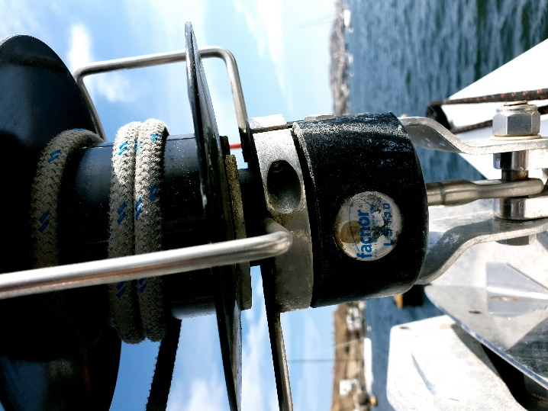

H25 Telltail Window: YES. PLEASE INCLUDE IN PRICE.
H31 Draft Stripe Color (red, blue, or black): BLACK

H32 Clew Height off Deck sailmaker: 38.0 CM
H33 Tack Height off Deck: 38.0 CM.
H34 Luff tape starts ??? up from Tack.: YOUR STANDARD.

