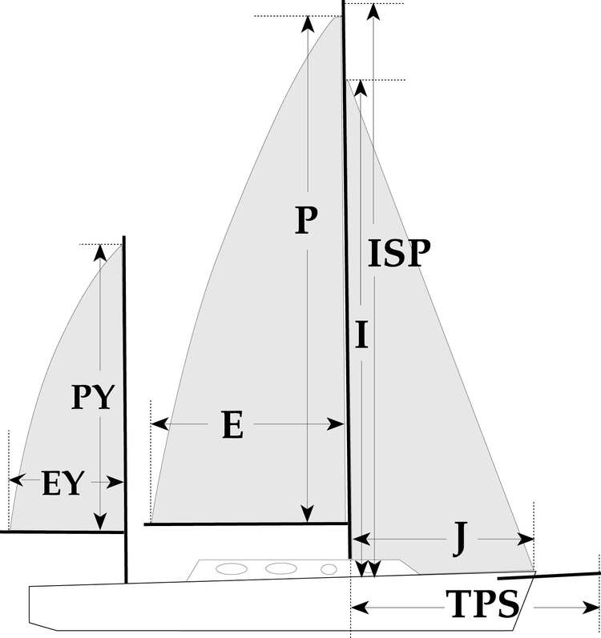

 | - - | 4000525 Stefan
S0 | Sail Layout | Not Yet Posted
S1 | Size of Headsail (110, 135, 150 etc.)" | Gennaker Code 0  Free Luff
S2 | Luff Length, Max Hoist, B measurement | 13.60m | HELP
S3 | Leech Length | sailmaker
S4 | Foot Length | sailmaker
S5 | Tack and Head Fittings | O-Rings
S6 | Vessel "ISP" Measurement | 14.8m (needs to be confirmed) | HELP
S7 | Vessel "TPS" Measurement | 4.80m (need to be confirmed) | HELP
S8 | Calculated Forestay Length | Sailmaker
S9 | Masthead or Fractional Spinnaker ? | Mast Head
S10 | Tack up for Code 0's | .45m
S11 | Correct Size for A/Spin or S/Spin | N/A
S12 | LP | Sailmaker | HELP
S13 | Cut Type | Full Radial
S14 | U/V Cover | N/A
S15 | Luff Type | Free  Will be used with:  BAMAR RollGen 10 furler
S16 | Furler Name | None
S17 | Sail Area | 62.01m2
S18 | Cloth Weight | 150 Maxlite
S19 | Sail Colors | To be provided | HELP
S20 | Sail Numbers and Color (red, blue or black) | No | HELP
S21 | Sail Logo | No
S22 | Sail Sock (White is std Color) | No
S23 | Sail Sock Length | N/A
S24 | Wire Size | N/A
S25 | Sail Sock Color |  | HELP
S26 | Specialty Sail |  | HELP
S27 | Score |  | HELP
 | Customer Note: All details we can check as sailmakers are based on accurate vessel I and J Measurements |  | HELP

