 | - Mainsail - | 4000523 Yngve
M0 | Sail Layout | Not Yet Posted
M1 | Tack Cut Back (Aft face of Mast to center of tack Pin - A) | 4.5in | HELP
M2 | Tack Cut Up (Top of Boom to Center of tack Pin - B) | 2.5in  Logo on tack  Blue 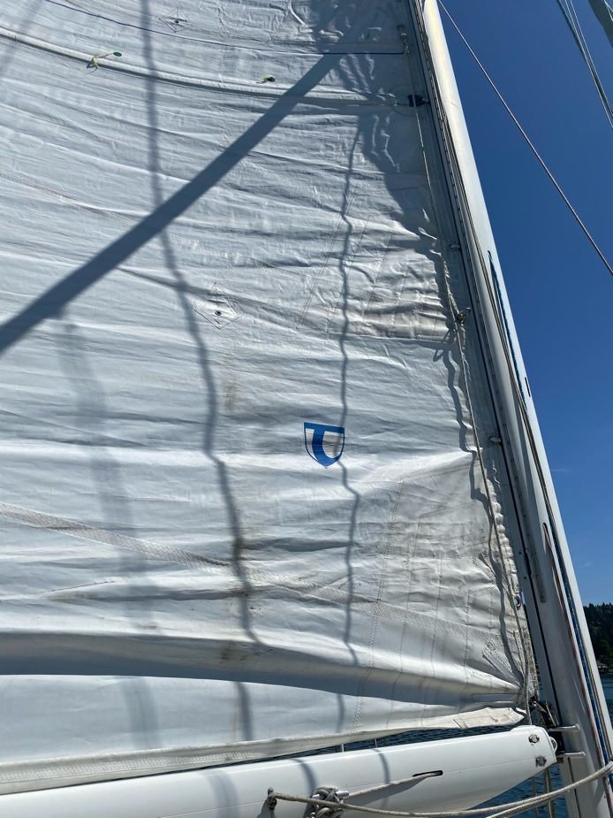 | HELP
M3 | Clew Cut Up (Top of Boom to Center of Tack Pin - X) | Loose Footed | HELP
M4 | Clew type (slug, outhaul car or ring with strap) | O ring with strap  Strap should be 2’6”. Boom is 7.5” in diameter. | HELP
M5 | Sunbrella clew cover for Furling Mains | na | HELP
M6 | Other Offsets |  | HELP
M7 | Headboard | Yes  6.5in  See pcitures | HELP
M8 | Leech Line | yes
M9 | Foot Line | No
M10 | Tack Ring Type | O ring | HELP
M11 | Tack angle | 88.5 see leech note | HELP
M12 | Jack Line | No | HELP
M13 | Mast Bend (Luff Round) | Std | HELP
M14 | Fractional Rig (Yes, No) | No | HELP
M15 | Mast - Keel or Deck Stepped? | Keel
M16 | Number of Reefs | 2 Reefs | HELP
M17 | Intermediate Reefing Diamond Eyes (Yes or No) | YES | HELP
M18 | Foot Reefing Grommets (next to boom) | N/A | HELP
M19 | Reefing Ring Type | Press Ring | HELP
M20 | Luff Length (Max Hoist - P) | (44.36Net Finished size day of Delivery) | HELP
M21 | Foot Length (Max Foot - E) | 15ft 1in Max  (Net Finished size day of Delivery) | HELP
M22 | Leech Length (straight line head to clew) | Sailmaker  - Note: With the Halyard 8” down from max hoist, a level boom(Measured with a leveler)has a leech of 46’10”. Boom at Max down position still clearing the Bimini the leech is 47’2.5”. As you can see in the attached photo, the boom with the current sail, is at a negative angle when the main sheet and Vang is pulled in max. Not sure what your recommendation is as far as what the Leech Length should be, so I included the above measurements. | HELP
M23 | Bimini to Clear (yes or no) | YES | HELP
M24 | Foot Round | Sailmaker
M25 | Aspect Ratio | Sailmaker | HELP
M26 | Vessel Backstay Measurement | 17’7.8” | HELP
M27 | Luff Slides (Part Number) | ??? | HELP
M28 | Foot Slides (Part Number) | Loose Footed | HELP
M29 | Roach Type | Cruise | HELP
M30 | Roach Factor | 1.1 | HELP
M31 | MGM | Sailmaker | HELP
M32 | MGU | Sailmaker | HELP
M33 | Batten Type (Partial or Full) | 4 Full | HELP
M34 | Include Battens | NO
M35 | Install Nylon Batten Holders | YES | HELP
M36 | Intermediate Sliders | YES | HELP
M37 | Cloth Weight | 8.18
M38 | Cut Type | Cross
M39 | Sail Area | Sailmaker
M40 | Cunningham | No | HELP
M41 | Telltails | Yes | HELP
M42 | Triple Stitch | Yes
M43 | Sail Logo and Color(red, blue or black) | YES – Blue  Logo with the 3700 | HELP
M44 | Sail Logo Artwork | N/A
M45 | Sail Numbers and Color | No | HELP
M46 | Draft Stripe and Color(red, blue or black) | Yes (blue) | HELP
M47 | Overhead Leech Line | No
M48 | Specialty Sail | No | HELP
M49 | Boom Cover | No | HELP
M50 | Lazy Bag | No | HELP

