 | - Mainsail - | 3001115 Greg
M0 | Sail Layout | Not Yet Posted
M1 | Tack Cut Back (Aft face of Mast to center of tack Pin - A) | 35mm | HELP
M2 | Tack Cut Up (Top of Boom to Center of tack Pin - B) | 20mm | HELP
M3 | Clew Cut Up (Top of Boom to Center of Tack Pin - X) | 25mm | HELP
M4 | Clew type (slug, outhaul car or ring with strap) | O ring with strap – 2ft 3in  3” maxi-ring with ring & bar diameter 11.1mm | HELP
M5 | Sunbrella clew cover for Furling Mains | na | HELP
M6 | Other Offsets |  | HELP
M7 | Headboard | 3” maxi-ring & bar (diameter 11.1 as clew ring above) | HELP
M8 | Leech Line | yes
M9 | Foot Line | No
M10 | Tack Ring Type | webbed maxi-ring (diameter 11.1 as above) | HELP
M11 | Tack angle | Luff Leech and Foot | HELP
M12 | Jack Line | No | HELP
M13 | Mast Bend (Luff Round) | Std | HELP
M14 | Fractional Rig (Yes, No) | Yes | HELP
M15 | Mast - Keel or Deck Stepped? | N/A
M16 | Number of Reefs | 3 Reefs | HELP
M17 | Intermediate Reefing Diamond Eyes (Yes or No) | Yes | HELP
M18 | Foot Reefing Grommets (next to boom) | N/A | HELP
M19 | Reefing Ring Type | 1st Floppy Ring 19cm  2nd Floppy Rings 23cm  3rd Floppy Ring 35.5cm | HELP
M20 | Luff Length (Max Hoist - P) | 47.335ft Max  (Sailmaker Net Finished size day of Delivery) | HELP
M21 | Foot Length (Max Foot - E) | 18ft Max  (Sailmaker Net Finished size day of Delivery) | HELP
M22 | Leech Length (straight line head to clew) | 49.755ft Max  (Sailmaker Net Finished size day of Delivery) | HELP
M23 | Bimini to Clear (yes or no) | N/A | HELP
M24 | Foot Round | Sailmaker
M25 | Aspect Ratio | Sailmaker | HELP
M26 | Vessel Backstay Measurement | Vessel has no backstay. Distance from back of mast to topping lift attachment point on boom end is 19’10.25” | HELP
M27 | Luff Slides (Part Number) | 6x 1601 Batten Holders | HELP
M28 | Foot Slides (Part Number) | Loose Footed | HELP
M29 | Roach Type | Sailmaker | HELP
M30 | Roach Factor | Sailmaker | HELP
M31 | MGM | 12ft 5.5in | HELP
M32 | MGU | 8ft 6.375in | HELP
M33 | Batten Type (Partial or Full) | 6 Full  Reinforcements on the back side of battens pockets | HELP
M34 | Include Battens | YES
M35 | Install Batten Holders | 1601 Batten Holders | HELP
M36 | Intermediate Sliders | Webbing Loops  1 intermediate car between foot and batten 1. 1 intermediate car between batten 1 and batten 2. (As counted up from tack). No other intermediate cars. | HELP
M37 | Cloth Weight | 393 Hydranet Radial - Tri Radial
M38 | Cut Type | Tri Radial
M39 | Sail Area | Sailmaker
M40 | Cunningham | No | HELP
M41 | Telltails | Yes | HELP
M42 | Triple Stitch | Yes
M43 | Sail Logo and Color(red, blue or black) | No | HELP
M44 | Sail Logo Artwork | N/A
M45 | Sail Numbers and Color | No | HELP
M46 | Draft Stripe and Color(red, blue or black) | Yes (Black) | HELP
M47 | Overhead Leech Line | YES - Over Head Leech line
M48 | Specialty Sail | No | HELP
M49 | Boom Cover | No | HELP
M50 | Lazy Bag | No | HELP

OTHER
- HEAD CAR. B = 0.9” D = 2.2”
- SLIDER. B = 1.25” D = 2.75”

(Only the last 1” of this is threaded for batten holder)

- Two intermediate cars (as noted in M36 above) do not connect to batten holders. They each lash to an eye in the mainsail luff (as supplied/shown on previous mainsail drawing).

 | - Headsail - | 3001115 Greg
H0 | Sail Layout | Not Yet Posted
H1 | Size of Headsail (110, 135, 150 etc.)" | Luff Leech and foot | HELP
H2 | Luff Length, Max Hoist, B measurement | 43ft webbing loop tip to webbing loop tip (Max)  (Sailmaker Net Finished size day of delivery) | HELP
H3 | Leech Length | 35.755ft | HELP
H4 | Foot Length | 19.550ft | HELP
H5 | Tack and Head Fittings | Webbing Loops
H6 | Clew Type (Press ring or 0-Ring) | Press Ring | HELP
H7 | Leech Line | Yes
H8 | Reefs for Hank on Sail (specify Qty of tiedowns) | No Manual Reefs
H9 | Foot Line | Yes
H10 | Track 1 (Tack to Genoa Track Beginning) | N/A | HELP
H11 | Track 2 (Tack to Genoa Track Ending) | N/A | HELP
H12 | Vessel "I" Measurement | N/A | HELP
H13 | Vessel "J" Measurement | N/A | HELP
H14 | Calculated Forestay Length | N/A
H15 | Reef | N/A
H16 | LP | Sailmaker | HELP
H17 | Color of Suncover | No UV Cover | HELP
H18 | Side of Sail for Suncover (port or Stbd) | Stbd
H19 | Luff Tape Size (such as #6) | 5mm finished | HELP
H20 | Furler Manufacturer | Profurl 430 (with 5mm finished luff tape)
H21 | Foam Luff | Yes | HELP
H22 | Cut Type | Tri Radial
H23 | Sail Area | Sailmaker
H24 | Telltails | Yes | HELP
H25 | Over head leech line | Yes - Over head leech line
H26 | Triple Stitch | YES
H27 | Logo | No | HELP
H28 | Cloth Weight | 343 Hydranet Radial
H29 | Sail Numbers and Color (red, blue or black) | No | HELP
H30 | Sheeting Stripe (red, blue, black) | No | HELP
H31 | Draft Stripe Color (red, blue or black) | Yes (Black) | HELP
H32 | Clew Height off Deck | sailmaker | HELP
H33 | Tack Height off Deck | 9’6” | HELP
H34 | Luff tape starts 16” up from Tack | 16” | HELP
H35 | Specialty Sail | No | HELP
 | Customer Note: All details we can check as sailmakers are based on accurate vessel I and J Measurements |  | HELP
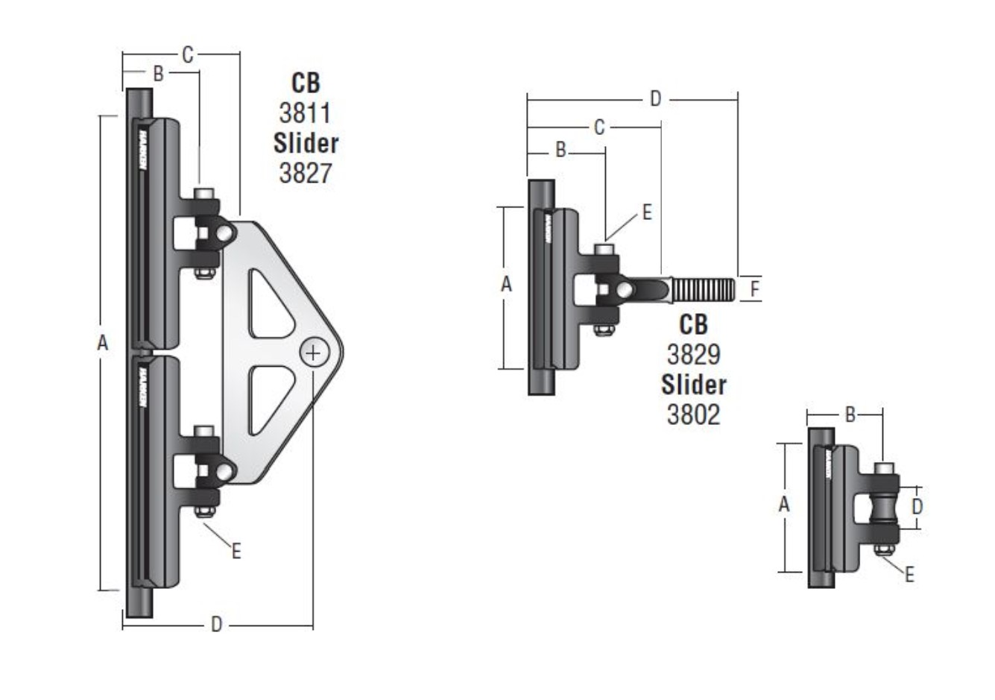

Head - Car: Need "B" an"D"
Batten Car: Need "B", "C" "D" and "F"
Intermediate Car: Need "B"

