 | - Mainsail - | 3001109 Michael
M0 | Sail Layout | Not Yet Posted
M1 | Tack Cut Back (Aft face of Mast to center of tack Pin - A) | 67mm | HELP
M2 | Tack Cut Up (Top of Boom to Center of tack Pin - B) | 23mm | HELP
M3 | Clew Cut Up (Top of Boom to Center of Tack Pin - X) | Metal Slug at clew (26mm center of pin but measurement not needed as metal slug? – see comments) | HELP
M4 | Clew type (slug, outhaul car or ring with strap) | Outhaul Car, see image in comments | HELP
M5 | Sunbrella clew cover for Furling Mains | na | HELP
M6 | Other Offsets |  | HELP
M7 | Headboard | Yes | HELP
M8 | Leech Line | yes
M9 | Foot Line | No
M10 | Tack Ring Type | Pressed Ring | HELP
M11 | Tack angle | 88.5 | HELP
M12 | Jack Line | No | HELP
M13 | Mast Bend (Luff Round) | Std | HELP
M14 | Fractional Rig (Yes, No) | No | HELP
M15 | Mast - Keel or Deck Stepped? | Deck
M16 | Number of Reefs | 3 Reefs | HELP
M17 | Intermediate Reefing Diamond Eyes (Yes or No) | Yes | HELP
M18 | Foot Reefing Grommets (next to boom) | Yes | HELP
M19 | Reefing Ring Type | Grommet through sail | HELP
M20 | Luff Length (Max Hoist - P) | 9.03 Max  (Net Finished size day of Delivery) | HELP
M21 | Foot Length (Max Foot - E) | 3.55m Max  (Net Finished size day of Delivery) | HELP
M22 | Leech Length (straight line head to clew) | Sailmaker | HELP
M23 | Bimini to Clear (yes or no) | N/A | HELP
M24 | Foot Round | Sailmaker
M25 | Aspect Ratio | Sailmaker | HELP
M26 | Vessel Backstay Measurement | 4.45 | HELP
M27 | Luff Slides (Part Number) | A014 | HELP
M28 | Foot Slides (Part Number) | Footed with Mainsail bolt rope finished size 10.92mm (part number HR6) | HELP
M29 | Roach Type | Cruise | HELP
M30 | Roach Factor | 1.07 | HELP
M31 | MGM | Sailmaker | HELP
M32 | MGU | Sailmaker | HELP
M33 | Batten Type (Partial or Full) | 4 Partial | HELP
M34 | Include Battens | YES
M35 | Install Nylon Batten Holders | N/A | HELP
M36 | Intermediate Sliders | N/A | HELP
M37 | Cloth Weight | 7.88
M38 | Cut Type | Cross
M39 | Sail Area | Sailmaker
M40 | Cunningham | No | HELP
M41 | Telltails | Yes | HELP
M42 | Triple Stitch | Yes
M43 | Sail Logo and Color(red, blue or black) | No | HELP
M44 | Sail Logo Artwork | N/A
M45 | Sail Numbers and Color | No | HELP
M46 | Draft Stripe and Color(red, blue or black) | Yes (Blue) | HELP
M47 | Overhead Leech Line | No
M48 | Specialty Sail | No | HELP
M49 | Boom Cover | No | HELP
M50 | Lazy Bag | No | HELP

 | - Headsail - | 3001109 Michael
H0 | Sail Layout | Not Yet Posted
H1 | Size of Headsail (110, 135, 150 etc.)" | Luff Leech and Foot | HELP
H2 | Luff Length, Max Hoist, B measurement | 10.85 webbing loop tip to webbing loop tip (Max)  (Net Finished size day of delivery) | HELP
H3 | Leech Length | 10.23m | HELP
H4 | Foot Length | 5.20m | HELP
H5 | Tack and Head Fittings | Webbing Loops
H6 | Clew Type (Press ring or 0-Ring) | Pressed Ring | HELP
H7 | Leech Line | Yes
H8 | Reefs for Hank on Sail (specify Qty of tiedowns) | No Manual Reefs
H9 | Foot Line | Yes
H10 | Track 1 (Tack to Genoa Track Beginning) | 4.10m | HELP
H11 | Track 2 (Tack to Genoa Track Ending) | 5.90 | HELP
H12 | Vessel "I" Measurement | 11.2 | HELP
H13 | Vessel "J" Measurement | 3.57 | HELP
H14 | Calculated Forestay Length | Sailmaker
H15 | Reef | N/A
H16 | LP | Sailmaker | HELP
H17 | Color of Suncover | Captain Navy | HELP
H18 | Side of Sail for Suncover (port or Stbd) | Port
H19 | Luff Tape Size (such as #6) | #7 | HELP
H20 | Furler Manufacturer | Sailspar
H21 | Foam Luff | YES | HELP
H22 | Cut Type | Cross
H23 | Sail Area | Sailmaker
H24 | Telltails | Yes | HELP
H25 | Telltail Window | No
H26 | Triple Stitch | YES
H27 | Logo | No | HELP
H28 | Cloth Weight
H29 | Sail Numbers and Color (red, blue or black) | No | HELP
H30 | Sheeting Stripe (red, blue, black) | No | HELP
H31 | Draft Stripe Color (red, blue or black) | Yes Blue | HELP
H32 | Clew Height off Deck | sailmaker | HELP
H33 | Tack Height off Deck | 26cm | HELP
H34 | Luff tape starts  up from Tack | 25cm | HELP
H35 | Specialty Sail | No | HELP
 | Customer Note: All details we can check as sailmakers are based on accurate vessel I and J Measurements |  | HELP

 | - Headsail - | 3001109 Michael
H0 | Sail Layout | Not Yet Posted
H1 | Size of Headsail (110, 135, 150 etc.)" | Luff Leech and Foot  Pistin Hanks | HELP
H2 | Luff Length, Max Hoist, B measurement | 10.25m (Max)  (Net Finished size day of delivery) | HELP
H3 | Leech Length | 8.89m | HELP
H4 | Foot Length | 4m | HELP
H5 | Tack and Head Fittings (Press ring or 0-Ring) | Press Ring
H6 | Clew Type (Press ring or 0-Ring) | Press Ring | HELP
H7 | Leech Line | Yes
H8 | Reefs for Hank on Sail (specify Qty of tiedowns) | No Manual Reefs
H9 | Foot Line | Yes
H10 | Track 1 (Tack to Genoa Track Beginning) | N/A | HELP
H11 | Track 2 (Tack to Genoa Track Ending) | N/A | HELP
H12 | Vessel "I" Measurement | N/A | HELP
H13 | Vessel "J" Measurement | N/A | HELP
H14 | Calculated Forestay Length | N/A
H15 | Reef | N/A
H16 | LP | N/A | HELP
H17 | Color of Suncover | N/A | HELP
H18 | Side of Sail for Suncover (port or Stbd) | N/A
H19 | Luff Tape Size (such as #6) | Size of Forestay Wire = 6mm | HELP
H20 | Furler Manufacturer | N/A
H21 | Foam Luff | N/A | HELP
H22 | Cut Type | Cross
H23 | Sail Area | Sailmaker
H24 | Telltails | Yes | HELP
H25 | Telltail Window | No
H26 | Triple Stitch | YES
H27 | Logo | No | HELP
H28 | Cloth Weight | 9.88
H29 | Sail Numbers and Color (red, blue or black) | No | HELP
H30 | Sheeting Stripe (red, blue, black) | No | HELP
H31 | Draft Stripe Color (red, blue or black) | Yes (Blue) | HELP
H32 | Clew Height off Deck | sailmaker – see comments | HELP
H33 | Tack Height off Deck | 40cm | HELP
H34 | Luff tape starts N/A up from Tack | N/A | HELP
H35 | Specialty Sail | No | HELP
 | Customer Note: All details we can check as sailmakers are based on accurate vessel I and J Measurements |  | HELP

Comments:
- 'M3' – Picture of outhaul car to make sure I have understood correctly
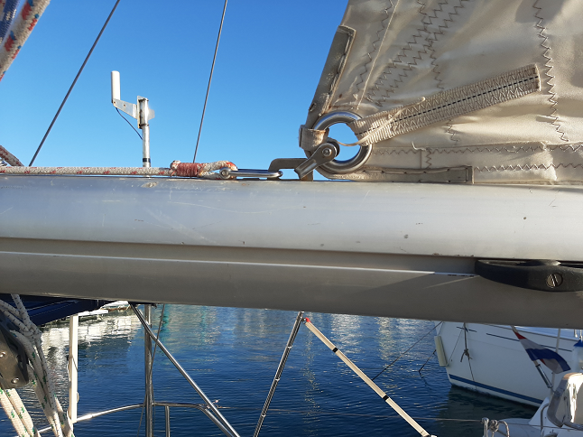
- 'H19' for furling genoa – Picture of Luff Tape Size being measured to make sure I have understood correctly, measurement was about 6.7 mm so #7 correct
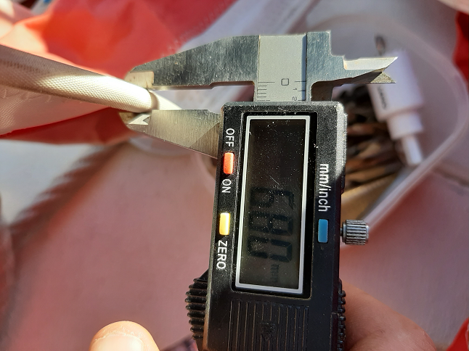
- Some of the Sail luff, leach and foots have been fine tuned after another re-measure, these are in the same red color
- Regarding H32 for hannked on sail – Tack of Height off Deck
  - A removable new inner forestay is being installed
  - The Sail tack will be 2.6 from the mast (0.97m back from current genoa tack)
  - The sail head will be approx. 15cm from the top of the mast (effectively giving a I measurement of 11.05 for this sail)
  - Allowing for connections and tensioning blocks etc the distance between the top tackle and bottom tackle will be 10.7, the luff of the sail is 10.25 so there is some room for movement
  - The existing genoa tracks and cars will be used for the new sail
  - It would be good if the sailmaker could work out the clew height with a tack height of 40cm

