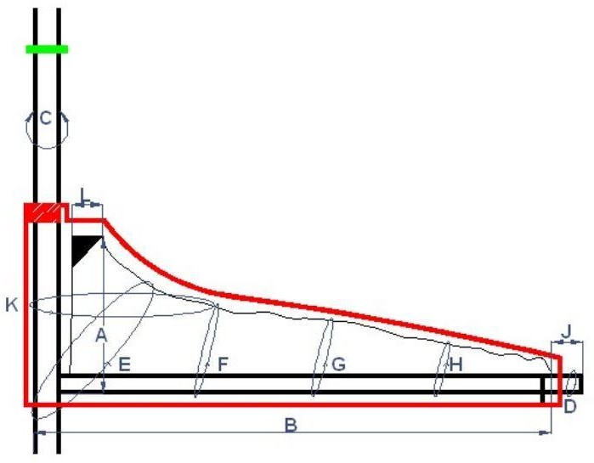

|  |
| --- |
| ・A |
| ・C |
| ・E |
| ・G |
| ・I |

|  |
| --- |
| 3100mm |
| 370mm |
| 1100mm |
| 600mm |
| 280mm |

|  |  |
| --- | --- |
| 650mm | ・B |
| 380mm | ・D |
| 1800mm | ・F |
| 1000mm | ・H |
| 220mm | ・J |