 | - Mainsail - | 3000717 Michael
M0 | Sail Layout | Not Yet Posted
M1 | Tack Cut Back (Aft face of Mast to center of tack Pin - A) | 40mm | HELP
M2 | Tack Cut Up (Top of Boom to Center of tack Pin - B) | 3mm | HELP
M3 | Clew Cut Up (Top of Boom to Center of Tack Pin - X) | 35mm, | HELP
M4 | Clew type (slug, outhaul car or ring with strap) | Press Ring with A Shackle | HELP
M5 | Sunbrella clew cover for Furling Mains | na | HELP
M6 | Other Offsets |  | HELP
M7 | Headboard | Yes | HELP
M8 | Leech Line | yes
M9 | Foot Line | No
M10 | Tack Ring Type | Pressed | HELP
M11 | Tack angle | 88.5 | HELP
M12 | Jack Line | No | HELP
M13 | Mast Bend (Luff Round) | Std | HELP
M14 | Fractional Rig (Yes, No) | Yes 7/8 see photo 1 | HELP
M15 | Mast - Keel or Deck Stepped? | Deck stepped
M16 | Number of Reefs | 1 Reef | HELP
M17 | Intermediate Reefing Diamond Eyes (Yes or No) | Yes | HELP
M18 | Foot Reefing Grommets (next to boom) | No | HELP
M19 | Reefing Ring Type | Press Ring | HELP
M20 | Luff Length (Max Hoist - P) | 6.4m Max  (Net Finished size day of Delivery) | HELP
M21 | Foot Length (Max Foot - E) | 2.3m Max  (Net Finished size day of Delivery) | HELP
M22 | Leech Length (straight line head to clew) | Sailmaker | HELP
M23 | Bimini to Clear (yes or no) |  | HELP
M24 | Foot Round | Sailmaker
M25 | Aspect Ratio | Sailmaker | HELP
M26 | Vessel Backstay Measurement | 3.2m | HELP
M27 | Luff Slides (Part Number) | A018  Slides start 210mm from tack | HELP
M28 | Foot Slides (Part Number) | HR6  Foot bolt rope starts from tack at 115mm | HELP
M29 | Roach Type | Cruise | HELP
M30 | Roach Factor | 1.07 | HELP
M31 | MGM | Sailmaker | HELP
M32 | MGU | Sailmaker | HELP
M33 | Batten Type (Partial or Full) | 4 Partial | HELP
M34 | Include Battens | YES
M35 | Install Nylon Batten Holders | N/A | HELP
M36 | Intermediate Sliders | N/A | HELP
M37 | Cloth Weight | 5.93
M38 | Cut Type | Cross
M39 | Sail Area | Sailmaker
M40 | Cunningham | No | HELP
M41 | Telltails | Yes | HELP
M42 | Triple Stitch | Yes
M43 | Sail Logo and Color(red, blue or black) | No | HELP
M44 | Sail Logo Artwork | N/A
M45 | Sail Numbers and Color | No | HELP
M46 | Draft Stripe and Color(red, blue or black) | Yes: Black | HELP
M47 | Overhead Leech Line | No
M48 | Specialty Sail | No | HELP
M49 | Boom Cover | No | HELP
M50 | Lazy Bag | No | HELP

See above 7/8 rig, deck stepped mast
\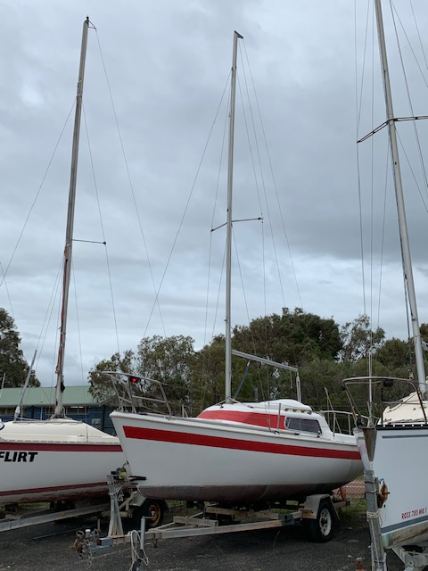
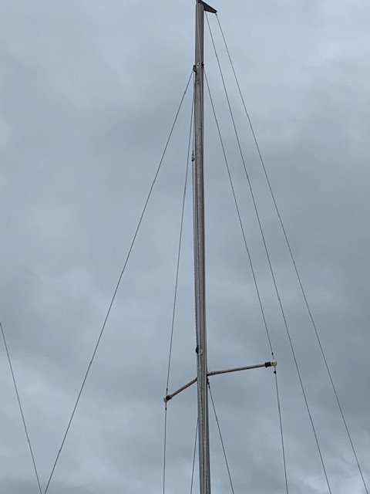
(2) Below: gooseneck arrangement 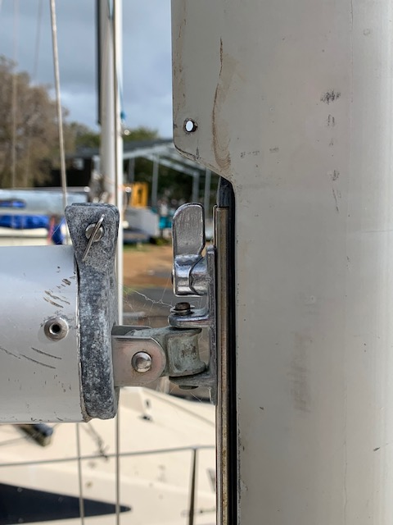
Bolt rope slides into pin

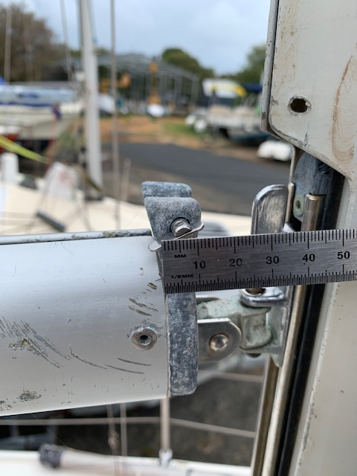

(3) showing distance of M3 on the sail data sheet.

(4) The mainsail uses a bolt rope currently to attach to the boom.
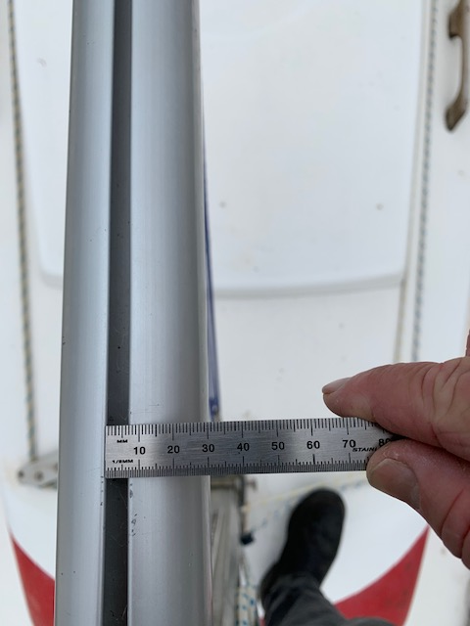

(5) bolt rope at the foot of the sail.

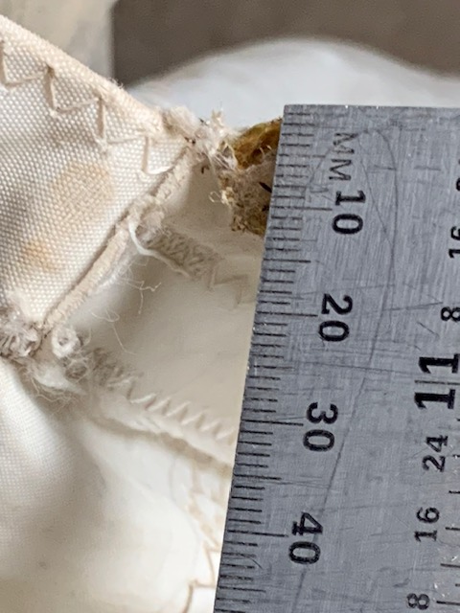
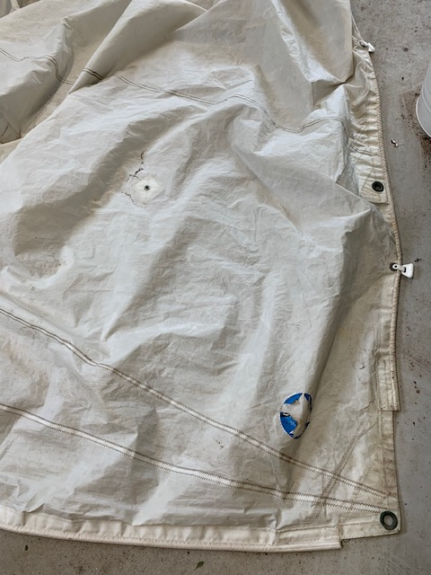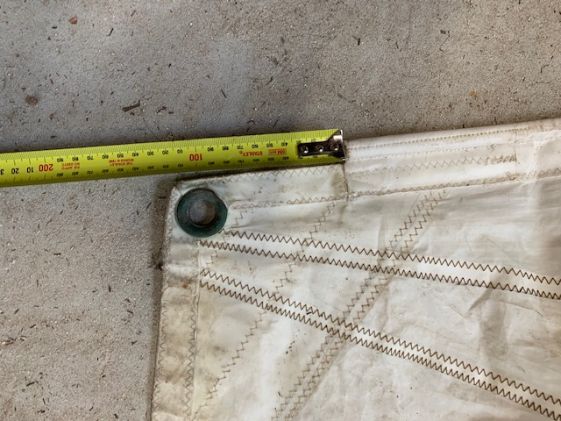
Luff
Foot
Foot bolt rope to luff 115mm

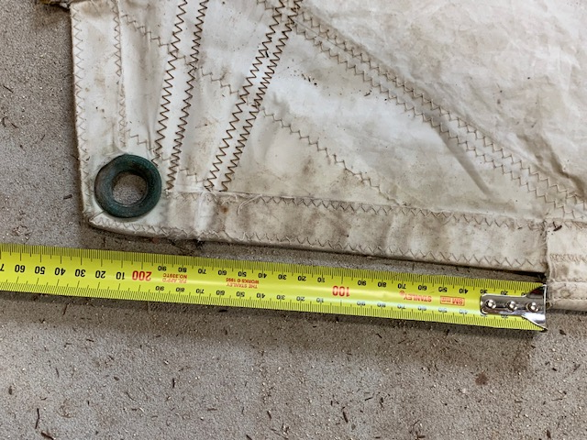
Luff measurement from bolt rope to foot (if it is of any use)!

