Table of Content:
a) for orientation the first pages show pictures o Old Lazy Bags
b) information on the design for new Lazy Bags

a) for orientation the first pages show pictures o Old Lazy Bags

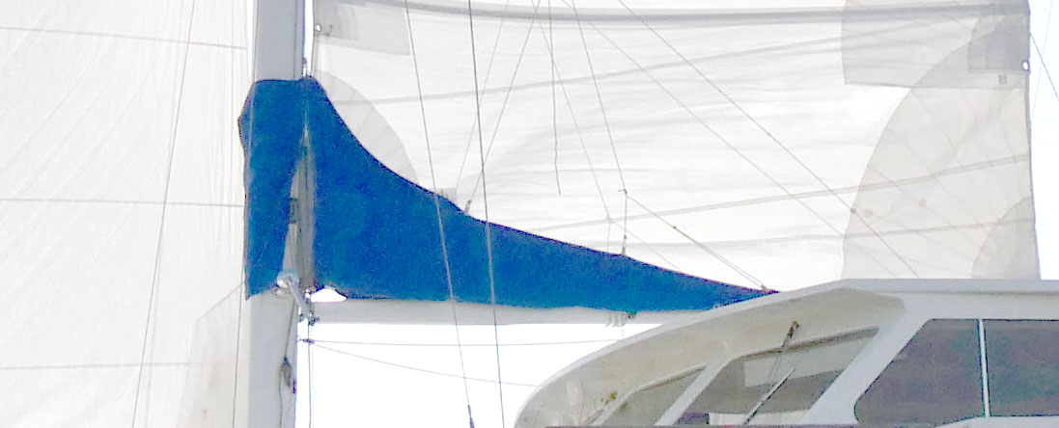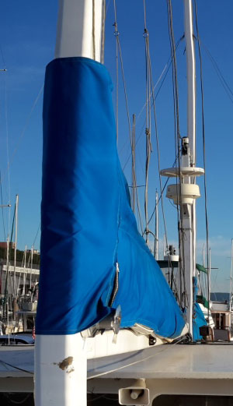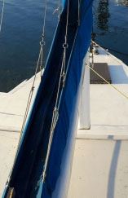
Side View Front, with winch Top view, battons, zipper

b) information on the design for new Lazy Bags

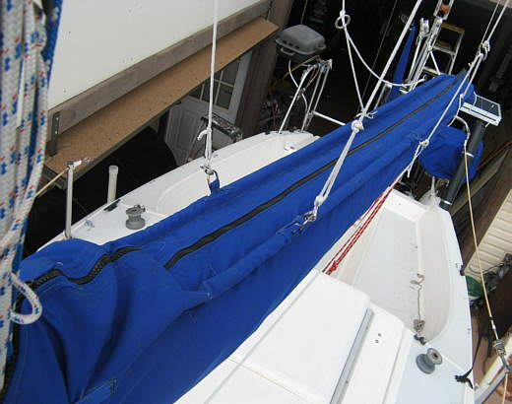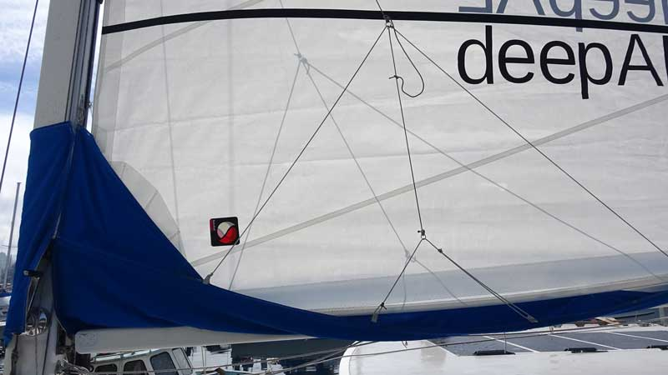
Top, battons, zipper, rings for Lazy Jack System 4 rings and ropes connect to Lazy Jack System

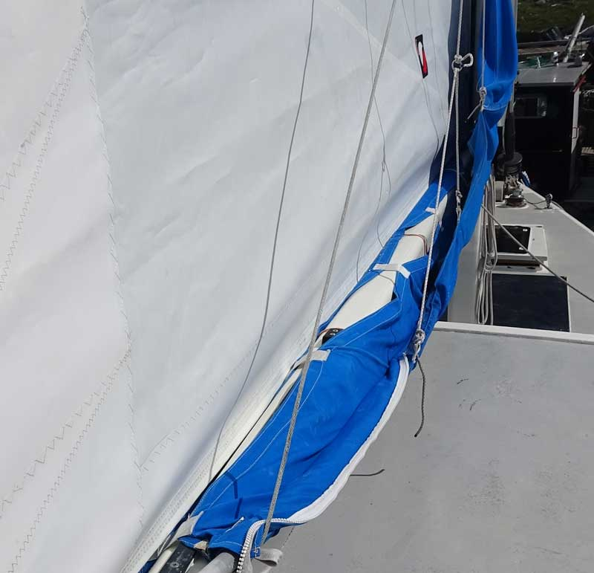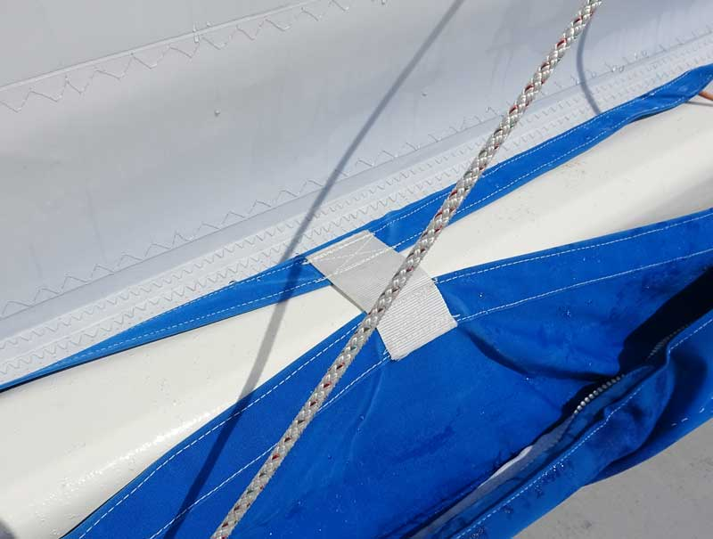
Loose sail, the bottom is semi closed. Connected by webbings approx. 4 cm long on top, 22cm long on each side underneath, with 12cm Velcro on each side to pull strap lazy bag system to boom, without injuring the wood.
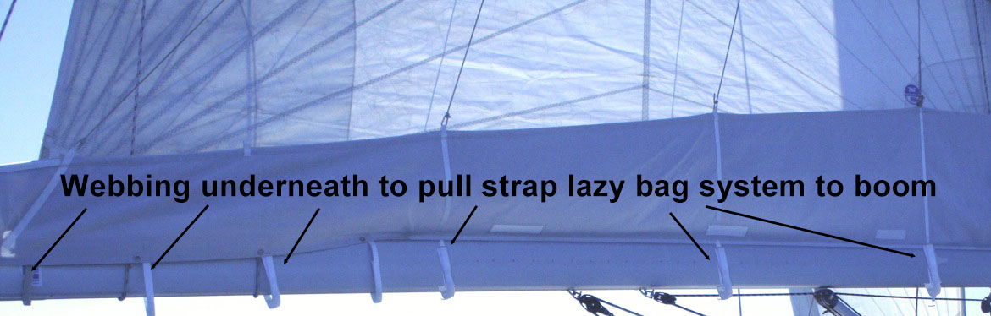

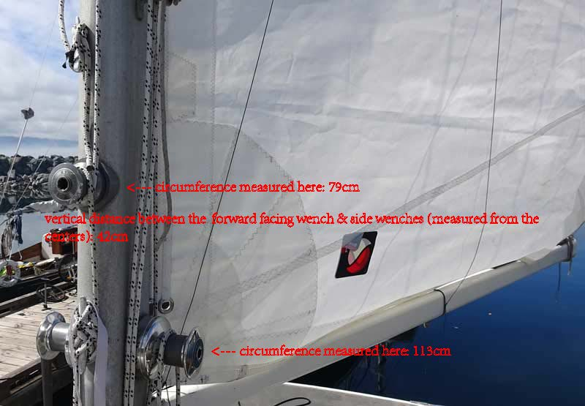
Mizzen Lazy Bag Front needs to be wider to include room for winches

Lazy Bag Main Sail
Lazy Bag – Color Granite Sunbrella UV Cover
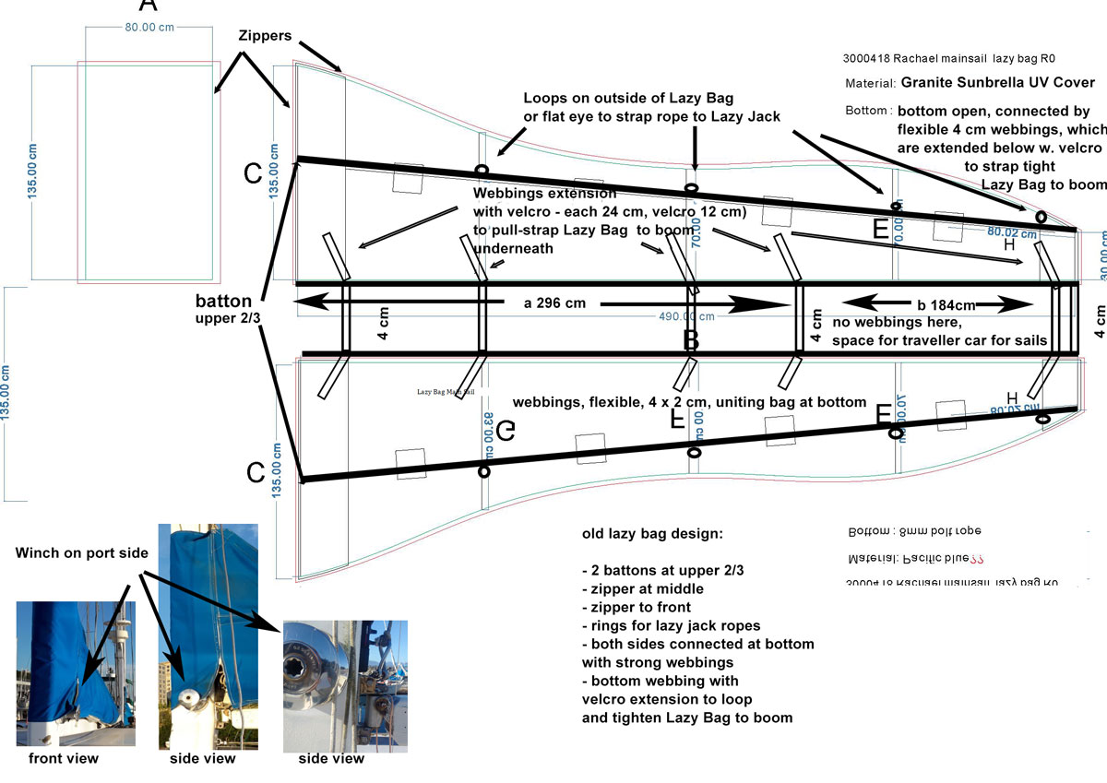

Lazy Bag Mizzen Sail
Lazy Bag – Color Granite Sunbrella UV Cover
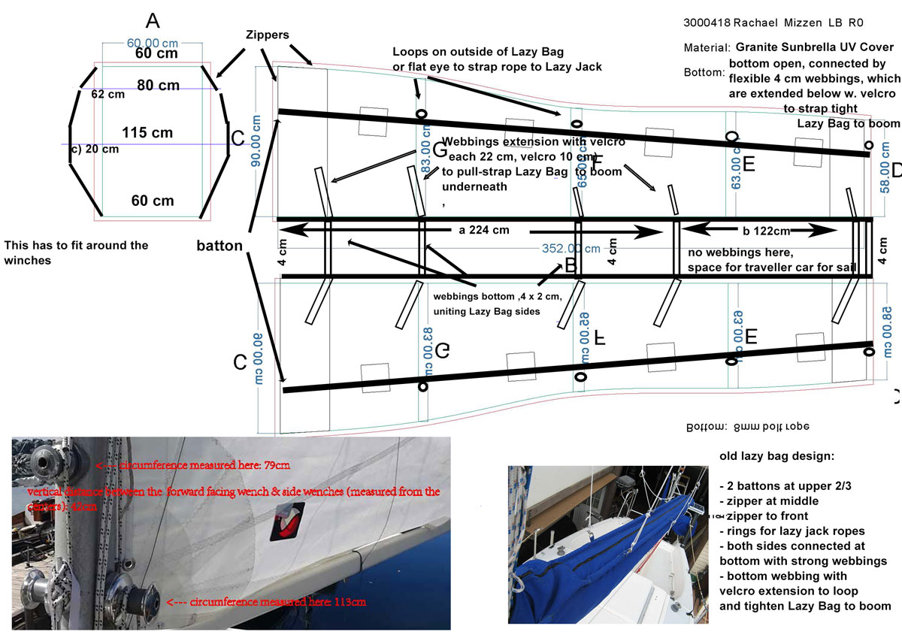

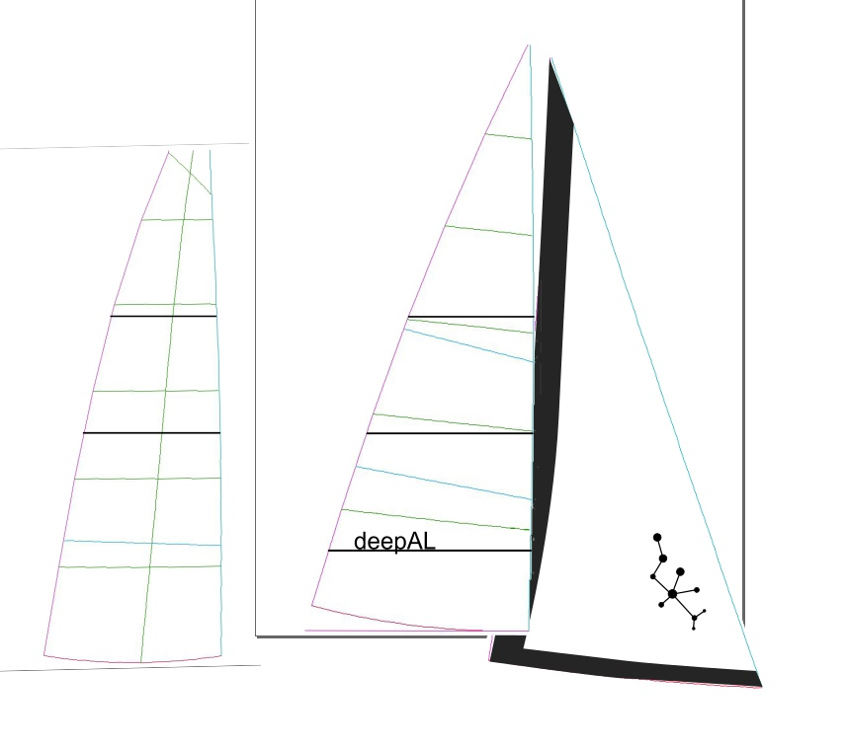
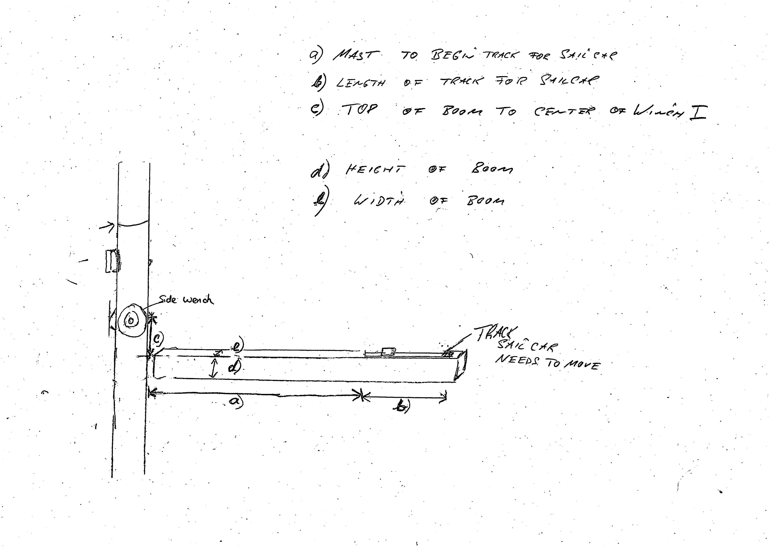
measurements for Mizzen and Main
- Distance: mast to beginning of track for boom-traveller (black track) | Mizzen:  - 2238mm.  (b) 1221mm.  (c) 192mm.  (d) 115mm fat part in middle.  (e) 83mm. | Main  - 2960mm.  (b) 1840mm.  (c) 59mm.  (d) 148mm.  (e) 106mm.
- Length of track for boom-traveller
- Distance: Top of Boom to center of Side-Winch
- Height of Boom
- Width of Boom

