 | - Mainsail - | 3000414 Luke
M0 | Sail Layout | Not Yet Posted
M1 | Tack Cut Back (Aft face of Mast to center of tack Pin - A) | 45mm | HELP
M2 | Tack Cut Up (Top of Boom to Center of tack Pin - B) | 40mm | HELP
M3 | Clew Cut Up (Top of Boom to Center of Tack Pin - X) | 35mm | HELP
M4 | Clew type (slug, outhaul car or ring with strap) | Ring & Strap | HELP
M5 | Sunbrella clew cover for Furling Mains | na | HELP
M6 | Other Offsets | A = 45 mm (Reefing hook cut back)  B = 40mm (reefing hook cut up)  D= 140mm boom groove cut back | HELP
M7 | Headboard | Yes | HELP
M8 | Leech Line | yes
M9 | Foot Line | No
M10 | Tack Ring Type | Press Ring | HELP
M11 | Tack angle | 88.5 | HELP
M12 | Jack Line | No | HELP
M13 | Mast Bend (Luff Round) | Std | HELP
M14 | Fractional Rig (Yes, No) | Yes | HELP
M15 | Mast - Keel or Deck Stepped? | Deck Stepped
M16 | Number of Reefs | 2 Reefs | HELP
M17 | Intermediate Reefing Diamond Eyes (Yes or No) | Yes | HELP
M18 | Foot Reefing Grommets (next to boom) | N/A | HELP
M19 | Reefing Ring Type | Press ring | HELP
M20 | Luff Length (Max Hoist - P) | 8530mm  Max  (Net Finished size day of Delivery) | HE8LP
M21 | Foot Length (Max Foot - E) | 3110mm  Max  (Net Finished size day of Delivery) | HELP
M22 | Leech Length (straight line head to clew) | Sailmaker | HELP
M23 | Bimini to Clear (yes or no) | N/A | HELP
M24 | Foot Round | Sailmaker
M25 | Aspect Ratio | Sailmaker | HELP
M26 | Vessel Backstay Measurement | 3800mm | HELP
M27 | Luff Slides (Part Number) | ??? (TBA) | HELP
M28 | Foot Slides (Part Number) | Fixed foot bolt rope | HELP
M29 | Roach Type | Racer/Cruiser | HELP
M30 | Roach Factor | 1.09 | HELP
M31 | MGM | Sailmaker | HELP
M32 | MGU | Sailmaker | HELP
M33 | Batten Type (Partial or Full) | 4 partial | HELP
M34 | Include Battens | Yes
M35 | Install Nylon Batten Holders | N/A | HELP
M36 | Intermediate Sliders | N/A | HELP
M37 | Cloth Weight | 5.93
M38 | Cut Type | Cross
M39 | Sail Area | Sailmaker
M40 | Cunningham | No | HELP
M41 | Telltails | Yes | HELP
M42 | Triple Stitch | Yes
M43 | Sail Logo and Color(red, blue or black) | No | HELP
M44 | Sail Logo Artwork | N/A
M45 | Sail Numbers and Color | SIN711 (Red colour) | HELP
M46 | Draft Stripe and Color(red, blue or black) | Yes (Black) | HELP
M47 | Overhead Leech Line | No
M48 | Specialty Sail | No | HELP
M49 | Boom Cover | Yes (Red) | HELP
M50 | Lazy Bag | No | HELP

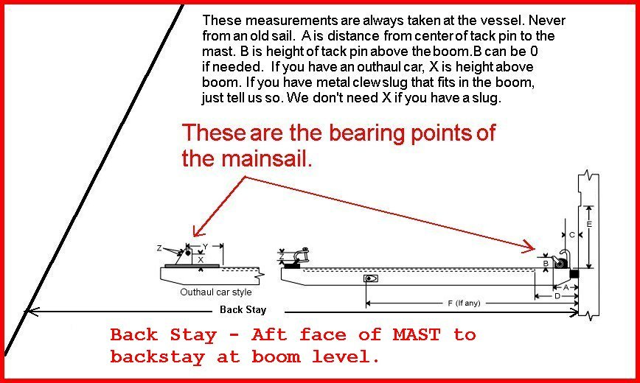

A = 45 mm
B = 40 mm
C = Flexible reefing horns (see photo)
D = 140 mm
E = 310 mm
F =
Backstay = 3800 mm
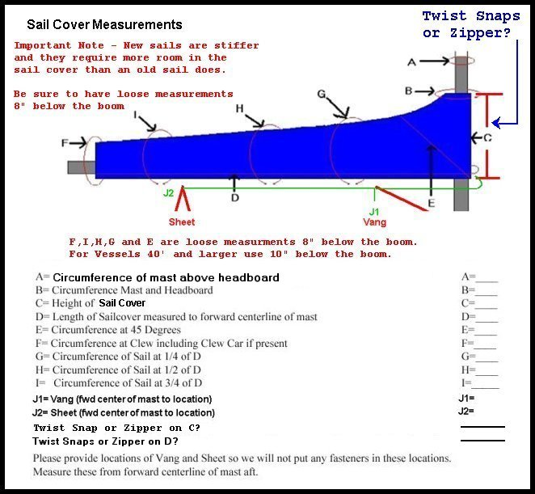

A = 320 mm
B =
C = 420 mm
D = 3260 mm
E = 680 mm
F = 900 mm
G = 1050 mm
H = 1020 mm
I = 980 mm
J1 = 950 mm
J2 = (at end of boom. No issue for fasteners)
Old Mainsail Measurements

9000mm
8320 mm (not under sailing load)

3020 mm (not under sailing load)

Factory Specifications Mainsail Measurements
9120 mm
8500 mm
3200 mm
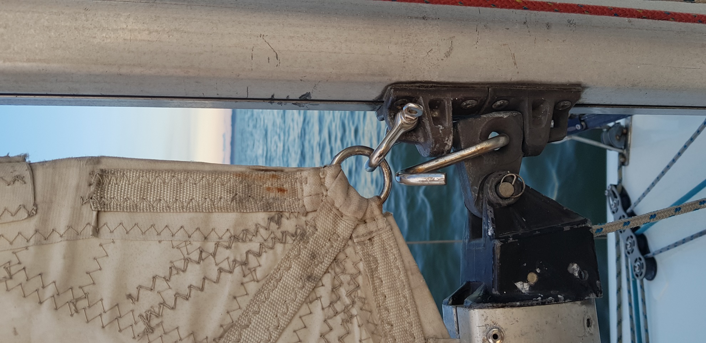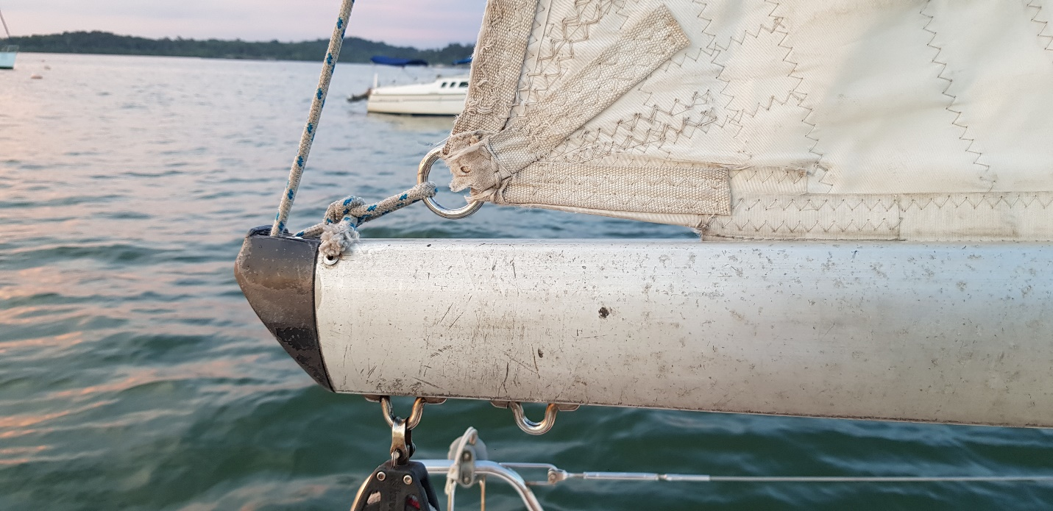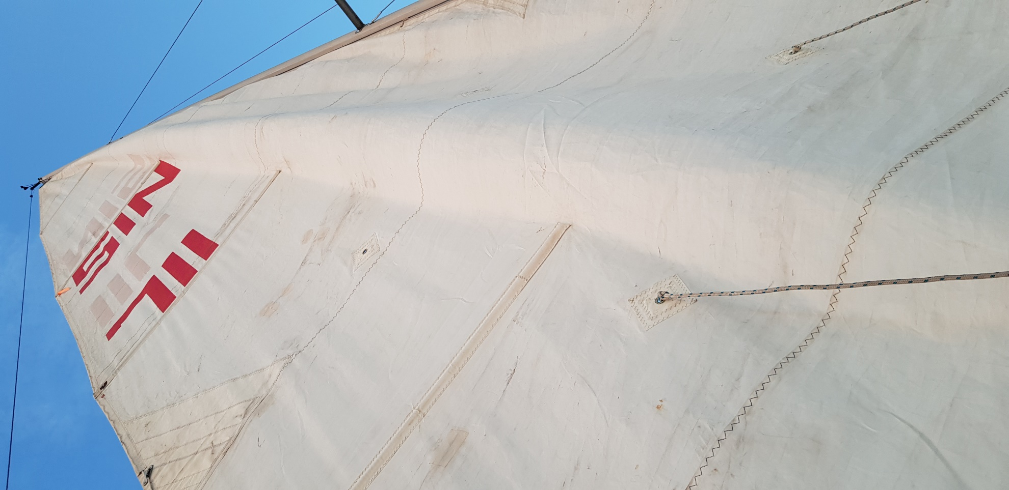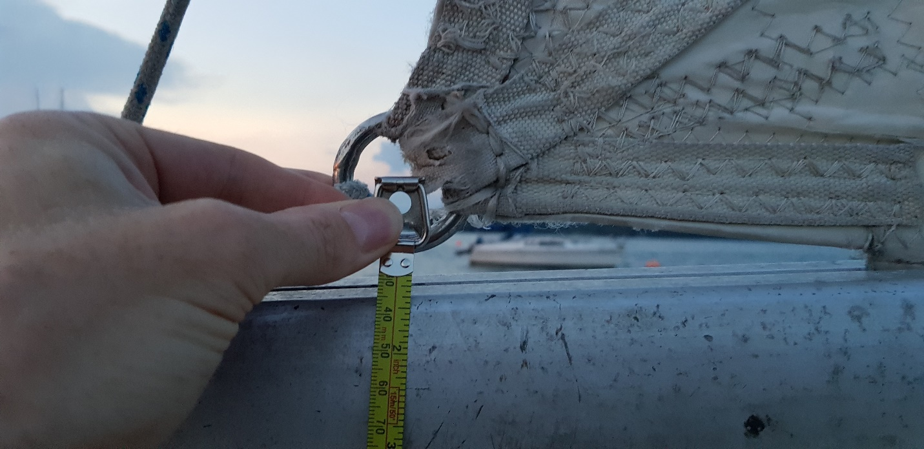
Clew attachment

