 | - Mainsail - | 3000409 Brian
M0 | Sail Layout | Not Yet Posted
M1 | Tack Cut Back (Aft face of Mast to center of tack Pin - A) | 46mm | HELP
M2 | Tack Cut Up (Top of Boom to Center of tack Pin - B) | 30mm | HELP
M3 | Clew Cut Up (Top of Boom to Center of Tack Pin - X) | 45mm | HELP
M4 | Clew type (slug, outhaul car or ring with strap) | Press ring with slug – A033 | HELP
M5 | Sunbrella clew cover for Furling Mains | na | HELP
M6 | Other Offsets |  | HELP
M7 | Headboard | Yes | HELP
M8 | Leech Line | yes
M9 | Foot Line | No
M10 | Tack Ring Type | #2 tack press ring | HELP
M11 | Tack angle | 88.5 | HELP
M12 | Jack Line | No | HELP
M13 | Mast Bend (Luff Round) | Std | HELP
M14 | Fractional Rig (Yes, No) | No | HELP
M15 | Mast - Keel or Deck Stepped? | Deck Stepped
M16 | Number of Reefs | 2 Reefs | HELP
M17 | Intermediate Reefing Diamond Eyes (Yes or No) | yes | HELP
M18 | Foot Reefing Grommets (next to boom) | N/A | HELP
M19 | Reefing Ring Type | Grommet through sail | HELP
M20 | Luff Length (Max Hoist - P) | 35ft Max  (34.47ft Net Finished size day of Delivery) | HELP
M21 | Foot Length (Max Foot - E) | 12ft Max  (11.32m Net Finished size day of Delivery) | HELP
M22 | Leech Length (straight line head to clew) | Sailmaker | HELP
M23 | Bimini to Clear (yes or no) | N/A | HELP
M24 | Foot Round | Sailmaker
M25 | Aspect Ratio | Sailmaker | HELP
M26 | Vessel Backstay Measurement | 15' 5" | HELP
M27 | Luff Slides (Part Number) | A009 with shackles | HELP
M28 | Foot Slides (Part Number) | HR6 bolt rope | HELP
M29 | Roach Type | Cruise | HELP
M30 | Roach Factor | 1.07 | HELP
M31 | MGM | Sailmaker | HELP
M32 | MGU | Sailmaker | HELP
M33 | Batten Type (Partial or Full) | 4 Partial | HELP
M34 | Include Battens | Yes
M35 | Install Nylon Batten Holders | N/A | HELP
M36 | Intermediate Sliders | N/A | HELP
M37 | Cloth Weight | 7.88
M38 | Cut Type | Cross
M39 | Sail Area | Sailmaker
M40 | Cunningham | No | HELP
M41 | Telltails | Yes | HELP
M42 | Triple Stitch | Yes
M43 | Sail Logo and Color(red, blue or black) | No | HELP
M44 | Sail Logo Artwork | N/A
M45 | Sail Numbers and Color | No | HELP
M46 | Draft Stripe and Color(red, blue or black) | Yes (Black) | HELP
M47 | Overhead Leech Line | No
M48 | Specialty Sail | No | HELP
M49 | Boom Cover | No | HELP
M50 | Lazy Bag | No | HELP

M1 picture
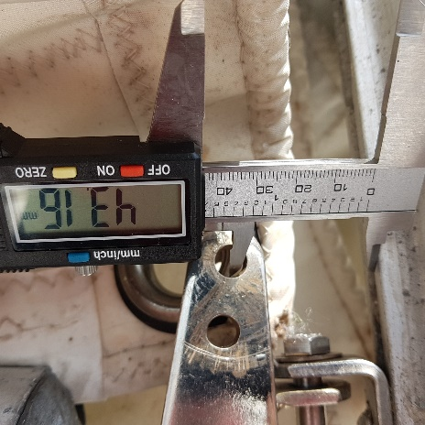
M1 jaw width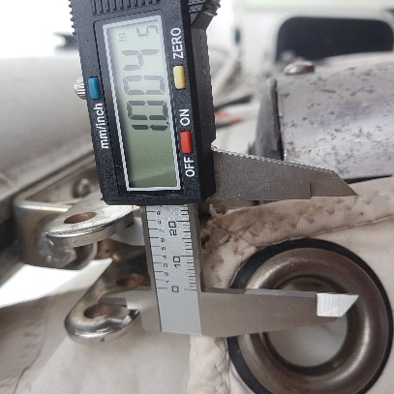 1 inch or 25.4mm
M2 picture
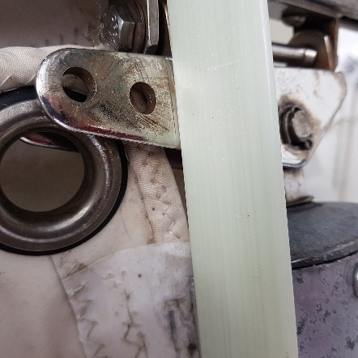 measured straight across boom, made a mark
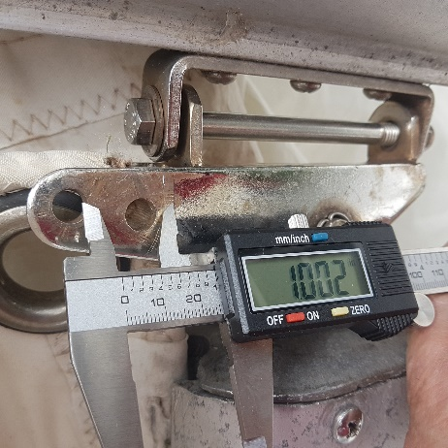 measured up
M3 picture
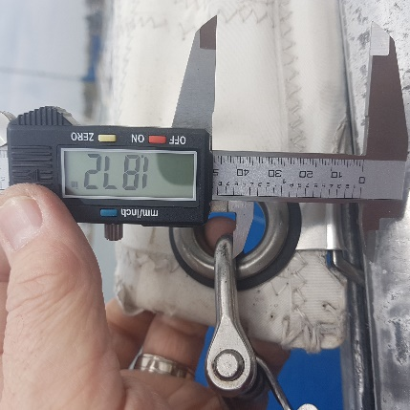 X measurement
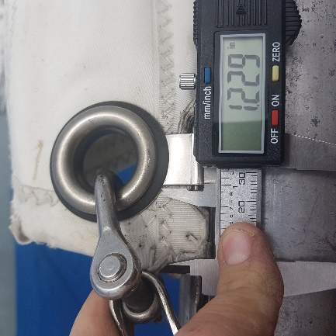 Y measurement
M4 pictures
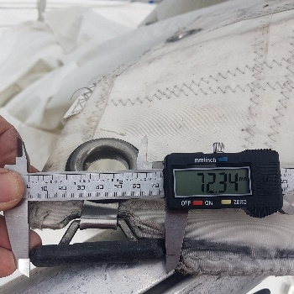
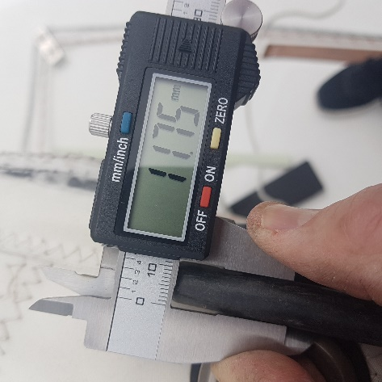

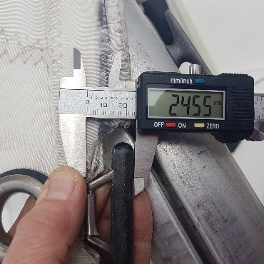
M19 pictures

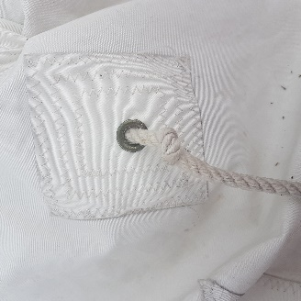
M27 pictures
