 | - Headsail - | 3000113 Alex
H0 | Sail Layout | Not Yet Posted
H1 | Size of Headsail (110, 135, 150 etc.)" | Luff Leech Foot | HELP
H2 | Luff Length, Max Hoist, B measurement | 14,25m webbing loop tip to webbing loop tip (Max)  (14.03m Net Finished size day of delivery) | HELP
H3 | Leech Length | 12,50m | HELP
H4 | Foot Length | 6,00m | HELP
H5 | Tack and Head Fittings | Webbing Loop
H6 | Clew Type (Press ring or 0-Ring) | Press Ring | HELP
H7 | Leech Line | Yes
H8 | Reefs for Hank on Sail (specify Qty of tiedowns) | No Manual Reefs
H9 | Foot Line | Yes
H10 | Track 1 (Tack to Genoa Track Beginning) | N/A | HELP
H11 | Track 2 (Tack to Genoa Track Ending) | N/A | HELP
H12 | Vessel "I" Measurement | 15m | HELP
H13 | Vessel "J" Measurement | 4.5m | HELP
H14 | Calculated Forestay Length | N/A
H15 | Reef | N/A
H16 | LP | Sailmaker | HELP
H17 | Color of Suncover | Red Jockey | HELP
H18 | Side of Sail for Suncover (port or Stbd) | counterclockwise  rolls in from stb to port
H19 | Luff Tape Size (such as #6) | 5mm | HELP
H20 | Furler Manufacturer | B35M
H21 | Foam Luff | YES | HELP
H22 | Cut Type | Cross
H23 | Sail Area | Sailmaker
H24 | Telltails | Yes | HELP
H25 | Telltail Window | No
H26 | Triple Stitch | YES
H27 | Logo | No | HELP
H28 | Cloth Weight | 9.88
H29 | Sail Numbers and Color (red, blue or black) | No | HELP
H30 | Sheeting Stripe (red, blue, black) | No | HELP
H31 | Draft Stripe Color (red, blue or black) | Yes (color ?) | HELP
H32 | Clew Height off Deck | sailmaker | HELP
H33 | Tack Height off Deck | N/A | HELP
H34 | Luff tape starts ??? up from Tack | ??? | HELP
H35 | Specialty Sail | No | HELP
 | Customer Note: All details we can check as sailmakers are based on accurate vessel I and J Measurements |  | HELP

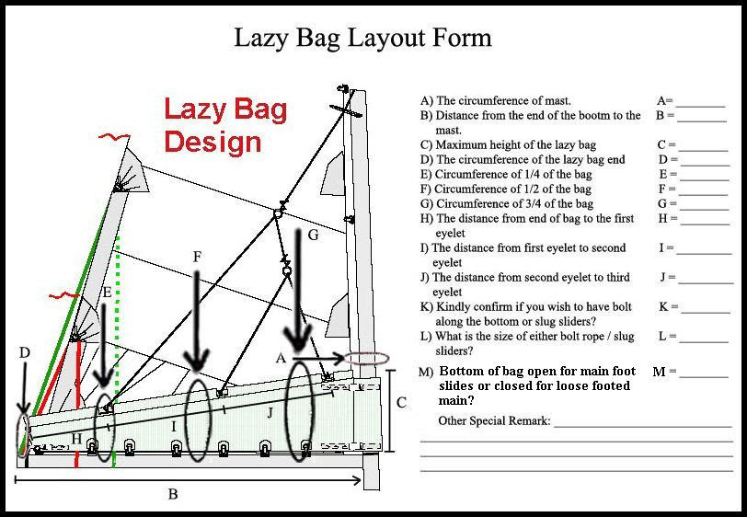
The mainsail to be loose footed, so the boom cover can have slides to fit on the boom.
2) ATTENTION, CHANGE: Length to be 5,25m + 5cm for the end/zipper (zipper open)
3) Cover Height: on the mast it is 115-120cm and 45cm at transom.
4) PLEASE INSTALL 2 GROMMETS on each side. 20mm diameter for reefing sheets
First grommets 10cm before end and second 25cm before end of lazy bag above boom.
FOTO OF BOOM SHOWING 2 SHEETS WAS SENT PRIOR.

