 | - Mainsail - | 3000112 Bernard
M0 | Sail Layout | See picture ‘Layout’
M1 | Tack Cut Back (Aft face of Mast to center of tack Pin - A) | 1.5 inch  Ring flush with corner. Picture 1 | HELP
M2 | Tack Cut Up (Top of Boom to Center of tack Pin - B) | 0.5 inch ( pic 1) | HELP
M3 | Clew Cut Up (Top of Boom to Center of Tack Pin - X) | 0.5 inch. Ring is flush with sail (Picure 2) | HELP
M4 | Clew type (slug, outhaul car or ring with strap) | Ring with strap (pic 2) | HELP
M5 | Sunbrella clew cover for Furling Mains | na | HELP
M6 | Other Offsets |  | HELP
M7 | Headboard | Yes | HELP
M8 | Leech Line | yes
M9 | Foot Line | No
M10 | Tack Ring Type | Ring + strap. | HELP
M11 | Tack angle | 88.5 | HELP
M12 | Jack Line | No | HELP
M13 | Mast Bend (Luff Round) | Std | HELP
M14 | Fractional Rig (Yes, No) | No | HELP
M15 | Mast - Keel or Deck Stepped? | Keel
M16 | Number of Reefs | 3 Reefs | HELP
M17 | Intermediate Reefing Diamond Eyes (Yes or No) | No | HELP
M18 | Foot Reefing Grommets (next to boom) | N/A | HELP
M19 | Reefing Ring Type | Press ring + strap.(Picture 3) | HELP
M20 | Luff Length (Max Hoist - P) | 43’6’’ Max  (Net Finished size day of Delivery) | HELP
M21 | Foot Length (Max Foot - E) | 13’3’’ Max  (Net Finished size day of Delivery) | HELP
M22 | Leech Length (straight line head to clew) | Sailmaker | HELP
M23 | Bimini to Clear (yes or no) | N/A | HELP
M24 | Foot Round | Sailmaker
M25 | Aspect Ratio | Sailmaker | HELP
M26 | Vessel Backstay Measurement | >15’( twin backstays) | HELP
M27 | Luff Slides (Part Number) | 10x Plastic hourglass-shaped spacers see picture4 + Diagram. Plastic shape: height:20mm. Diameter:12mm. Hole diameter:4mm. For use on harken ball bearing slides on mast. | HELP
M28 | Foot Slides (Part Number) | Loose foot | HELP
M29 | Roach Type | Cruise | HELP
M30 | Roach Factor | 1.1 | HELP
M31 | MGM | Sailmaker | HELP
M32 | MGU | Sailmaker | HELP
M33 | Batten Type (Partial or Full) | 4 full | HELP
M34 | Include Battens | No
M35 | Install Nylon Batten Holders | Holders being sent to loft | HELP
M36 | Intermediate Sliders | 2 between Each Batten | HELP
M37 | Cloth Weight | 9.3
M38 | Cut Type | Cross
M39 | Sail Area | Sailmaker
M40 | Cunningham | No | HELP
M41 | Telltails | Yes | HELP
M42 | Triple Stitch | Yes
M43 | Sail Logo and Color(red, blue or black) |  | HELP
M44 | Sail Logo Artwork | see picture 5  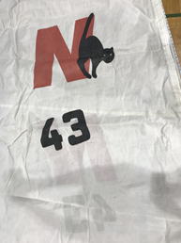
M45 | Sail Numbers and Color |  | HELP
M46 | Draft Stripe and Color(red, blue or black) | Yes (Black) | HELP
M47 | Overhead Leech Line | No
M48 | Specialty Sail | No | HELP
M49 | Boom Cover | No | HELP
M50 | Lazy Bag | Yes, see below. | HELP

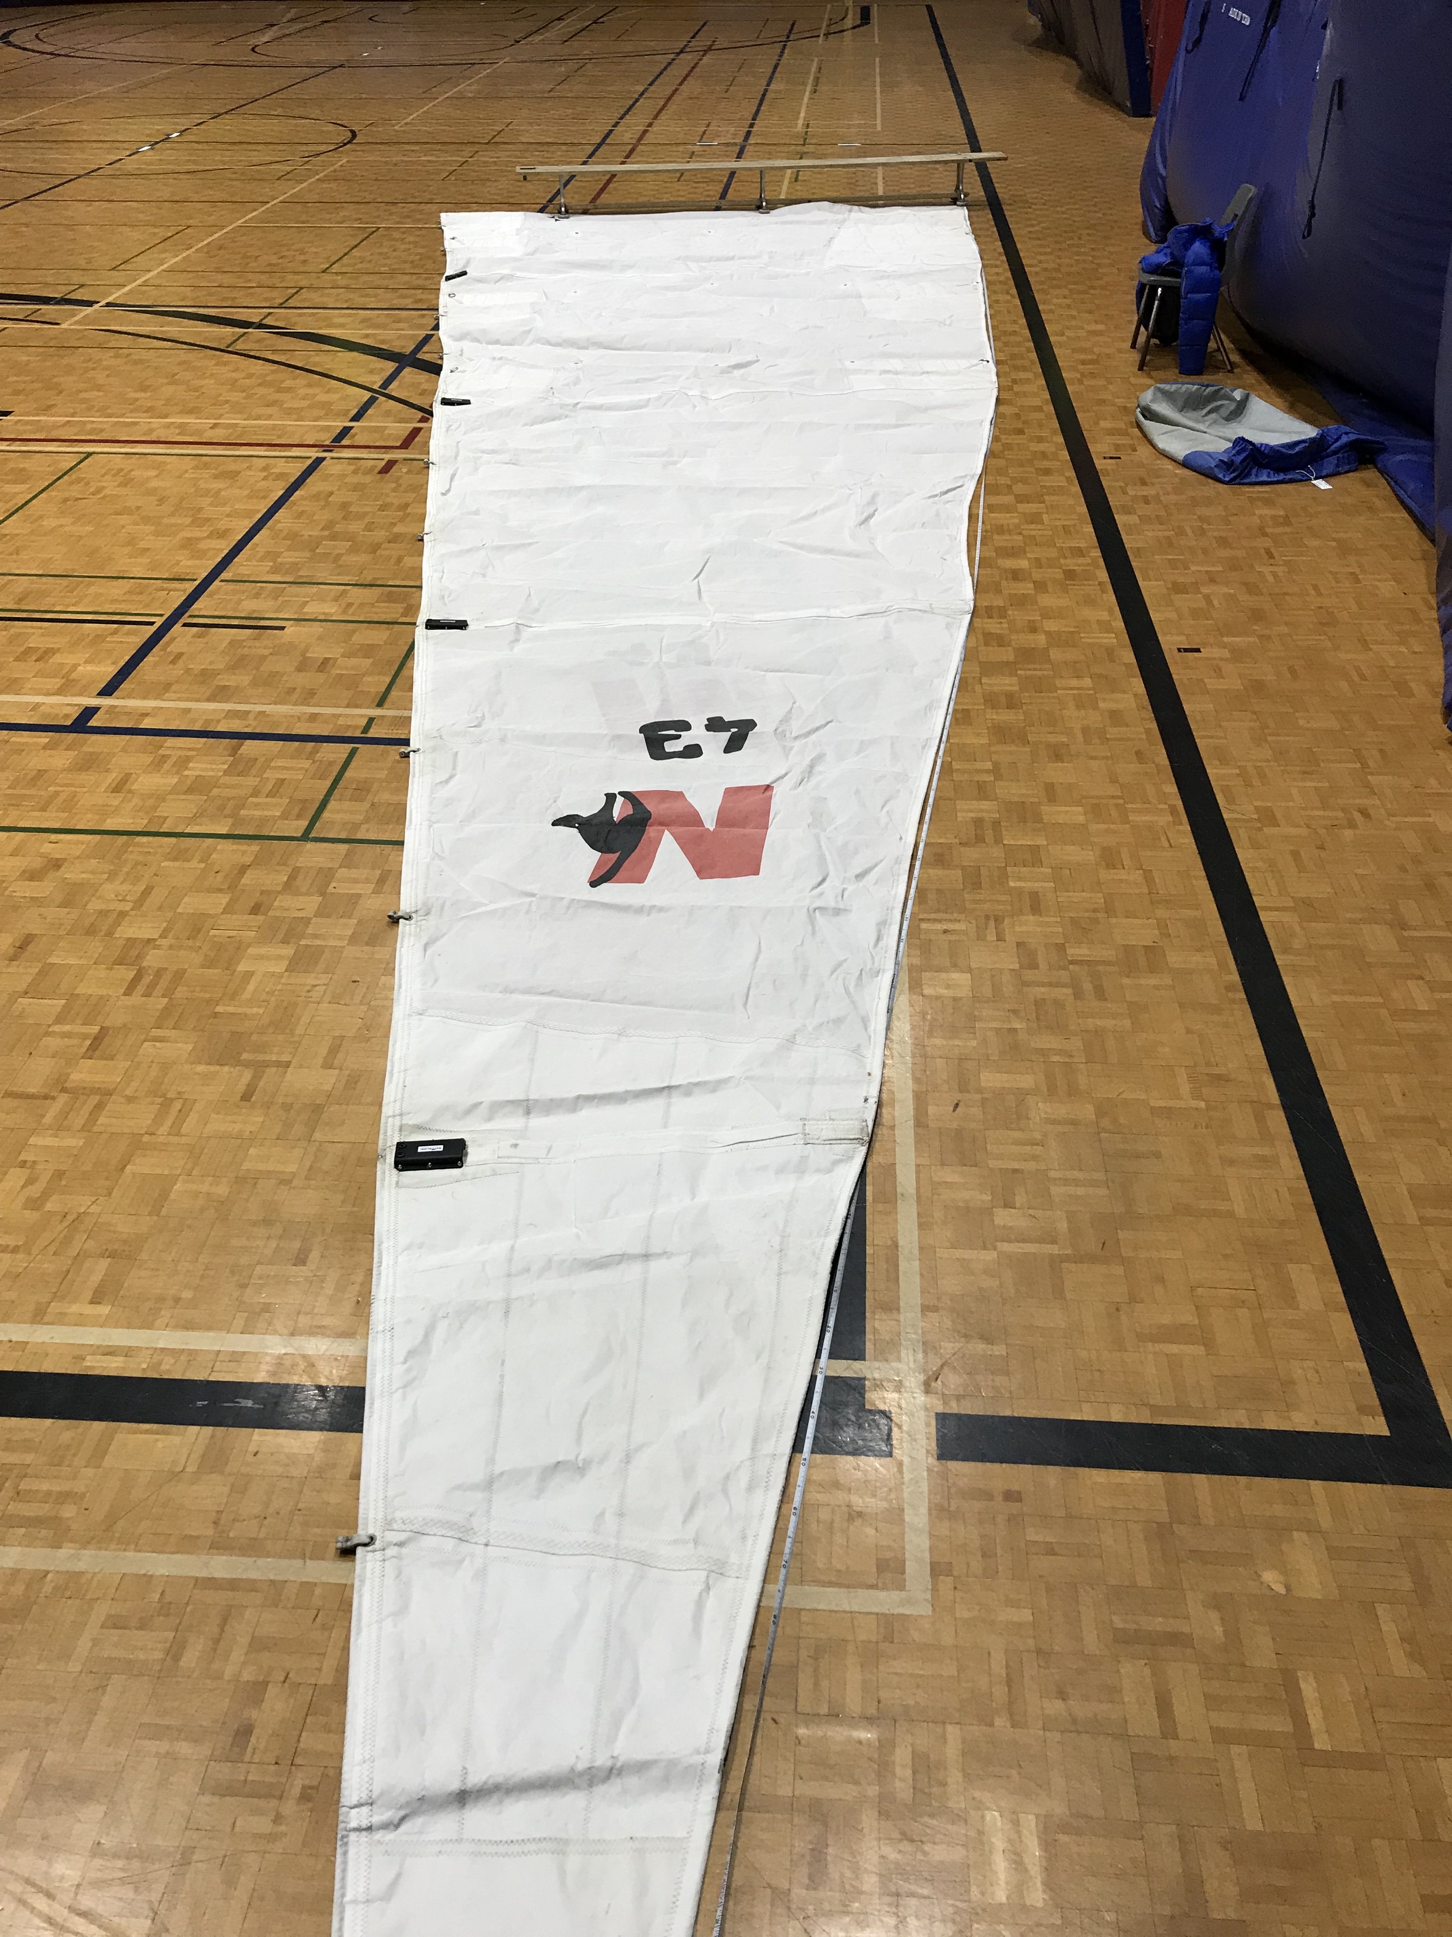

Picture A: Mainsail layout
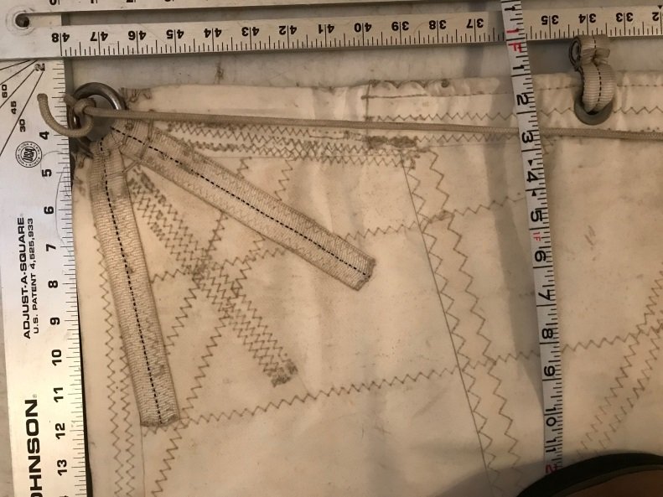Picture 1: Tack cut M1+ M2
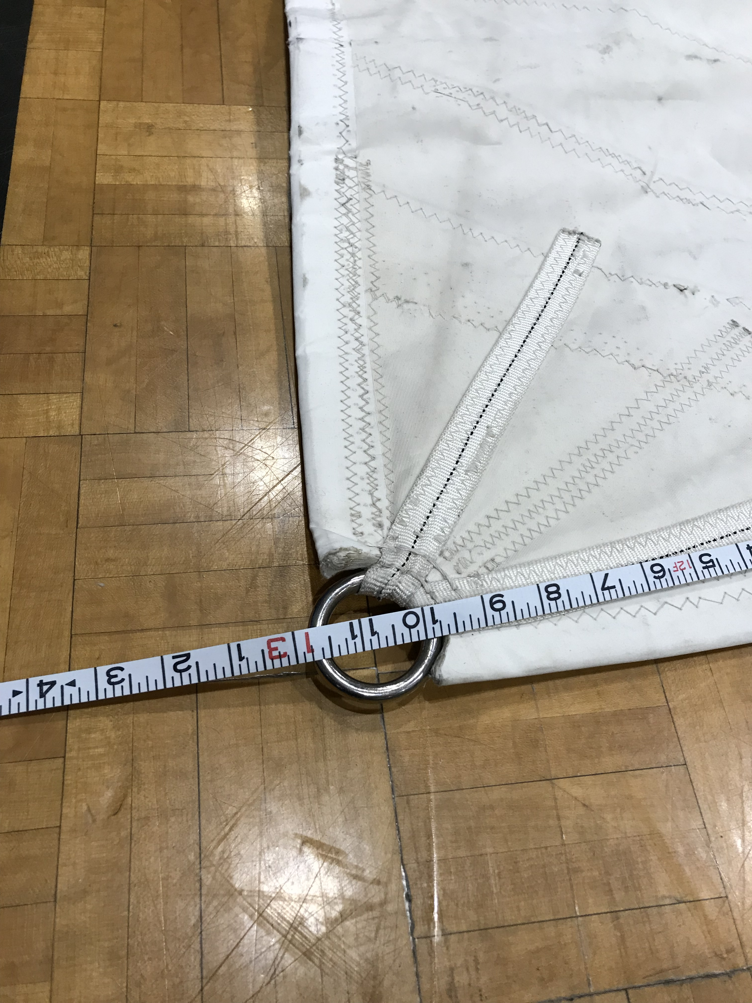 Picture 2: Clew cut up
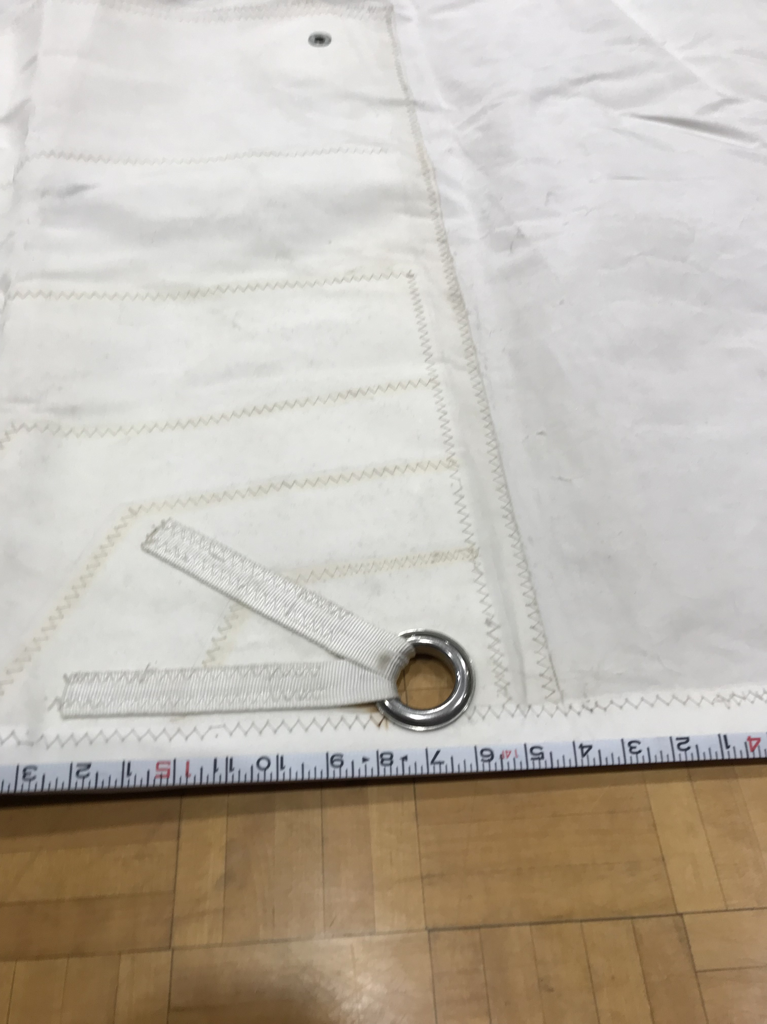Picture 3 : Press ring+ straps for reefing points (both ends of sail)

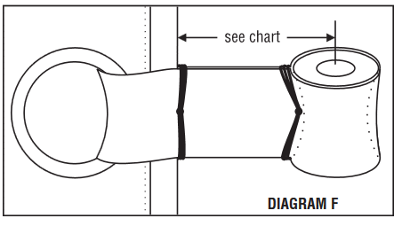 Plastic hourglass-shaped spacers: 20mm high, 12mm diameter and 4mm hole for clevis pin.
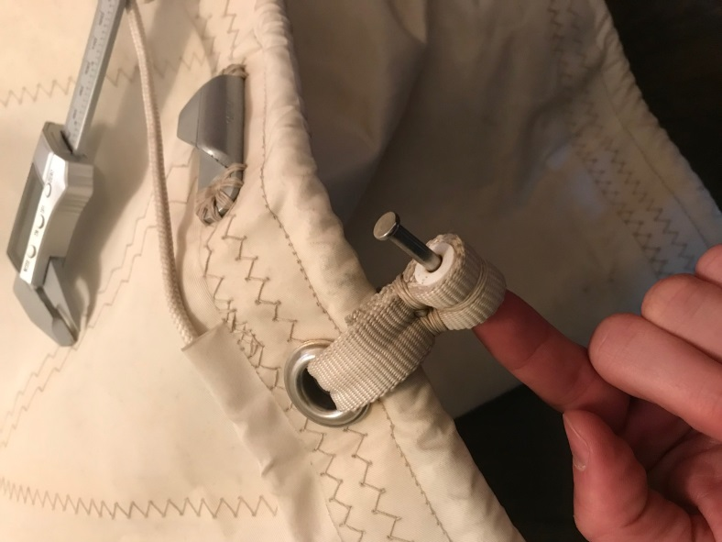 Picture 4-a
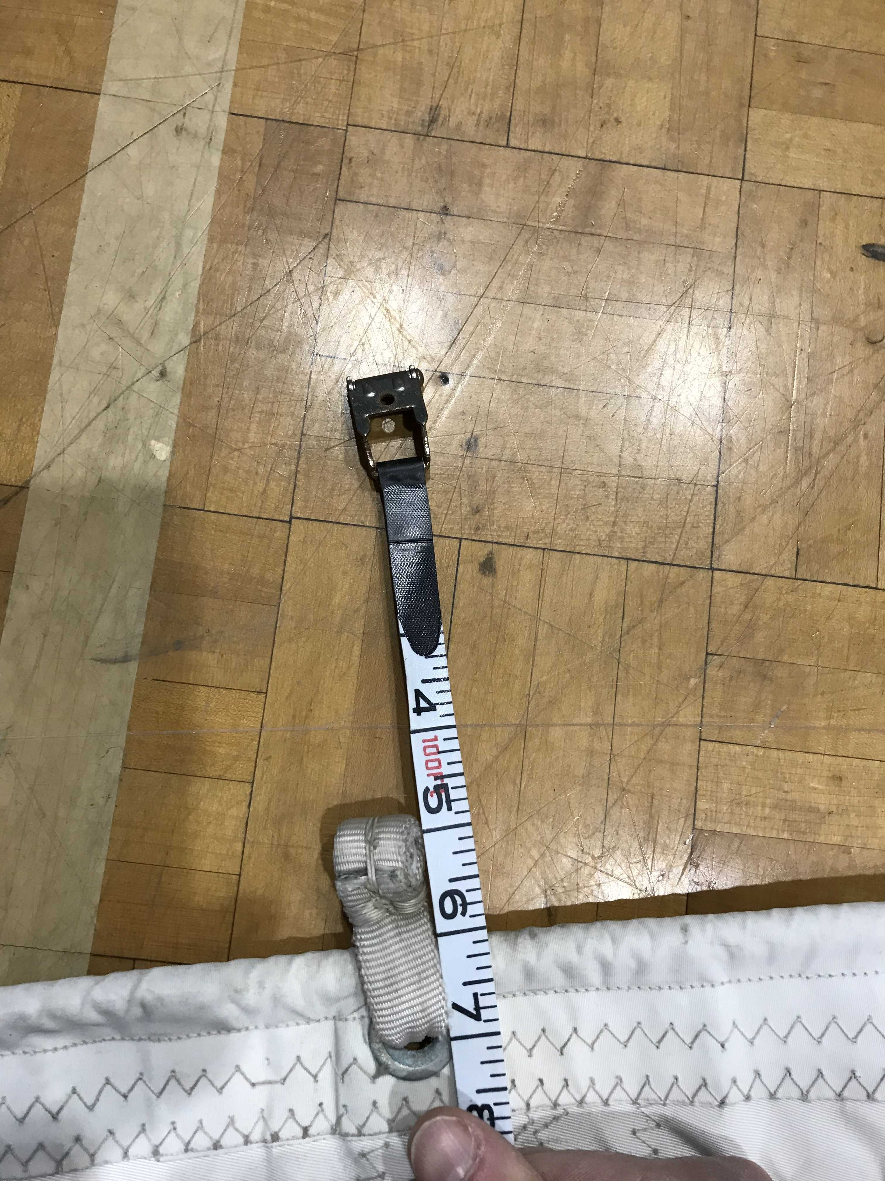Picture 4-b
Lugs are set back 1 inch from sail, measured from centerhole to sail edge. Double webbing 1 inch is used to attach lug to grommet on the sail.
Picture 5: Nauticat LOGO
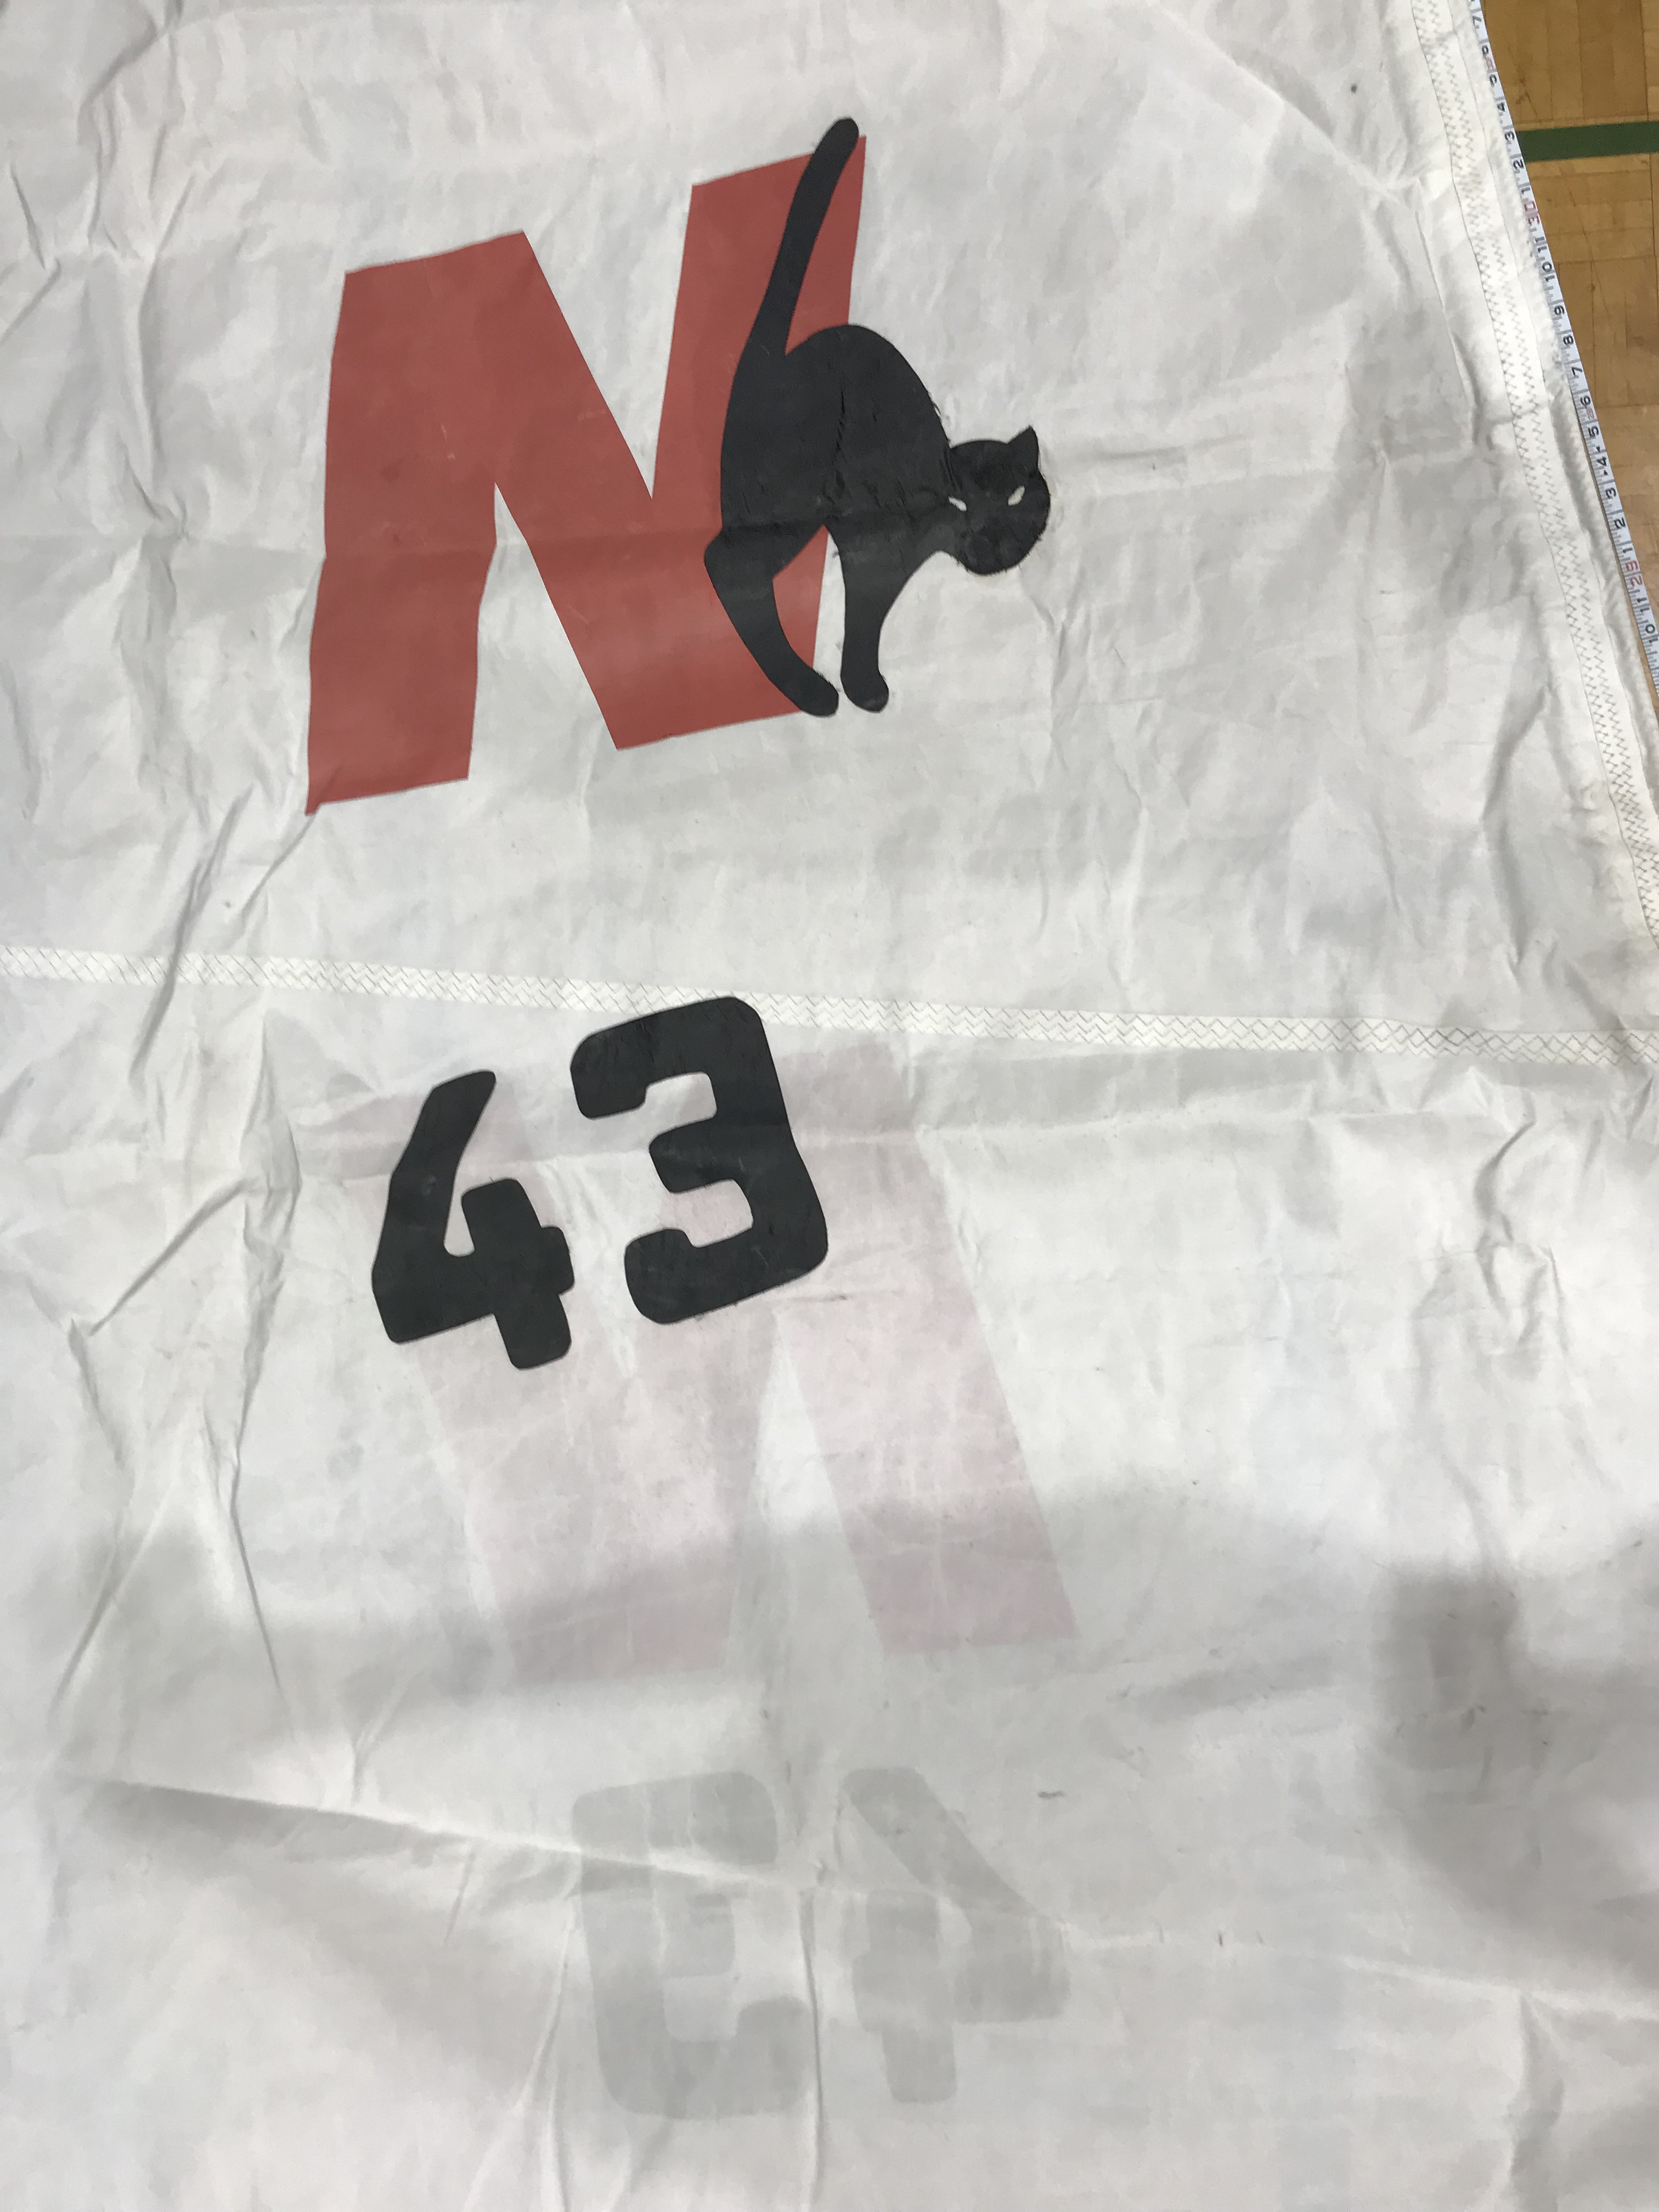
Lazybag Layout form:
- Mast circumference: 36’’
- Distance from end of boom to the mast: 13.94
- Maximum height of lazybag: 4’4’’
- Circumference of lazybag end: 3’
- Circumference of lazybag ¼: 4’
- Circumference of lazybag ½: 4’6’’
- Circumference of lazybag ¾: 5’6’’
- Distance from end of bag to 1st eyelet: 3’
- Distance from first to second eyelet: 2’9’’
- Distance from 2nd to 3rd eyelet: 2’ 9’’
Distance from 3rd to 4th eyelet: 2’9’’ ( there are 4 eyelets on my cover)
- Bottom is a 10 mm boltrope.
- Boltrope diameter: 10mm
- Bottom of bag is closed.
Other remarks: Present boltrope is 11’ long so that reefing can occur. Boltrope starts one feet behind mast ( and stops 2 feet before end of boom). The bag has some more room at the base of the mast as the battcar systems stacks on top of another and this creates more height. Let me know if this is a possible way to make the bag or if you suggest making it symmetrical.
Top of bag is a nylon zipper.
There is an opening at the sides of lazybag for the reefing lines to exit the bag and attach the reefing lines to the boom. That opening is stiched in the middle. See picture A.
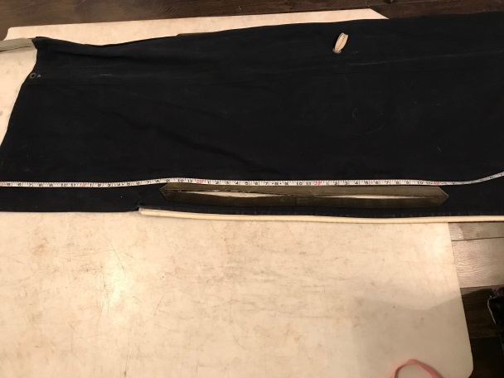Lazybag openings for reefing lines ( both sides, reinforced)
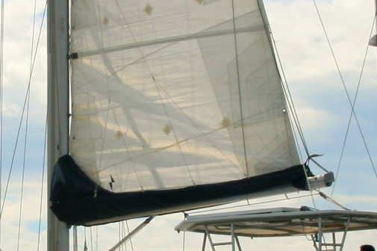 Actual lazybag shape: Enlargement at base of mast for battcar stakings

